Biodiversity and Protected Areas Management
(BIOPAMA 2 project)

First concept for a
Planning-monitoring module

July 2019

Index
Index 2
1 Planning – Monitoring proposal 3
1.1 Planning - Monitoring operational summary 3
2 Planning conceptualise 4
2.1 Purpose of Planning 4
2.2 Vision 4
2.3 Mission 4
2.4 Long-term objectives 4
3 Long-term objectives development 6
3.1 DPSIR causal framework 6
3.1.1 Previous and current state (situation analysis) 9
3.1.2 Driving forces and Pressures 9
3.1.3 Responses 9
3.1.4 Expected conditions 10
4 Planning special elements 10
4.1 Conservation targets/objectives and Human wellbeing targets/objectives 10
4.2 Road map or Timetable 11
4.3 Special element of planning 12
4.3.1 Threats and opportunities 12
4.4 Strategies 12
4.5 Social benefits for local communities 12
4.6 Develop a monitoring plan 13
4.6.1 Analyses 13
4.7 Work plan or Operational plan 13
4.8 Budget plan 13
5 Annex 5.#: Free, Prior and Informed Consent – FPIC 14

Index of figures
Index of tables
Table 1: Matrix for the use of DPSIR scheme with explanation 7
Table 2: Simplified matrix to use to analyse the logic chain of the responses proposed in the DPSIR matrix 9
Table 3: Logic chain from activities (Reponses) schedule to achieve the outcomes/Impact (Expected conditions) in elephant protection 10

Planning – Monitoring proposal

Planning - Monitoring operational summary
The proposal uses a proactive approach trying to link the key management elements to an outcome or a ‘Long-term objective-LTO’ paying attention that all the LTO should be functional interrelated in the management plan including a monitoring plan.
The proposal also provides a road map for the planning. The road map is organised handling decision-making moments to ensure that the proposals are aligned and support planning strategies and management requirements of the protected area.
The identification of the issues to be overcome in a protected area management and governance allows the development of the key intervention points and strategies to be adopted to achieve the expected conditions or Long-Term Objectives for every topic of the adaptive management exercise. The use of the logic chain – LC – and the problem tree – PT – analyses can synthetically depict the assumptions of the DPSIR matrix of the functional and interaction links between actions and long-term biodiversity objectives and natural resource management issues.
The module works on organising the elements of the intervention logic with tools to build a road map of planned actions and expected outputs/outcomes to achieve allowing consolidating the planning exercise with practical issues as inputs, budget, etc.
The module organises all the elements in the management plan and it first working plan to put the planning proposals into action for the first step of intervention.
Specific elements supporting the planning exercise complete and integrate the proposal as relationship between conservation and human wellbeing targets/objectives, threats and opportunities, monitoring plan, etc.

Planning conceptualise
This beginning of planning involves determining the main elements of the plan:
- the purpose of the planning and decisions that plan will support,
- the vision of what we hope to achieve,
- the conservation and development associated targets and goals,
- the stakeholders involved in the planning and in the implementation,
- the road map to elaborate the plan.

Purpose of Planning
The conceptualisation of the plan for the management of a protected area includes identifying of:
- the management/governance scope,
- the thematic scope,
- the geographic scope,
- the threats and the opportunities,
- the key stakeholders – included disadvantage stakeholders – and their influence/power in decision-making about lands and natural resources,
- the decisions already made and any constraints or limits.
The planning exercise should define what the Management plan intends to affect. The exercise may reference to specific targets of biodiversity conservation, geographic management – zoning, protected areas, landscapes, transborder, ecoregion, etc. – , specific threats to minimise, opportunities to foster, ecosystem services to improve and valorise, governance to establish/improve, etc.
Box 1: Integrated planning, monitoring and evaluation - PME
The conservation, becoming more results-oriented, needs to improve its focus on good planning, monitoring and evaluation and enhances conservation interventions by establishing clear links between past, present and future initiatives and the long-term goals. Monitoring and evaluation can help organisation extract relevant information from past and ongoing activities that can be used as the basis for programmatic fine-tuning, reorientation and future planning. Without effective integration between planning, monitoring and evaluation, it would be impossible to judge if work is going in the right direction, whether progress and success can be claimed, and how future efforts might be improved.

Vision
The planning needs to specify a clear and coherent vision corresponding to a statement, which meets the criteria of being relatively general, visionary, and brief. A protected area’s vision should fit within the context of the national and international conservation strategies.

Mission
The planning needs to identify, if there are, special assignments to perform in the protected area. The mission could include the protection of an endangered species, a natural water tower area, a specific cultural ecosystem services, etc.). The planning must take account of the specific tasks assigned to the protected area

Long-term objectives
Management of protected areas is increasingly being carried out following the ‘management by objectives’ or ’management result oriented’. The approach is considered proactive, i.e. designed to achieve specific set of goals, rather than reactive, i.e. merely responding to issues that arise. The goals and objectives of the protected area have to be clearly identified. They should relate to the key values of the protected area (species or ecological systems/habitats), ecosystem services (provisioning, regulating, cultural, support services) or other themes (tourism, education) that are chosen to represent and encompass the full conservation of the protected area. The objectives are the basis for setting the management and working plan, carrying out conservation actions, and measuring conservation effectiveness. The planning exercise needs to select a limited number of objectives with a strong focus on key conservation elements (species, threat – opportunities, or other themes). Implementing these key conservation elements subject will, by definition, be working to conserve all the elements of the protected area (e.g. to reduce poaching of elephants and illegal wildlife trade of ivory). If a conservation objective occurs at a large scale (e.g. a bird species across it ranges or the full extent of an ecosystem type), it may also be helpful to divide it into spatially explicit sub-objectives (e.g. specific habitat protection of the populations of migratory bird species).
Box 2: Distinction between objectives/outcomes and targets/outputs
In this planning we use the follow distinction between objectives/outcomes and targets/outputs.
- OUTCOMES relate to OBJECTIVES (GOALS), i.e. long-term objectives/goals related to the vision/mission expressed in the management plan. These objectives/goals are usually specific statements relating to the key values of the protected area (i.e. important species or ecosystem services) or to major areas of management activities (e.g. tourism, education).
- OUTPUTS relate to TARGETS, i.e. short-term (or relatively short-term) quantitative targets to achieve the long-term objectives/goals and specific objectives.
The use of many low-level conservation targets is an obstacle to achieving high-level conservation performance.

Long-term objectives development

DPSIR causal framework
The planning is basic problem solving exercise that must take into account several aspects and their interaction in the formulation of solutions.
The DPSIR is an acronym for the causal framework that assumes a chain of causal links starting with ‘driving forces’ (economic sectors, human activities) through ‘pressures’ (poaching, slash-and-burns) to ‘states’ (physical, biological) and ‘impacts’ on ecosystems and functions (loss of biodiversity, ecosystem services), eventually leading to ‘responses’ (target setting, planning, activities) looking to expect conditions to achieve (impact).
Picture 1: DPSIR causal framework
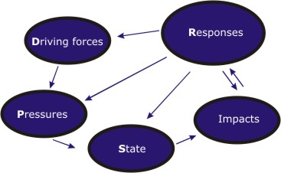
The DPSIR model was developed for the determination of indicators and then refined for a stronger strategic orientation towards critical planning reflections. The DPSIR framework could be organised in a scheme (see pictures 1 and 2) to facilitate analysis and to provide responses to achieve the expected conditions or Long-Term Objectives.
Picture 2: DPSIR framework organises in a scheme to facilitate analysis and to provide responses to LTO
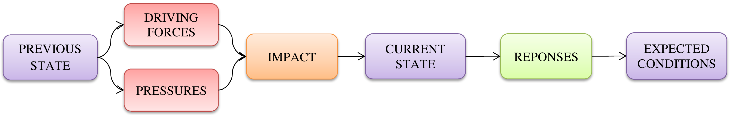
The DPSIR scheme is converted in a matrix to facilitate work group inside and between the services of the management team (see table 1).
The DPSIR matrix builds off of work you have already started related to the strategic planning (scope, conservation targets, and direct threats). It supports completing a management analysis and prospective by identifying the key factors concerning the previous situation and the driving forces and direct threats that determine, with their impact, the current state. In this way, feasible opportunities and responses must be proposed in order to identify the expected favourable conditions. These correspond to long-term objectives to achieve in a variable period of time depending on their importance and the complexity and complexity to manage.
In order to identify the necessary conservation measures, it is vital to have a sound information base of the existing conditions of the site, as well as on the conservation status, threats, pressures and needs of the species and habitat types present and on the overall socio-economic context (existing land uses and ownership, stakeholder interests, ongoing economic activities, etc.).
Table 1: Matrix for the use of DPSIR scheme with explanation
Previous state | Driving forces | Impacts | Current state | Responses | Expected conditions
 | Pressures
Elements of the previous state are useful to a better comprehension of the driving forces and pressures that impacted and influenced the current state | Key external forces human-induced (such as policy, economy, illegal trade, climate change) that shape the future of conservation. | The overall and long-term effect of interventions or conditions in the values of a protected area. Results of effects either planned or not, positive or negative, that contributes to changing the objectives or long-term goals of conservation. | Elements of the present set of the protected area. For conservation purposes, it is very important to closely review the protected area current state with respect to its values. The driving forces and direct threats determine, with their impact, the current state | Actions or reactions to go from the current state to expected conditions.  Activities that should be promoted/adapted/excluded in order to improve the site’s conservation conditions.  Conservation responses can address through the involvement of multiple actors across different institutional and spatial levels | Conservation objectives that are intended to define as precisely as possible the desired state or degree of conservation to be reached in a particular protected area, complex, landscape in the time.
 | A human-induced stressor that causes disturbance, damage or loss of one or more components of the protected area values temporarily or permanently.
Below you can find an example of DPSIR planning exercise concerning the elephant population management exploiting one element of the Regional biodiversity hotspot of the Adaptive Management’ exercise.

Picture 3: Exemple of DPSIR scheme utilise for elephant population targets and long-term objectives
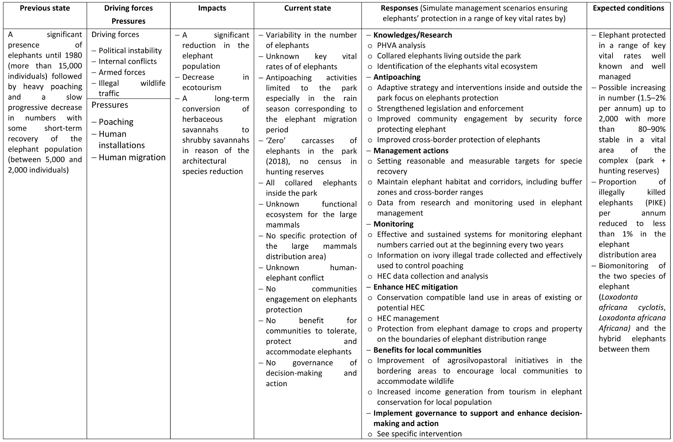

Previous and current state (situation analysis)
A situation analysis is processes that will help the protected area team to create a common understanding of the context of key management elements. It describes the previous and current state and the relationships between the protected area values and the social, economic, political, and institutional systems and drivers that affect the conservation targets you want to conserve. As part of your situation analysis, you should conduct a stakeholder analysis. Stakeholders analyses help clarify relationships that may warrant attention and influence success or failure of your management. You need to consider both powerful and influential stakeholders and those that might be disadvantaged or marginalised. The review stakeholders also must identify which stakeholders are likely to be important strategic partners for the project. An important product of a stakeholder analysis is the identification of primary interests – what your stakeholders ultimately care about or value. Defining primary interest helps make transparent what is driving the behaviour and decisions key stakeholders. To capture the relationships among conservation targets, threats, opportunities, and primary interests is to construct as simple as possible a conceptual model (e.g. factors-threats-targets/objective model) to visually portrays the relationships between the different factors in your situation analysis.

Driving forces and Pressures
It including describes the relationships between the biological environment and the social, economic, political, and institutional systems and drivers that affect the conservation targets you want to conserve.

Responses
Filling the column ‘Responses’ with the various categories of activities leading to the outputs and outcomes is a fundamental part of elaborating the management plan. The exercise allows developing a clear programme of activities of what you would like to achieve (see table 1 and picture 3).
Although the DPSIR matrix helps to identify the various categories of management intervention, we need to be sure that the proposals (responses) will contribute to achieving the expected condition. The logic chain (LC) depicts these assumptions, in a causal (‘if – then’) progression of intermediate results that lead to long-term objectives (expected conditions). The LC is hypothesised descriptions of the chain of causes and effects leading to an outcome/impact of interest (e.g. endangered species, ecosystem services management, human wellbeing from conservation objectives, etc.). The LC usually takes form in a graphical depiction of the ‘if-then’ (causal) relationships between the various elements leading to the outcome. Depending on the purpose of the logic model, elements depicted and the relationship between them is more or less detailed.
A simplified matrix to use to analyse the logic chain of the responses in the DPSIR matrix is proposed below. The standard LC uses more elements to demonstrate the clear links between the problem, the required inputs and the activities, the outputs and the outcomes to achieve the potential for longer-term impacts than the simplified matrix proposed below.
Table 2: Simplified matrix to use to analyse the logic chain of the responses proposed in the DPSIR matrix
Activities | Outputs | Outcomes/Impacts
what activities the program undertakes | what is produced through those activities | the changes or benefits that result from the program
Exploiting the example of DPSIR scheme utilise in the example of elephant population long-term objectives (see picture 3), the logic model shows the links between the various elements leading to the expected condition, see below.
Table 3: Logic chain from activities (Reponses) schedule to achieve the outcomes/Impact (Expected conditions) in elephant protection
Activities | Outputs | Outcomes/Impacts
what activities the program undertakes | what is produced through those activities | the changes or benefits that result from the program
- Knowledges/Research  - Antipoaching  - Management actions  - Monitoring  - Enhance HEC mitigation  - Benefits for local communities | - Identification of the key vital rates and the distribution area of the two species and hybrids  - Minimise PIKE and IWT ivory in the region  - Benefits for the elephants key vital rates (habitats, corridors, HEC, etc.)  - Information for elephant conservation of key vital rate variables, IWT ivory, PIKE, HEC, etc.  - Local communities engagement to tolerate elephants protection  - Local communities benefits to protect and accommodate elephants | - Elephant protected in a range of key vital rates  - Increasing number of elephants  - Maintain a population of two species + hybrids of elephants

Expected conditions
Developing a clear idea of the expected conditions or desired state is the essential part of elaborating planning. A long-term objective represents the desired status of the conservation or human wellbeing goal in the time. They are formal statements of the ultimate impacts you hope to achieve. Developing a long-term objective is a matter of converting information into a goal statement.

Planning special elements

Conservation targets/objectives and Human wellbeing targets/objectives
The management plan could include the benefits of the conservation interventions to local communities. In the case, the plan should include human wellbeing targets as direct effects/impact of specific development interventions or affected by the status of conservation targets.
We can also use logic chains to show how the conservation targets provide services that contribute to human wellbeing (see picture 4). In planning it is important to specify when the actions are contributing to human wellbeing outputs and outcomes via ecosystem services and when they are contributing more directly via a conservation strategy of biodiversity (environmental services). The interests of the local communities are generally being enhanced or achieved as ecosystem services and it is important to stress the contribution of the biodiversity strategy to the human wellbeing.
Picture 4: Relationship between conservation and human wellbeing targets/objectives
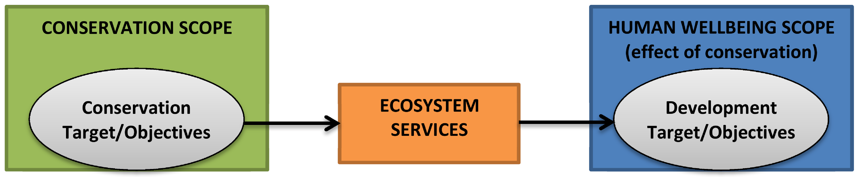
Concerning the human wellbeing, the protected area team should make sure their outputs and outcomes dependent upon the status of the conservation and ecosystem services goals. It means that the protected area team should establish only (or as possible) human wellbeing goals related to biological goals, such as treats reduction (benefit to accommodate wildlife), ecosystem services of provisioning (water access, crop pollination, NFTP, etc.) or regulating (benefits from tourism).

Road map or Timetable
Filling the DPSIR matrix, we define the elements to have a well establish long-term objectives. The same elements will be useful to know what inputs you need, by when you hope to achieve the outputs and the outcomes/impact (desired status), and what you need to monitor to assess the achievement of the goal. These elements of the DPSIR matrix could be organised in tables of inputs and budget, timetables of intervention, and expected output and outcomes. Below you can find the example of the elephant LTO.
Picture 5: Possible outputs and outcomes for a long-term objective of elephant population
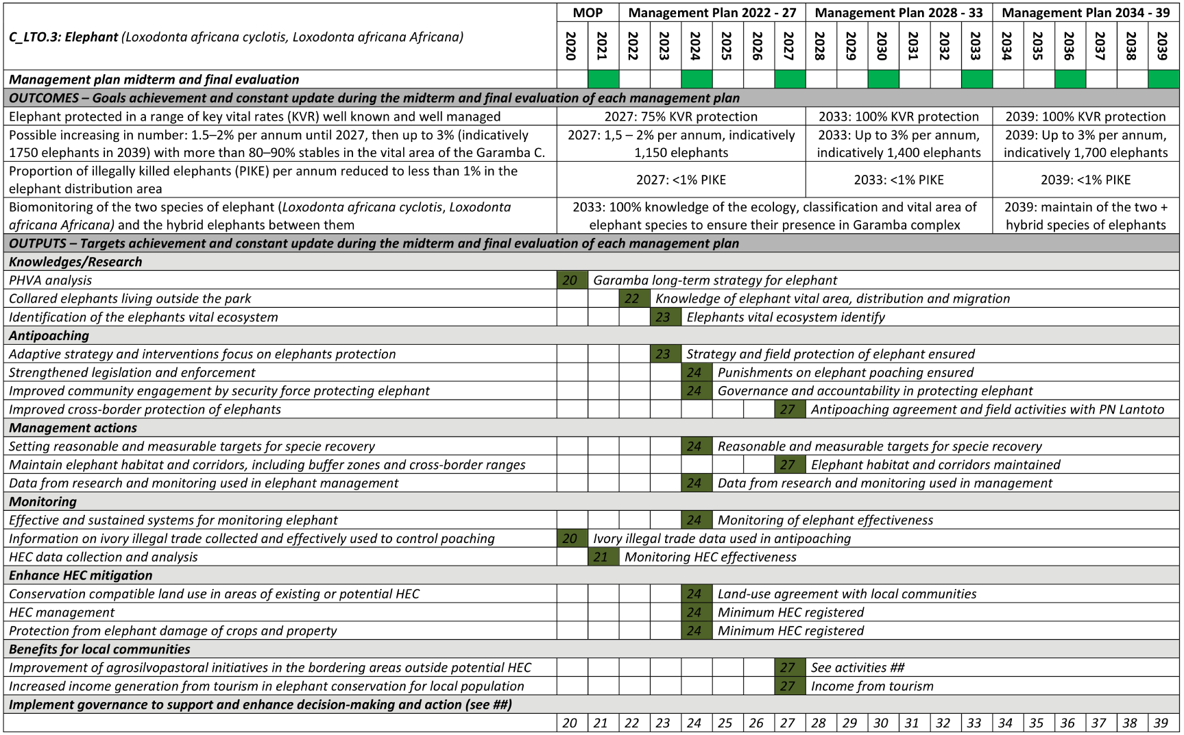
Picture 6: Possible road map for a long-term objective on elephant population
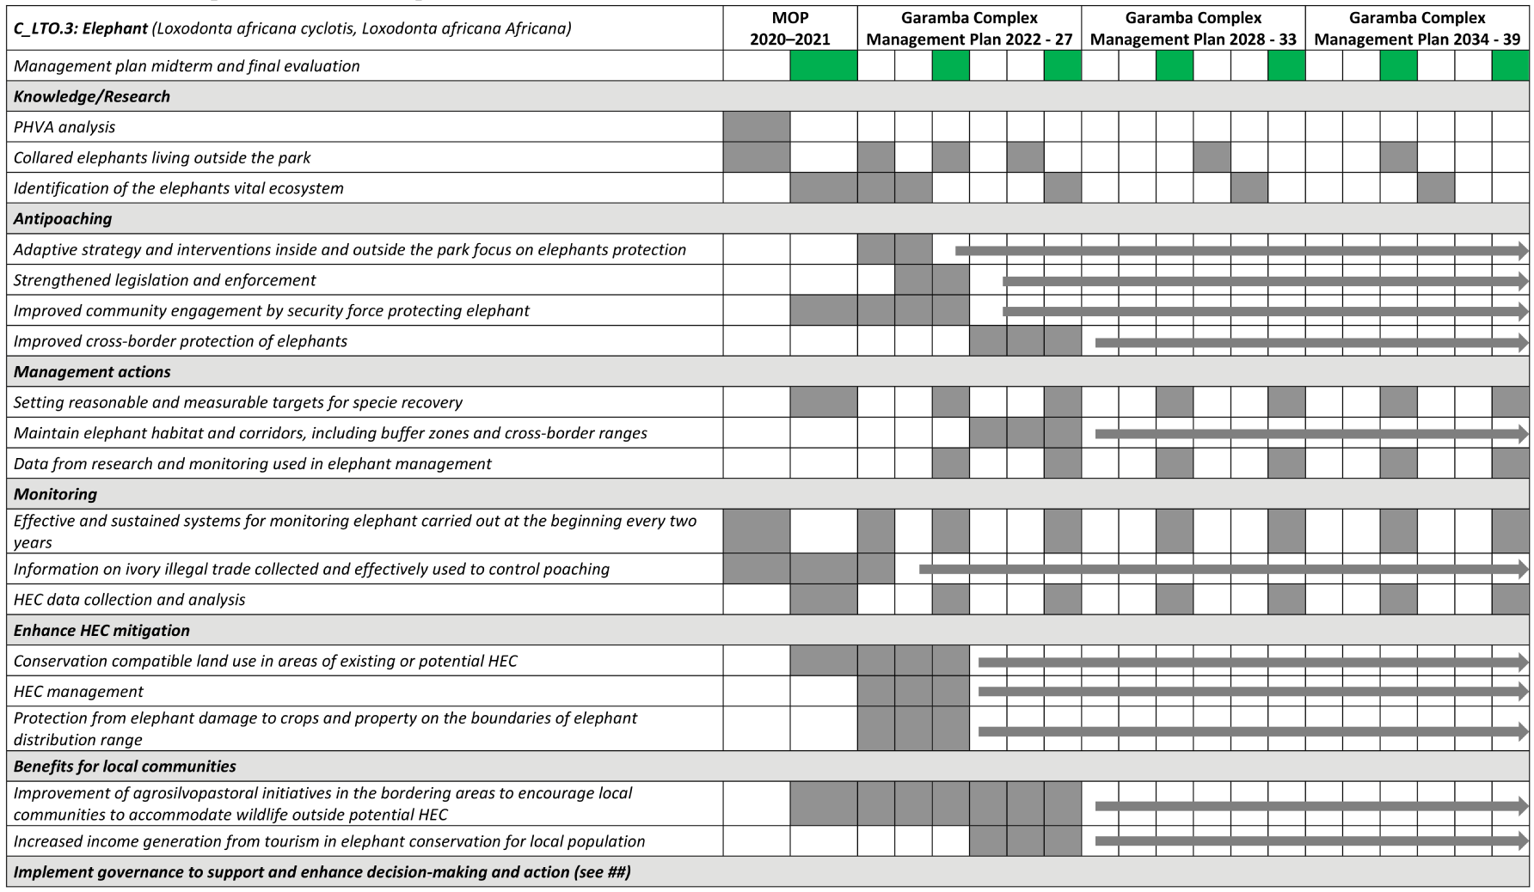

Special element of planning

Threats and opportunities
Although the final definition of objectives will take time, once we have settled on our priority conservation objectives, we need to identify the direct threats that influence them and the potential opportunities if the objective is achieved. Generally, a discussion about threats and opportunities across the short and long term bring the current situation in relation to the vision, assigned the mission and objectives of the protected area. The threats/opportunities analyses can facilitate a shared understanding and shows the need to set new strategy, and avoid the trap set by the urgency of responses to threats.

Strategies
After prioritise the key intervention, the planning needs to work on strategies to develop a range of potential solutions that have the practicality to achieve the LTO. The strategies must have a common focus to achieve specific LTOs by targeting harmonised intervention, integrating opportunities and limiting constraints. Working on strategies involves investigating how others have attempted to intervene in similar situations and whether those interventions succeeded or failed and why. In addition, it always makes sense to work on strategies that look at stakeholders’ interests, limit potential conflicts or build stakeholder support. The planning process should also consider other criteria such as feasibility (technical, financial, political), cost, niche or gap the strategy would fill, and ability to leverage additional funds. A simplified strategy schema could add to the problem-solution analysis.

Social benefits for local communities
In addition to provided ecosystem services important for human wellbeing, it is important to work on important social issues that have benefits and address interests beyond conservation (e.g. promoting alternative livelihoods or building capacity for good governance). In such cases, the conservation strategy could provide social benefits. They are benefits that are derived from a strategy that is done in the service of conservation. These benefits are not equivalent of the human wellbeing outputs and outcomes from the ecosystem services or the environmental services that will be enhanced or achieved as a result of the conservation of an ecosystem, habitat, or species and its associated ecosystem services.

Develop a monitoring plan
The conservation needs to improve or to adapt its interventions to quickly evolution of its context of intervention. An integrated system of planning, monitoring and evaluation could allow a better adaptive approach in management to achieve conservation outcomes. In the spirit of adaptive management, the protected area should conduct monitoring to validate proposals of the management plan, track work plans outputs and progressively outcomes achievement, and learn from information collected in a way that the information, experience and lesson learned can be integrated into current and future programming.
The monitoring plan also needs to develop the specific indicators to collect and analyse the data required to meet your information needs, identify the resources and elaborate a timeline for its implementation. The monitoring should use the minimum amount of financial and human resources to provide reliable information on the evolution of the programme and on achieving stated objectives.

Analyses
The analysis of data from monitoring and experience to convert them into useful information is capacity demanding and time consuming. Sometime the PA managers dispose of lots of data that they have collected but not analysed or used. The levels of complexity in analysis range from very simple and fast to extremely time intensive and complex. In adopting monitoring methods, we should make sure that the capacities and the level of analysis match the management situation.

Work plan or Operational plan
The work plan (WP) is the instrument to put the planning proposals into action. The WP develops and implements specific short-term plans in much greater detail that could cover one or more years and ensure sufficient resources, capacity, and partners.

Budget plan
The WP, establishing exactly the tasks and the activities to undertake, allows figuring out the resources needed for implementing the short-term plans.

Annex 5.#: Free, Prior and Informed Consent – FPIC
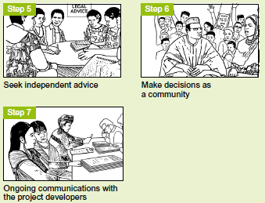
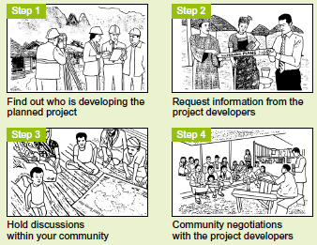

Ecosystem services: (i) provisioning; (ii) regulating; (iii) cultural services; (iv) support services
Environmental services: (i) biodiversity conservation; (ii) water resource protection; (iii) landscape conservation; (iv) carbon sequestration
Threats & Opportunities Matrix is a simple 2 × 2 (short term and long term) grid that captures the threats of not implementing a proposed solution and, conversely, the potential opportunities if the solution is accepted.

