OFAC

-

Biodiversity and Protected Areas Management (BIOPAMA2) project

Network of protected areas of Burundi: Analysis report

July 2018

Methodological approach and analysis provided by the JRC   
(Carlo Paolini, Piotr Bialowolski, Paolo Roggeri)

# Index

Index 2

Introduction 5

Preamble 8

1 Analysis of the Burundi protected areas network 9

1.1 Grouping of Burundi’s protected areas 9

1.2 Ranking 13

1.3 Management cycle elements analysis 16

1.3.1 Management Context 16

1.3.1.1 Value and Importance (Context) 18

1.3.2 Planning 24

1.3.3 Inputs 30

1.3.4 Process 35

1.3.5 Outputs 46

1.3.6 Outcomes 49

2 Overall Conclusion and Suggestions 57

3 Annexes 60

3.1 Annexe: Can the Key Landscapes of Conservation (KLC) criteria be used for grouping PAs? Can the PAs grouped in Key Landscapes of Conservation (KLC) be analysed with management effectiveness criteria? 60

3.2 Annexe: Cross analysis (work in progress) 64

**Index of figures**

Figure 1: Performance in the six elements of the management cycle in the groups identified for Burundi 10

Figure 2: Presentation of the Burundi protected areas with respect to the six elements of the management cycle aggregated into three dimensions (1. Context, Planning and Inputs, 2. Process, 3. Outputs and Outcomes) 11

Figure 3: Representation of the Burundi protected areas network in relation with the six elements of the management cycle aggregated into three dimensions (1. Context, Planning and Inputs, 2. Process, 3. Outputs and Outcomes) 12

Figure 4: Ranking of protected areas in Burundi with respect to the IMET score 14

Figure 5: Average contribution of the management cycle elements 15

Figure 6: Ranking Context 16

Figure 7: Average contribution by the six sun-indicators to Value and Importance 21

Figure 8: Ranking of the context elements 22

Figure 9: Ranking of protected areas in Burundi with respect to the score in the dimension of Planning 24

Figure 10: The average contribution to planning of its dimensions for all of the protected areas 28

Figure 11: Ranking of protected areas in Burundi with respect to the score in the dimension of Inputs 30

Figure 12: Average contribution of the sub-dimensions of Inputs to the total Inputs score 33

Figure 13: The ranking of protected areas in Burundi with respect to the score in the dimensions of Processes 35

Figure 14: Average performance in the sub-dimensions of Processes in Burundi 43

Figure 15: Ranking Outputs 46

Figure 16: Average contribution of the Outputs elements 48

Figure 17: The ranking of protected areas in Burundi with respect to the score in the dimensions of Outcomes 49

Figure 18: Average contribution of the Outcome elements 53

Figure 19: Number of IMET indicators (out of 41) with missing responses 55

Figure 20: Discrepancy between the IMET score obtained with the use of raw data and imputed data 55

Figure 21: Performance in the six elements of the management cycle in the groups proposed as Burundi’s KLC. Source Own calculations 61

Figure 22: Performance in the six elements of the management cycle in the groups identified as Burundi’s KLC in the grouping performed in this study. Source Own calculations 62

Figure 23: Performance in the six elements of the management cycle in the groups proposed as Burundi’s KLC. Source Own calculations 63

**Index of tables**

Table 1: Elements used in the analysis (synoptic table and complete list) 6

Table 2 : The protected areas of Burundi 8

Table 3: Grouping of the protected areas of Burundi 9

Table 4: Averaging of the three synthesis elements of the protected areas of Burundi 13

Table 5: IMET score of the Ranking of protected areas in Burundi 15

Table 6: Scores of the indicators of Context 17

Table 7: Ranking Value and Importance 17

Table 8: Ranking Political and Civil Environment 18

Table 9: Ranking Threats 18

Table 10: Ranking of the 6 sub-indicators of the Value and Importance (Context 19

Table 11: Scores of the indicators of Planning 24

Table 12: Ranking Planning 25

Table 13: Ranking Adequacy of legal and regulatory provisions 25

Table 14: Ranking Design and layout of the protected area 26

Table 15: Ranking Demarcation of the protected area 26

Table 16: Ranking Objectives of the protected area 27

Table 17: Ranking Management plan and Work plan 27

Table 18: Scores of the indicators of Inputs 30

Table 19: Ranking Inputs 31

Table 20: Ranking Basic information 31

Table 21: Ranking I2: Staff 32

Table 22: Ranking Current Budget and I4: Securing the budget 32

Table 23: Ranking I5: Infrastructure, equipment and facilities 33

Table 24: Ranking Process 36

Table 25: Scores of all indicators of the Process 36

Table 26: Ranking Internal Management 38

Table 27: Ranking Protection and Management 39

Table 28: Ranking Relationship 40

Table 29: Ranking Tourism 40

Table 30: Ranking Monitoring and research 41

Table 31: Ranking Climate change and Ecosystem Services 42

Table 32: Scores of the indicators of the Outputs 46

Table 33: Ranking Outputs 47

Table 34: Ranking Implementation of the programme of work and outputs achieved 47

Table 35: Scores of the indicators of the Outcomes 49

Table 36: Ranking OUTCOMES 50

Table 37: Achievement of conservation objective 51

Table 38: Ranking Implementation of the programme of work and outputs achieved 51

Table 39: Outcomes for local communities 52

Table 40: Outcomes for ecosystem services 52

Table 41: Outcomes of mitigation and adaptation to climate change 53

Table 42: Ranking of the six elements of the management cycle for all Burundi’ protected areas 57

Table 43: Characteristic elements of the Burundi PAS network in the form of a SWOT exercise 57

Table 44: Possible improvement in protected areas management in Burundi 58

Table 45: Table of visualisation of the cross analysis for the management effectiveness indicators 65

# Introduction

This report provides a comprehensive overview of the management effectiveness situation of the Burundi’s network of protected areas (PAs). Possible strategic and operational solutions are proposed to enhance both the management and the governance of the protected areas network. Operational indications can also be drawn at site level, for each individual PA assessed.

This work represents the first exercise of scaling-up of the results of IMET assessments from the site level (PA) to the national level.

In this report, the technical analysis is supported by the statistical assessment of the IMET scores provided by the PAs’ staff during the assessments.

The **general analysis of the PAs network** shows the overall situation of the protected areas and of the national PAs network, based on different approaches to assessment:

1. **Grouping**, to identify PAs with ‘sufficiently’ similar (homogeneous) scores for the 6 different elements of the management cycle (Management context, Planning, Inputs, Process, Outputs and Outcomes), possibly requiring similar improvement measures.
2. **Ranking**, to identify targeted benchmarks that should be reached or exceeded by the protected areas in specific elements of the management cycle or in specific indicators. Also, an ‘**IMET Index**’ is proposed to provide an assessment of the overall protected area performance. The index is calculated as a simple average of effectiveness performance of a protected area in the six elements of the management cycle.
3. **Averaging**, to define for many elements of analysis the ‘average’ with regards to the IMET scores. Averaging supports easy identification of critical or inconsistent situations. This will allow highlighting key strong and weak patterns requiring/imposing recovery activities.
4. **Cross-analysis**, to easily identify the supposed inconsistency between the scores of groups of indicators which are supposed to be “functionally linked” among them. The aim of the cross-analysis, as for the averaging, is to go deeper into the analysis, to identify possible recovery approaches or activities (see annexe 3.2).
5. **Indicators of non-response** to IMET questions oriented on determining the propensity of PAs’ staff to avoid to respond to specific questions or to provide “difficult” responses. This is approached by analysing for each protected area the deviation between the raw score and the score based on imputed data.
6. **Specific technical analysis** to support biodiversity conservation from an operational point of view and to increase natural resources management and conservation effectiveness based on the values of the IMET tool indicators.

The report includes specific chapters for the first two approaches indicating a possible structure of the network of the PAs. Then the report analyses the elements of management cycle exploiting at the same time all the different approaches of the above list. The result of this work is an overview of the management effectiveness situation of the Burundi’s network of protected areas, based on the scores provided by the PAs’ staff during the assessments.

**The specific analysis at the PA network level** provides operational information to address management effectiveness issues related, in light of different approaches:

1. the situation of the average between the groups or specific selected protected areas of the network;
2. the consistency of the responses (scores) given by PAs’ staffs during the assessments;
3. the detailed analysis of the results with reference to the specific indicators and variables of the 6 steps of the management cycle of a protected area, namely “Context”, “Planning”, “Inputs”, “Process”, “Outputs” and “Outcomes”;
4. the consistency (cross analysis) among the different indicators for the accuracy of the assessment.

The report also provides general considerations on PAs management modalities in Burundi and includes possible suggestions for:

* the identification of operational priorities;
* necessary improvements in management policies;
* key elements to be addressed in ad hoc capacity building programmes aiming at enforcing management capacities;
* threats to be mitigated and strengths to build on;
* the elaboration of a possible national strategy for improving the management of PAs in Burundi.

The analyses presented here are supported by images, radar-plots, tables and graphs in view of facilitating the visualization of specific situations and therefore a more immediate perception and understanding of specific situations, as well as management patterns and functional correlations.

The elements and Indicators of the management cycle exploited in this analysis are (see Table 1 below):

* 6 elements of the management cycle o in a protected area;
* 6 sub-elements for the Processes element;
* 41indicators of either “Context”, “Plan”, “Input”, “Processes”, “Outputs” or “Outcomes”;
* 6 sub-indicators for the Value and importance indicator of the “Context”.

Table 1: Elements used in the analysis (synoptic table and complete list)

**Synoptic table**

| **Element of the cycle** | **Number of sub-elements** | **Number of indicators** | **Number of sub indicators** |
| --- | --- | --- | --- |
| **Context or Management context** | 0 | 3 | 6 |
| **Planning** | 0 | 6 | 0 |
| **Inputs** | 0 | 5 | 0 |
| **Process** | 6 (more specific)  A – Internal management systems and processes  B – Management/Protection of the values  C - Stakeholder relations  D - Tourism management  E – Monitoring and research  F – Management of the effects of climate change and ecosystem services | 19 | 0 |
| **Outputs** | 0 | 2 | 0 |
| **Outcomes** | 0 | 6 | 0 |
| **Total** |  | **41** | **6** |

**Complete list**

**Management context**

|  |  |
| --- | --- |
| C1: Value and Importance | *C1.1: Governance*  *C1.2: Classifications*  *C1.3: Key Species*  *C1.4: Habitats*  *C1.5: Climate Change*  *C1.6: Ecosystem Services* |
| C2: Political and civil environment | C3: Threats |

**Planning**

|  |  |
| --- | --- |
| P1: Adequacy of legal and regulatory provisions | P2: Design and layout of the protected area |
| P3: Demarcation of the protected area | P4: Objectives of the protected area |
| P5: Management plan | P6: Work plan |

**Inputs**

|  |  |
| --- | --- |
| I1: Basic information | I2: Staff |
| I3: Current budget | I4: Securing the budget |
| I5: Infrastructure, equipment and facilities |  |

**Process**

***PR. A – Internal management***

|  |  |
| --- | --- |
| PR1: Capacities and Staff Training | PR2: Human Resource Management Policies and Procedures |
| PR3: HR Management Systems and Processes | PR 4: Management and Internal Leadership |
| PR 5: Accounting and Financial Management | PR 6: Maintenance of Infrastructure, Equipment and Facilities |

***PR. B – Protection Management***

|  |  |
| --- | --- |
| PR 7: Management of Values and Significance Aspects of the Protected Area | PR 8: Degree of Protection of the Values and Significance of the Protected Area |
| R 9: Control of Protected Area | PR 10: Law Enforcement |

***PR. C – Relationships***

|  |  |
| --- | --- |
| PR 11: Involvement of communities, rights holders and stakeholders | PR 12: Appropriate benefits/assistance for communities |
| PR 13: Stakeholder Relations and Environmental Education | |

***PR. D – Tourism***

|  |  |
| --- | --- |
| PR 14: Visitor Management | PR 15: Visitors and Impacts |

***PR. E – Monitoring and Research***

|  |  |
| --- | --- |
| PR 16: Monitoring systems for protected area values and aspects of importance | PR 17: Research and biomonitoring |

***PR. F – Climate change and Ecosystem Services.***

|  |  |
| --- | --- |
| PR 18: Managing the effects of climate change | PR19: Ecosystem services |

**Outputs**

|  |  |
| --- | --- |
| O/P1: Implementation of the programme of work | O/P2: Outputs achieved |

**Outcomes**

|  |  |
| --- | --- |
| E/I: Achievement of conservation objectives | E/2: Conservation status of the designated values for the protected area |
| E/3: Trends in the conservation status of the designated values for the protected area | E/4: Outcomes for local communities |
| E/5: Outcomes for ecosystem services | E/6: Outcomes of mitigation of and adaptation to climate change |

# Preamble

The analysis builds on the data from 14 IMET assessments carried out in 3 subsequent campaigns from 2015 to 2016 in the following PAs in Burundi:

Table 2 : The protected areas of Burundi

|  |  |  |
| --- | --- | --- |
| **Protected area** | **Surface Km²** | **Identification World Database on Protected Areas (WDPA)** |
| Bururi | 33,0 | 9164 |
| Chutes de Karera | 1,42 | 9168 |
| Gisagara | 61,26 | 61707 |
| Kibira | 477.46 | 9161 |
| Kigwena Forest | 5 | 9166 |
| Lac Rwihinda | 191,75 | 555558381 |
| Makamba | 49,5 |  |
| Monge | 40,8 | 28464 |
| Nyakazu Gorge | 6 | 9167 |
| RN Malagarazi | 8 | 555558380 |
| Rumonge | 6 | 9165 |
| Rusizi | 106,73 | 9162 |
| Ruvubu | 508 | 9160 |
| Vyanda Forest | 39 | 101434 |

The IMET assessments were performed after a specific training organized for the staff of the Burundi national service in charge of PAs. All the IMET exercises were carried out with the support of the two national coaches trained during the main capacity-building workshop on IMET organized in 2015, in Niger, for staff from Western and Central Africa countries, in the frame of the BIOPAMA1 project, aiming at supporting the establishing of a regional network of IMET coaches. In the frame of such workshop the participants were also trained on the use of the “Coach Observatory Mission Information Toolkit” (COMIT), the operational manual for IMET, specifically addressed to the coaches.

# Analysis of the Burundi protected areas network

## Grouping of Burundi’s protected areas

The “Grouping” assessment was based on a cluster analysis aiming at generating the partition of a number of observations into “k” clusters (k-means approach[1]). The “Grouping” was carried out for the 14 PAs of the Burundi network, exploiting the values of the 6 elements of the management cycle of protected areas. The goal of the analysis was to create groups with the highest possible homogeneity for PAs belonging to the same group and the highest possible heterogeneity between different groups.

In the case of Burundi, the analysis carried out through this approach outlines the possible identification of 4 different groups, composed by the following PAs:

Table 3: Grouping of the protected areas of Burundi

| **Group 1** | **Group 2** | **Group 3** | **Group 4** |
| --- | --- | --- | --- |
| Bururi | Kibira | Nyakazu Gorge | Monge |
|  | Ruvubu | Rumonge | Makamba |
|  |  | Chutes de Karera | Kigwena Forest |
|  |  | Rusizi | RN Malagarazi |
|  |  | Lac Rwihinda | Vyanda Forest |
|  |  |  | Gisagara |

The best scoring PA in Burundi is Bururi, which scores the highest among all of the protected areas and is the sole member of Group 1. In Group 2 there are only two PAs, Kibira and Ruvubu. The remaining two groups are much bigger. Group 3 consists of Nyakazu Gorge, Rumonge, Chutes de Karera, Rusizi, Lac Rwihinda. Eventually, Group 4, the largest group of PAs, is composed by: Monge, Makamba, Kigwena Forest, RN Malagarazi, Vyanda Forest and Gisagara.

According to the results of the “Grouping approach” the average performance reported for each of the groups is reflected in the following graph (figure 1).

It is evident that the performance of Group 1 is significantly higher than the performance observed in all the other groups. Bururi outperforms the other groups in all of the 6 elements of the management effectiveness cycle. The biggest differences between Group 1 and the other groups are observed on “Inputs” and on Outcomes. The lowest difference between Group 1 and the other groups is observed on “Planning”.

Group 2 (composed by 2 PAs only) does not clearly lead all the PAs of Groups 3 and 4 in all of the dimensions of the management cycle. The PAs of Group 2 are significantly better performing in “Planning” and “Inputs” than PAs from Groups 3 and 4. However, the average score for PAs of Group 2 (as well as the difference with Groups 3 and 4) is lower in “Process”, yet still they maintain an edge over Group 3 and 4 in this dimension. Even more, PAs of Group 2 do not significantly outperform areas in Group 3 and 4 with respect to “Outputs” and “Outcomes”.

Groups 3 and 4 represent the two worst performing clusters of PAs. Nevertheless, PAs in Group 3 significantly outperform PAs from Group 4. The better management effectiveness performance of Group 3 (over Group 4) stems from better “Planning” and better “Process”, but not from Inputs and even less from “Outputs” and “Outcomes”.

Figure 1: Performance in the six elements of the management cycle in the groups identified for Burundi

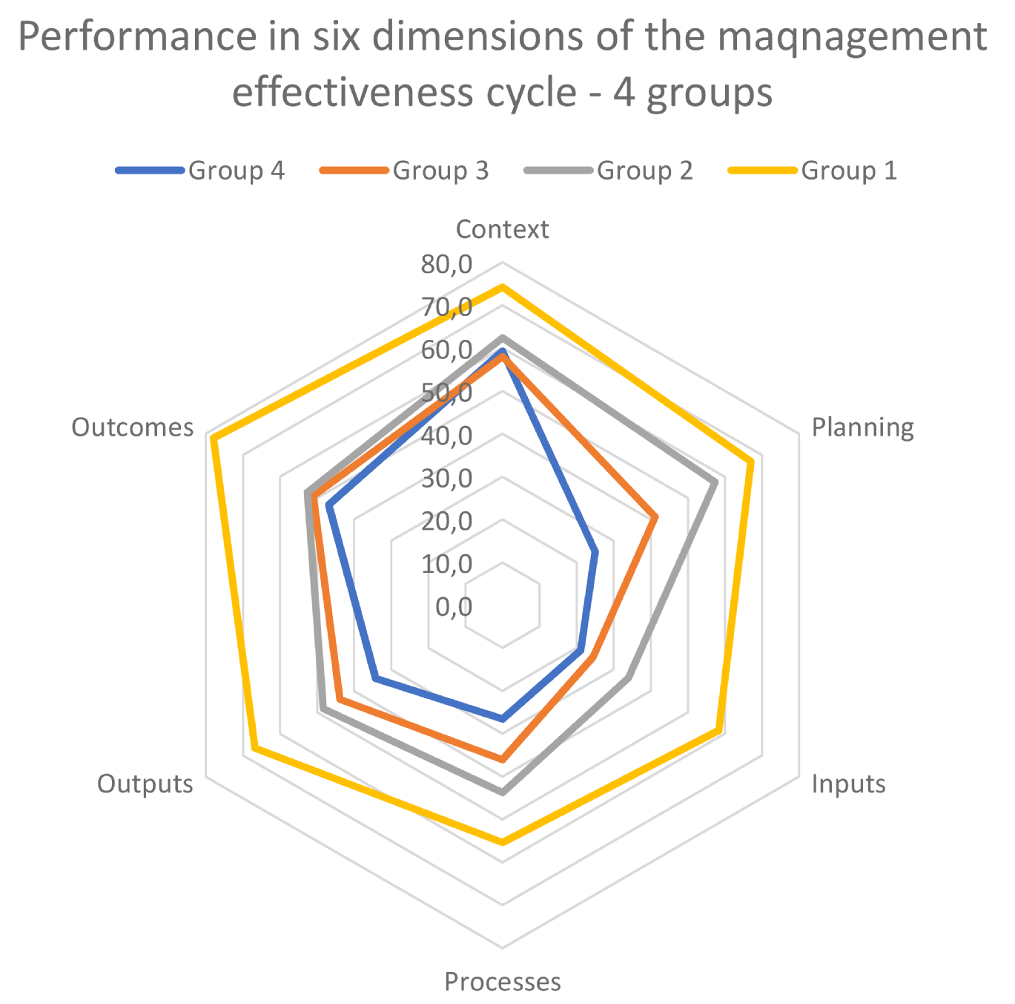

Generally, it should be noted that, apart from the case of Bururi (Group 1), “Outcomes” are the most difficult to achieve. It is worth noting that the difference in “Outcomes” performance between Groups 2, 3 and 4 is very low.

It is also worth noting that all the PAs of Group 2, 3 and 4 report similar scores in the area of “Context”. Their performances in this element are rather good (with clear lead of Group 1). The differences in the “Context” for the other groups are almost inexistent. Considering that Burundi is a small country with relatively little diversity in environmental conditions, this might have been expected.

The Grouping analysis can be summarised through a visualisation synthetizing the values of the six elements of the management cycle into three synthesis elements:

1. Basic elements: “Management context – Planning – Inputs”, as basic or fundamental elements of the PA management exercise.

2. “Process”, related to: Internal management systems and processes, Management / Protection of the values, Stakeholder relations, Tourism management, “Monitoring and research”, “Management of the effects of climate change and ecosystem services”.

3. Targets and Goals: “Outputs and Outcomes” achieved.

The combination of the basic elements (“Management context” – ”Planning” – ”Inputs”) with those of the Process is displayed in a field of values established on percentage scales (0–100%), associated with the global values of Outputs/Outcomes also measured on a percentage scale (0–100%). The scores obtained by PAs fall into one of four categories, which are displayed with a coloured background. This representation allows to immediately visualize PA management effectiveness values and to follow their evolution.

The reference values are:

|  |  |  |
| --- | --- | --- |
|  | 0 | Zero |
|  | 1-32 | Very low value |
|  | 33-50 | Low value |
|  | 51-100 | Positive value |

Corresponding classification into 4 categories is used for an overall visualisation of the state of the PAs management effectiveness (see figures 2 and 3)[2]. This approach also supports tracking the evolution of management process over time to better understand and support the PA conservation efforts.

Figure 2: Presentation of the Burundi protected areas with respect to the six elements of the management cycle aggregated into three dimensions (1. Context, Planning and Inputs, 2. Process, 3. Outputs and Outcomes)

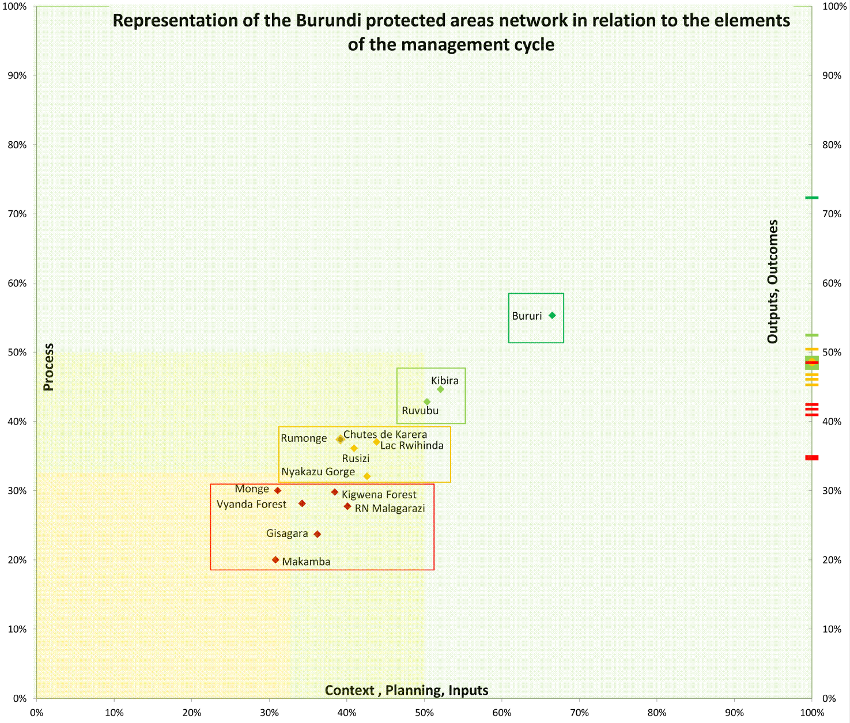

This first classification of PAs facilitates evaluation and monitoring of specific PAs or Group of PAs. It also facilitates ad hoc analysis aiming at improving the conservation and the necessary support required by the network, as well by individual PAs belonging to a specific Group.

The global visualisation, together with the analysis of each element of the management cycle, highlights the diversity of the Bururi National Park compared to the other PAs of the Burundi PAs network.

The overall result of the Grouping analysis, outlined in the below figure 3, clearly shows that the Burundi network is characterized by two main groups of PAs, the first with low or very low management effectiveness values (Groups 3 and 4) and the second with low positive or positive management effectiveness values (Groups 1 and 2).

Group 4 shows major problems in “Context”, Planning and Inputs, that are lower than the value of Process. Group 3 shows slightly higher performance in the basic elements of the management but does not outperform Group 4 in the Process. Group 2 scores higher with respect to Process than in “Context”, Planning and Inputs. Eventually Group 1 (with only Bururi) is more positive and equilibrated than all the others.

Figure 3: Representation of the Burundi protected areas network in relation with the six elements of the management cycle aggregated into three dimensions (1. Context, Planning and Inputs, 2. Process, 3. Outputs and Outcomes)

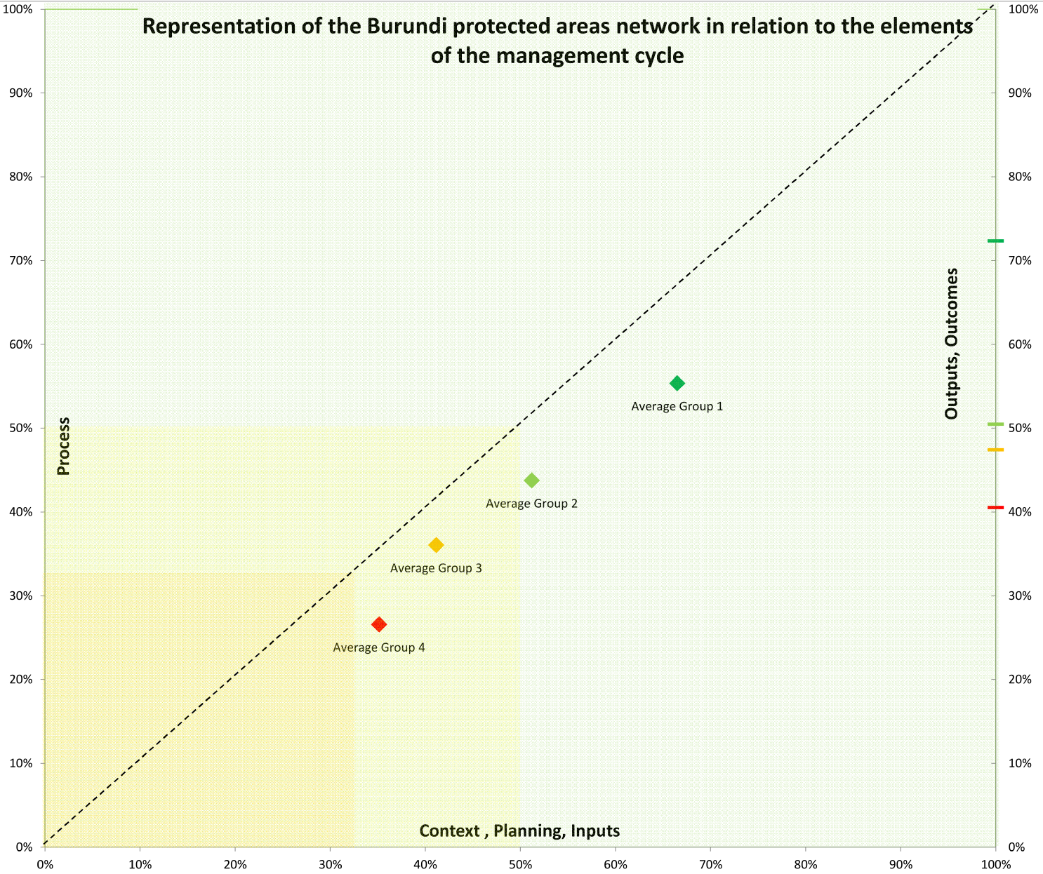

Some unbalanced elements can be noted on Outputs and Outcomes (targets and goals), as few protected areas of Groups 3 (Chute de Karera, Rumonge) and 4 (Kigwena Forest) score better than the PAs of Group 2. This inconsistency could be attributed to confusion between Outputs (targets) and Outcomes (goals) but also can be explained by the hypothesis that PAs in Groups 3 and 4 might have set too low objectives for their management plan.

A simplified visualization of the values of the different groups, based on the average value for each single Group, is proposed in the following figure (figure 3), here above.

The average values for each group lie below the 45° line (the line representing equal values of basic elements -“Management context – Planning – Inputs”- and “Process”) show lower values of “Process” than the value of the basic elements of the management, “Context”, “Planning” and “Inputs”. This is a general problem for most of the protected areas in Western and Central Africa: It is very often the case that sufficient or good “Context” does not translate into a good Process in conservation. This visualisation suggests that capacity building and targeted actions towards the development of different aspects of process are required to enhance management effectiveness.

PAs on average score lower in Processes than in Outputs or Outcomes. This implies that Burundi PAs are scoring higher in terms of targets and goals, rather than in the process to achieve the results. This happens, in spite of high threats and very low inputs. This is extremely difficult to explain, unless hypothesizing inconsistencies or misunderstandings among some of the responses given during the assessment, particularly while assessing Outputs and Outcomes. This is confirmed by the table below, showing the largest imbalances between groups in Outputs/Outcomes.

Table 4: Averaging of the three synthesis elements of the protected areas of Burundi

|  |  |  |  |
| --- | --- | --- | --- |
| **PA** | **Context+Plannning+Inputs** | **Process** | **Outputs+Outcomes** |
| Average Group1 | 66.5% | 55.4% | 72.3% |
| Average Group2 | 51.2% | 43.8% | 50.5% |
| Average Group3 | 41.2% | 36.1% | 47.4% |
| Average Group4 | 35.1% | 26.6% | 40.5% |

**This first analysis at national level shows the necessity for a strong commitment from national authorities to improve management effectiveness and conservation in Burundi national parks. Priority should be addressed to a better identification (knowledge and characterization) of the management context based on a stronger analysis of the context of intervention. It is also essential to identify long-term targets and goals. Such clearer identification of baselines and clearer definition of medium – long term targets/goals would ensure a better interconnection among the different elements of the management cycle, which would improve both their functioning and performance. As a result, the process would be improved by maintaining a clear focus on the identified priorities even in case of low inputs (as it is the case for Burundi PAs).**

## Ranking

The ranking of Burundi’s PAs outlines their overall performance in management effectiveness (see figure 4). An “**IMET Index”** is proposed here, generated as a simple average of performance of a protected area in the six elements of management cycle. The reliability of the index, measured with the Cronbach’s alpha methodology, is at the level of 0.92[3], which confirms its high reliability as a measure of the overall performance of protected areas in Burundi.

The best performance with respect to the total IMET score is observed in Bururi. The score of Bururi is 66.6 points, which is almost 17 points above the score observed in the second scoring PA, Ruvubu. Distances between the protected areas positioning in the following places are much less pronounced. Distance between the 2nd – Ruvubu and the 3rd – Kibira is merely 0.2 points. The group of protected areas ranked in places from 4 to 9 shows relatively small differences in the score, ranking from 43.2 (Lac Rwihinda) to 40.4 (Kigwena Forest), following areas in the places from the 10th to 14th score from 32.7 to 36.2.

The ranking reveals not only the best and the worst performers within the Burundi PA system, but it also helps to identify positive or negative aspects of the protected areas. Bururi is clearly leading in all of the management effectiveness dimensions, yet the following areas – Ruvubu and Kibiri – get their advantage from excellent performance in specific dimensions of the management effectiveness cycle, particularly from Planning and Outcomes. Good performance of Lac Rwihinda, despite relatively poor Outcomes, builds on quite good Planning and sufficiently high Outputs.

Protected areas that are lagging in the ranking are most evidently scoring lower in Planning and Inputs. Differences are less visible for Outputs and Outcomes. In terms of Outcomes, for example, Makamba, which is the last in the ranking, scores similarly to Kibira, which is holding the 3rd position.

Figure 4: Ranking of protected areas in Burundi with respect to the IMET score

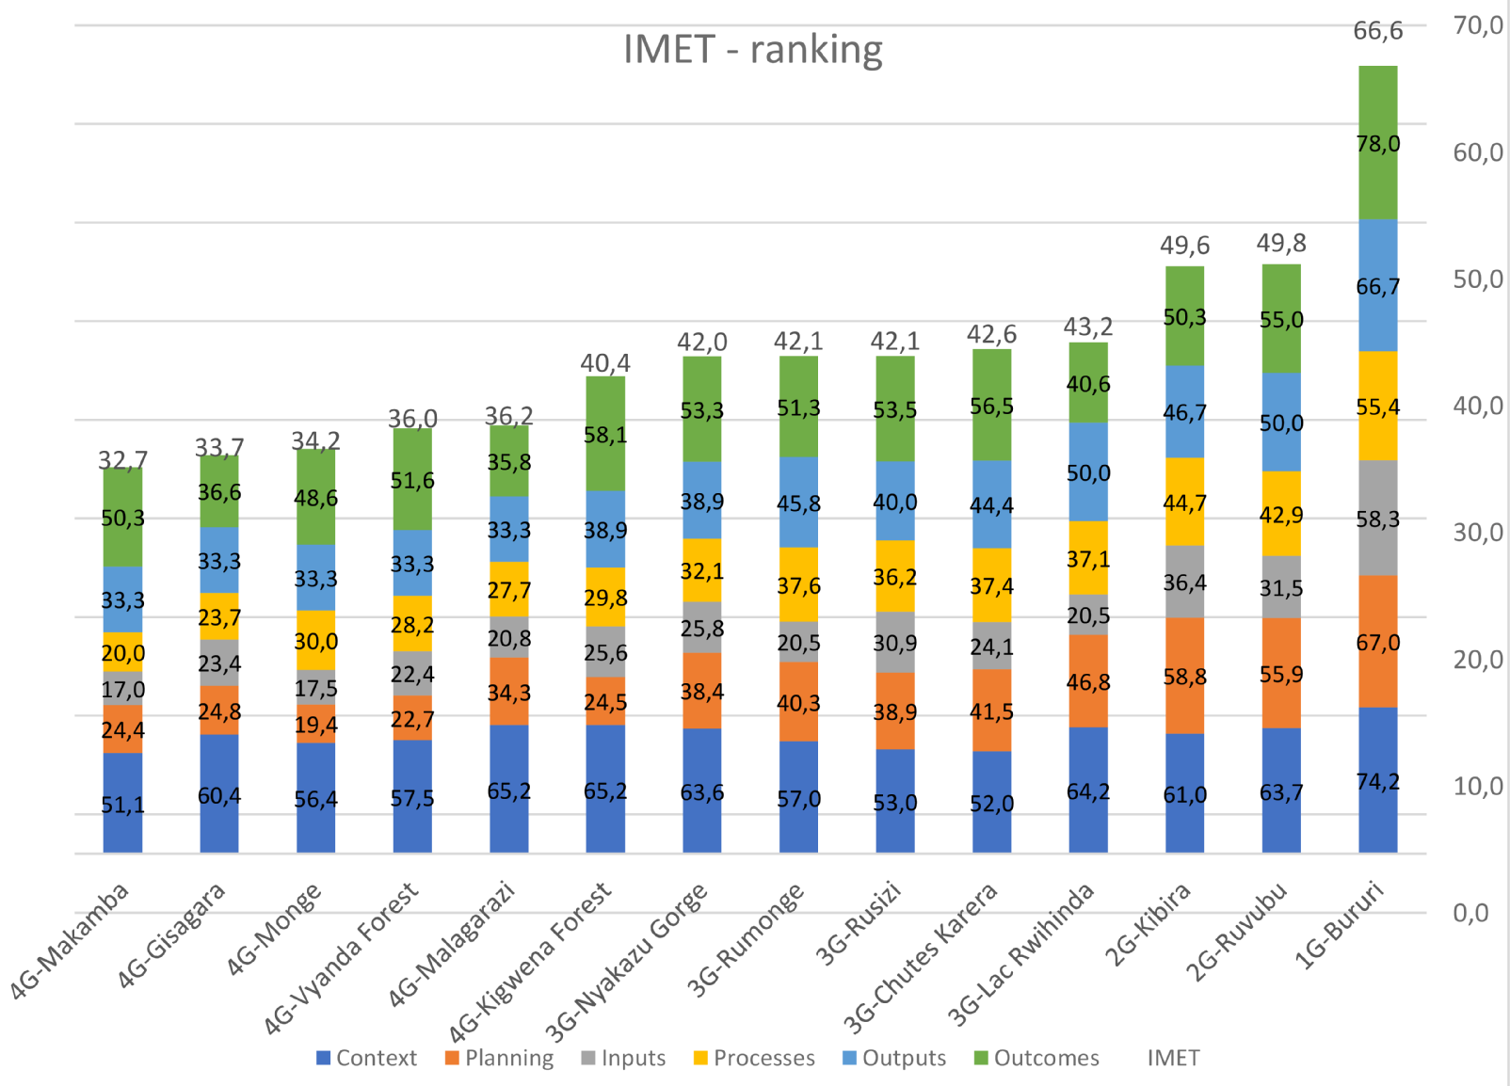

The scores for each management effectiveness (ME) element are normalised between 0 and 100 and thus relative performance in each dimension can be compared. The graph below presents the average of the score in each of the ME elements, which helps to visualize and understand the contribution of each dimension in average, to the IMET score.

The most significant contributor to performance of Burundi protected areas is, on average, the “Context” element, with a score of 60.3. Also the deviations from the average among different PAs are not high in the “Context” dimension. Whiskers (visualised through a red line)[4], representing dispersion between the 10th and the 90th percentile, show a very low variability of “Context” in Burundi. Performance in other dimensions is relatively weak.

However, surprisingly relatively good “Outcomes” are achieved by protected areas in Burundi. The average Outcomes are at the level of 51.4 points. Then, the Outputs, the Planning and the Process follow with gradually declining scores. It is worth noting that Planning is associated with very high variability among different PAs. This means that very different planning standards are observed across protected areas in Burundi. Process is low, compared to the scores of Outputs and particularly of Outcomes. The values of Outcomes are high considering the low scores of the Planning indicators and the almost complete absence of long-term goals among all the PAs in Burundi (see table 16). The most severe lack of performance is observed in terms of Inputs. The strong limitation of inputs is rather widespread as the differences between best and worst performers (spread of whiskers) are not very large. Through a more detailed analysis, we will try to establish which specific elements contribute to this low performance in the dimension of Inputs.

Figure 5: Average contribution of the management cycle elements



The table below shows the different scores achieved by each PA for each of the dimensions of the management cycle, as well as for the overall “**IMET index**”.

Table 5: IMET score of the Ranking of protected areas in Burundi

|  |  |  |  |  |  |  |  |
| --- | --- | --- | --- | --- | --- | --- | --- |
| **PA** | **IMET index** | **Context** | **Planning** | **Inputs** | **Processes** | **Outputs** | **Outcomes** |
| 1G-Bururi | 66,6 | 74,2 | 67,0 | 58,3 | 55,4 | 66,7 | 78,0 |
| 2G-Ruvubu | 49,8 | 63,7 | 55,9 | 31,5 | 42,9 | 50,0 | 55,0 |
| 2G-Kibira | 49,6 | 61,0 | 58,8 | 36,4 | 44,7 | 46,7 | 50,3 |
| 3G-Lac Rwihinda | 43,2 | 64,2 | 46,8 | 20,5 | 37,1 | 50,0 | 40,6 |
| 3G-Chutes de Karera | 42,6 | 52,0 | 41,5 | 24,1 | 37,4 | 44,4 | 56,5 |
| 3G-Rumonge | 42,1 | 57,0 | 40,3 | 20,5 | 37,6 | 45,8 | 51,3 |
| 3G-Rusizi | 42,1 | 53,0 | 38,9 | 30,9 | 36,2 | 40,0 | 53,5 |
| 3G-Nyakazu Gorge | 42,0 | 63,6 | 38,4 | 25,8 | 32,1 | 38,9 | 53,3 |
| 4G-Kigwena Forest | 40,4 | 65,2 | 24,5 | 25,6 | 29,8 | 38,9 | 58,1 |
| 4G-RN Malagarazi | 36,2 | 65,2 | 34,3 | 20,8 | 27,7 | 33,3 | 35,8 |
| 4G-Vyanda Forest | 36,0 | 57,5 | 22,7 | 22,4 | 28,2 | 33,3 | 51,6 |
| 4G-Monge | 34,2 | 56,4 | 19,4 | 17,5 | 30,0 | 33,3 | 48,6 |
| 4G-Gisagara | 33,7 | 60,4 | 24,8 | 23,4 | 23,7 | 33,3 | 36,6 |
| 4G-Makamba | 32,7 | 51,1 | 24,4 | 17,0 | 20,0 | 33,3 | 50,3 |

|  |  |  |  |  |  |  |  |  |
| --- | --- | --- | --- | --- | --- | --- | --- | --- |
| Value visualisation for categories: | 0 |  | 1-32 |  | 33-50 |  | 51-100 |  |

**It is worth noting that from the “IMET Index” it possible to generate an equivalent “METT Index”.**

## Management cycle elements analysis

### Management Context

The dimension of the management cycle of a protected area which determines the functioning of a specific PA is the “Management Context”. This main indicator reports the values on which protected areas operate but also the threats which they face and the general political and civil context which can support or slow-down the work carried out at field level. The assessment of the “Management Context” dimension in IMET results from weighting (0.33 each) the following three key indicators: (i) Value and Importance (composed of six sub-indicators – each one individually assessed, with weight 0.16), (ii) Political and Civil Environment and (iii) Threats. The ranking of protected areas of Burundi context system is presented in the figure below.

Figure 6: Ranking Context

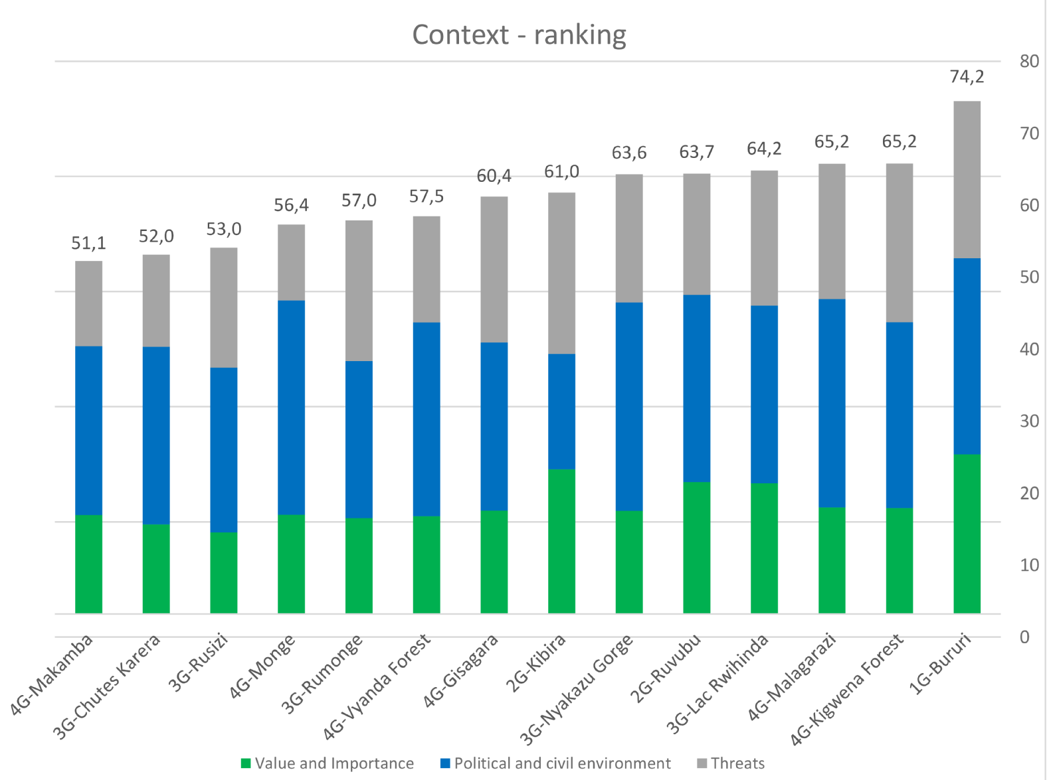

The analysis delivers a context situation strongly influenced by a general high value of Political and Civil Environment independently from the groups of PAs. The PAs of Groups 1 and 2 (in theory those with best management) show a strong value of the management context.

On the other hand, the high value of “Political and Civil Environment” associated with low relative value of “Value and Importance” and “Threats” pushes some of the PAs of Groups 3 and 4 (see Kigwena Forest, Malagarazi, Lac Rwihinda, etc.) high in the ranking. In the technical analysis we must take into account that despite apparently favourable “Political and Civil Environment”, very often opposite value of “Threats” (see Monge, Vyanda Forest, Makamba, etc.) are visible.

Table 6: Scores of the indicators of Context

|  |  |  |  |  |  |  |  |  |  |  |  |  |
| --- | --- | --- | --- | --- | --- | --- | --- | --- | --- | --- | --- | --- |
| **Protected Areas** | **Synthesis of Management context** | | | | **Value and Importance** | | | | **Political and civil environment** | | | **Threats** |
| 1G-Bururi | 74,2 | | | | 69,2 | | | | 85,3 | | | -31,9 |
| 4G-Kigwena Forest | 65,2 | | | | 46,0 | | | | 80,7 | | | -31,1 |
| 4G-Malagarazi | 65,2 | | | | 46,3 | | | | 90,3 | | | -41,2 |
| 3G-Lac Rwihinda | 64,2 | | | | 56,7 | | | | 77,2 | | | -41,3 |
| 2G-Ruvubu | 63,7 | | | | 57,3 | | | | 81,3 | | | -47,3 |
| 3G-Nyakazu Gorge | 63,6 | | | | 44,7 | | | | 90,5 | | | -44,4 |
| 2G-Kibira | 61,0 | | | | 62,9 | | | | 50,0 | | | -29,9 |
| 4G-Gisagara | 60,4 | | | | 44,9 | | | | 73,1 | | | -36,7 |
| 4G-Vyanda Forest | 57,5 | | | | 42,4 | | | | 84,2 | | | -54,0 |
| 3G-Rumonge | 57,0 | | | | 41,7 | | | | 68,2 | | | -38,9 |
| 4G-Monge | 56,4 | | | | 43,1 | | | | 93,1 | | | -67,1 |
| 3G-Rusizi | 53,0 | | | | 35,4 | | | | 71,5 | | | -48,0 |
| 3G-Chutes Karera | 52,0 | | | | 38,8 | | | | 77,3 | | | -60,1 |
| 4G-Makamba | 51,1 | | | | 43,0 | | | | 73,3 | | | -63,1 |
| Value visualisation for categories: | |  | 0 |  | | 1–32 |  | 33–50 | |  | 51–100 |
|  | 0 |  | | -1/-32 |  | -33/-50 | |  | -51/-100 |

**In summary:**

Table 7: Ranking Value and Importance

|  |  |
| --- | --- |
| **Protected Areas** | **Value and Importance** |
| 1G-Bururi | 69,2 |
| 2G-Kibira | 62,9 |
| 2G-Ruvubu | 57,3 |
| 3G-Lac Rwihinda | 56,7 |
| 4G-Malagarazi | 46,3 |
| 4G-Kigwena Forest | 46,0 |
| 4G-Gisagara | 44,9 |
| 3G-Nyakazu Gorge | 44,7 |
| 4G-Monge | 43,1 |
| 4G-Makamba | 43,0 |
| 4G-Vyanda Forest | 42,4 |
| 3G-Rumonge | 41,7 |
| 3G-Chutes Karera | 38,8 |
| 3G-Rusizi | 35,4 |

|  |  |  |  |  |
| --- | --- | --- | --- | --- |
| Value visualisation for categories: |  | 0 |  | 1–32 |
|  | 33–50 |  | 51–100 |

**Value and Importance** (main indicator composed of five sub-indicators, see more details in the detailed explanation, in the section here below)

With respect to “Value and Importance”, the highest-scoring PA is Bururi. Also Kibira, Ruvubu (Group 2) and Lac Rwihinda (Group 3) score close to the leader. The differences among the other PAs of Groups 3 and 4, following in the ranking, are much less pronounced. All of them show low values for this indicator. The worst scoring PAs in terms of “Value and Importance” are three protected areas belonging to Group 3: Rumonge, Chutes de Karera and Rusizi. All the PAs of Group 4 score better. The weakest in the indicator of Value and Importance is Rusizi, scoring only about half of the score of Bururi. The least performing PAs in the ranking show low levels for all the sub-indicators (tentatively): Key species, Habitats, Ecosystem services and Classification. More specific analyses are carried out, below.

**Political and Civil Environment**

Table 8: Ranking Political and Civil Environment

|  |  |
| --- | --- |
| **Protected Areas** | **Political and Civil Environment** |
| 4G-Monge | 93,1 |
| 3G-Nyakazu Gorge | 90,5 |
| 4G-Malagarazi | 90,3 |
| 1G-Bururi | 85,3 |
| 4G-Vyanda Forest | 84,2 |
| 2G-Ruvubu | 81,3 |
| 4G-Kigwena Forest | 80,7 |
| 3G-Chutes Karera | 77,3 |
| 3G-Lac Rwihinda | 77,2 |
| 4G-Makamba | 73,3 |
| 4G-Gisagara | 73,1 |
| 3G-Rusizi | 71,5 |
| 3G-Rumonge | 68,2 |
| 2G-Kibira | 50,0 |

|  |  |  |  |  |
| --- | --- | --- | --- | --- |
| Value visualisation for categories: |  | 0 |  | 1-32 |
|  | 33-50 |  | 51-100 |

The assessment of the “Context”, with regards to the “Political and Civil Environment” shows high values for all the protected areas. It is worth noting that Monge, Nyakazu Gorge and Malagarazi (Group 4) score higher than Bururi. The score of this indicator for Kibira (Group 2) – the weakest performer - is only slightly above half of the level reported for Monge (Group 4) and for Nyakazu Gorge (Group 3), while relationship between the score of threats is exactly opposite for those PAs (see next section). Many protected areas of Groups 3 and 4 benefit from significant support from the Government or from the local communities. Nevertheless, in spite of this favourable environment, such support does not minimise threats values as it would be expected. Such inconsistency could be due to a misinterpretation of the assessment questions related to “good relationships” and to “support for the PAs”.

**Threats**

Table 9: Ranking Threats

|  |  |
| --- | --- |
| **Protected Areas** | **Threats** |
| 2G-Kibira | -29,9 |
| 4G-Kigwena Forest | -31,1 |
| 1G-Bururi | -31,9 |
| 4G-Gisagara | -36,7 |
| 3G-Rumonge | -38,9 |
| 4G-Malagarazi | -41,2 |
| 3G-Lac Rwihinda | -41,3 |
| 3G-Nyakazu Gorge | -44,4 |
| 2G-Ruvubu | -47,3 |
| 3G-Rusizi | -48,0 |
| 4G-Vyanda Forest | -54,0 |
| 3G-Chutes Karera | -60,1 |
| 4G-Makamba | -63,1 |
| 4G-Monge | -67,1 |

|  |  |  |  |  |
| --- | --- | --- | --- | --- |
| Value visualisation for categories: |  | -51/-100 |  | -33/-50 |
|  | -1/-32 |  | 0 |

Generally, all PAs suffer from high levels of threats with Monge (Group 4) being the most exposed to outside threats. Considering the relative low presence of biodiversity in Burundi PAs, there is an apparent inconsistency with the scores observed for “Threats” and “Values and Importance”. This aspect would require further reflection. For now we can hypothesise that the inconsistency is partly due to insufficient analysis capacities of staff related to protected areas management. In order to reduce possible misunderstanding or inconsistencies capacity-building on analysis strongly connected (or oriented) to field interventions should be planed.

#### Value and Importance (Context)

The “Value and importance” indicator is contributing 1/3 to the overall «Context» score. However, it is worth recalling here that “Value and importance” is also a composite measure, which is constructed by averaging six sub-indicators: Governance, Classifications, Key Species, Habitats, Climate Change and Ecosystem Services, all assessed in detail with the PA staff during the IMET assessment. The ranking of “Value and Importance” and the specific contribution of each of the 6 components (sub-indicators) of Value and Importance to the overall score are presented in Figure 8, below.

Again, the clear leader in the “Value and Importance” score is Bururi. Kibira and Ruvubu (Group 2) as well as and Lac Rwihinda (Group 3) have lower scores but the difference is not substantial. Then, the following protected areas show significant decline in the average scores. The lowest-scoring PAs are Rusizi and Chutes de Karera that are only slightly above half of the score for Bururi.

The contribution of different elements of Value and Importance to the final score is diverse. Contributions of elements are presented in table 10.

Figure 8: Ranking of protected areas in Burundi with respect to the score in the sub-dimension of Value and Importance

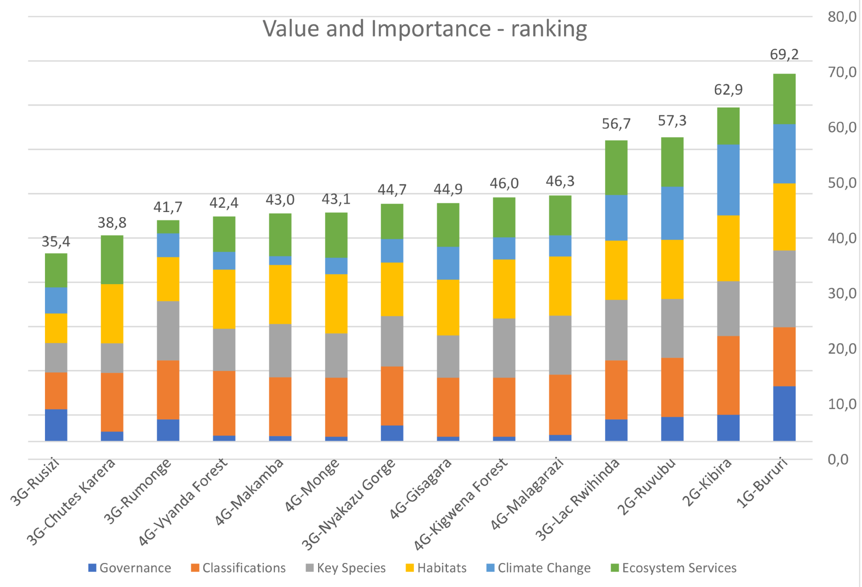

Table 10: Ranking of the 6 sub-indicators of the Value and Importance (Context

|  |  |  |  |  |  |  |
| --- | --- | --- | --- | --- | --- | --- |
| **Protected areas** | **Governance** | **Classifications** | **Key Species** | **Habitats** | **Climate Change** | **Ecosystem Services** |
| 1G-Bururi | 62,5 | 66,7 | 86,7 | 75,8 | 66,7 | 57,0 |
| 2G-Kibira | 30,3 | 88,9 | 61,9 | 74,4 | 80,0 | 41,8 |
| 2G-Ruvubu | 27,8 | 66,7 | 66,7 | 66,7 | 60,0 | 55,7 |
| 3G-Chutes Karera | 11,1 | 66,7 | 33,3 | 66,7 | 0,0 | 55,0 |
| 3G-Lac Rwihinda | 25,0 | 66,7 | 68,4 | 66,7 | 51,9 | 61,4 |
| 3G-Nyakazu Gorge | 18,2 | 66,7 | 56,8 | 60,3 | 26,7 | 39,7 |
| 3G-Rumonge | 25,0 | 66,7 | 66,7 | 50,0 | 26,7 | 14,8 |
| 3G-Rusizi | 36,4 | 41,7 | 33,3 | 33,3 | 29,6 | 38,3 |
| 4G-Gisagara | 5,6 | 66,7 | 47,6 | 63,0 | 37,0 | 49,3 |
| 4G-Kigwena Forest | 5,6 | 66,7 | 66,7 | 66,7 | 25,0 | 45,0 |
| 4G-Makamba | 6,1 | 66,7 | 60,0 | 66,7 | 10,0 | 48,2 |
| 4G-Malagarazi | 7,4 | 68,1 | 66,7 | 66,7 | 23,8 | 45,2 |
| 4G-Monge | 5,6 | 66,7 | 50,0 | 66,7 | 18,5 | 51,1 |
| 4G-Vyanda Forest | 6,7 | 73,2 | 47,6 | 66,7 | 20,0 | 40,1 |

|  |  |  |  |  |  |  |  |  |
| --- | --- | --- | --- | --- | --- | --- | --- | --- |
| Value visualisation for categories: | 0 |  | 1-32 |  | 33-50 |  | 51-100 |  |

**Governance**

Bururi is clearly the top scoring protected areas in terms of Governance. All the other PAs score low or very low in this sub-indicator. The worst situation is reported for Rusizi. The low value of quite all PAs on this aspect highlights significant deficiencies with regards to the “operational” collaboration between PAs and key stakeholders.

**Classifications**

The high scores observed on this indicator for all the protected areas, with the exception – again - of Rusizi, would normally have a significant influence on the overall performance of the global value of the Management context indicator. However, such a convergence of the answers (very positive scores on this indicator for nearly all the PAs), suggests a possible misunderstanding of the question. The potential discrepancy stems from the fact that PAs’ staff praised the mere existence of “Classifications” and their perceived importance, in absolute terms, rather than assessing the consistency of “Classifications” in management activities with the actual “Values and importance” of the PA. A specific coaching activity should be conceived to address this situation and to avoid any future misunderstanding.

**Key Species**

The integration of specific key species in the management activities is generally high for almost all of the protected areas. This is a good sign. However, such a score is inconsistently high when compared with the Planning analysis. As before, a misunderstanding might result from the fact that PAs’ staff, rather than scoring the level of integration of key species in the management process, they have scored the mere presence of “Key species” in the PA, and their importance in absolute terms. A specific coaching activity should be conceived to address this situation and to avoid any future misunderstanding.

**Habitats**

The same considerations as for the previous indicator can be formulated here.

**Climate Change**

Generally, the protected areas assessed are not ready or in the position to undertake immediate action to address mitigation and adaptation to Climate change. This is particularly true in the case of PAs of Groups 3 and 4, scoring very low for this indicator. The PAs of Groups 1 and 2, show better scores.

**Ecosystem Services**

As for the management of Climate change effects, the protected areas assessed are not very much used to work on Ecosystem services management. PAs of Groups 1 and 2 (even if slightly less for Kibira) score relatively high in this dimension. Protected Areas of Groups 3 and 4 are less fluent in ecosystem services management, yet their scores are still high. This is an important base to improve the management of Burundi’s PAs considering the fact that the importance of Ecosystem services for the national economy is particularly high, especially in consideration of the high human density in the country.

**General analysis for the six sub-indicators on “Values and Importance”**

Figure 7: Average contribution by the six sun-indicators to Value and Importance

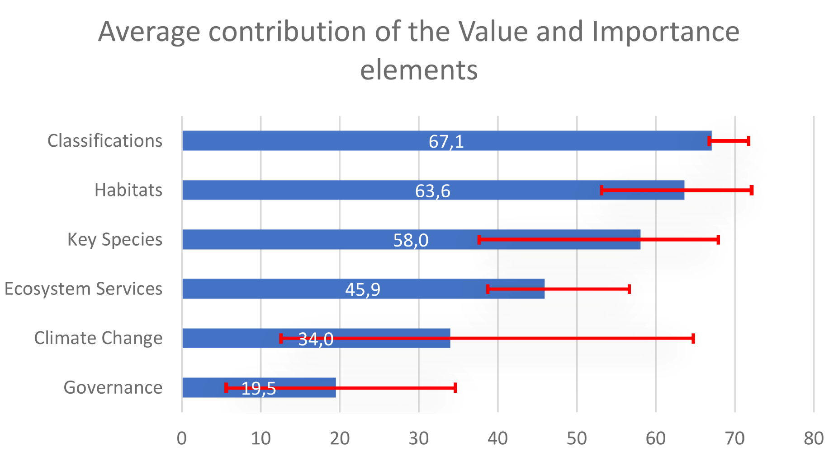

The average contribution from different indicators to the overall score of “Value and Importance” is presented in the figure below. The most significant contribution to the overall score of “Value and Importance” is observed, in average terms, for “Classifications”, showing an average level of 67.1 points (out of 100). The relatively low difference between the worst and the best-performing areas could result from a misunderstanding of the question, rather than from an actual strong integration of the values and the importance of the classification in the management process itself.

Habitats and Key Species also provide a significant contribution to the overall performance in the area of Value and Importance. The average score in these domains for the Burundi protected areas is 63.6 (Habitats) and 58.0 (Key species) points respectively. However, for these indicators, as noted above, there is a worry about the possible misunderstanding of the questions. This would need to be further assessed and in any case would require specific attention in terms of coaching and training. With regards to Habitats, the dispersion of the scores is not large. However, differences in the scores for the Key Species are very significant. This is not necessarily surprising and might be attributed to the fact that each protected area is specific. Also, many PAs of Burundi are used to focus their management activities only on few species rather than on functional groups of key species, on other values of the PA, or on threats.

The contribution of Ecosystem Services is significantly lower but still in the fourth place among the components of “Value and Importance”. The average score for Ecosystem Services is 45.9. The score regarding the Ecosystem services is more or less equal across all the protected areas, which could be attributed to an acceptable level of awareness of the importance of the services delivered by the protected areas in a small country with high population density, such as Burundi.

The fifth contributor to the “Value and Importance” score at the PA level is the response to “Climate change”. The score in this domain is on average 34 points, which is low. However, the differences between the worst and the best performing PAs are very considerable. As the issue of Climate change is relatively new and PAs have had a relatively small amount of time to adjust their policies to Climate change, high diversity in scores might have been expected. Some of the areas adopt policies to minimise the effects of Climate change while some remain still completely inexperienced in this respect.

The lowest score, in average terms, is reported in the area of “Governance”. Low governance score can be attributed mostly to the lack of collaboration with stakeholders in decision-making processes.

**General analysis on the results of the assessment of the Management Context**

Figure 8: Ranking of the context elements

(Note: In order to present the relative importance for the Context of (1) Political and civil environment, and (2) Threats, these indicators were normalized from their original scale to the scale ranging from 0 (worst situation) to +100 (the best situation))

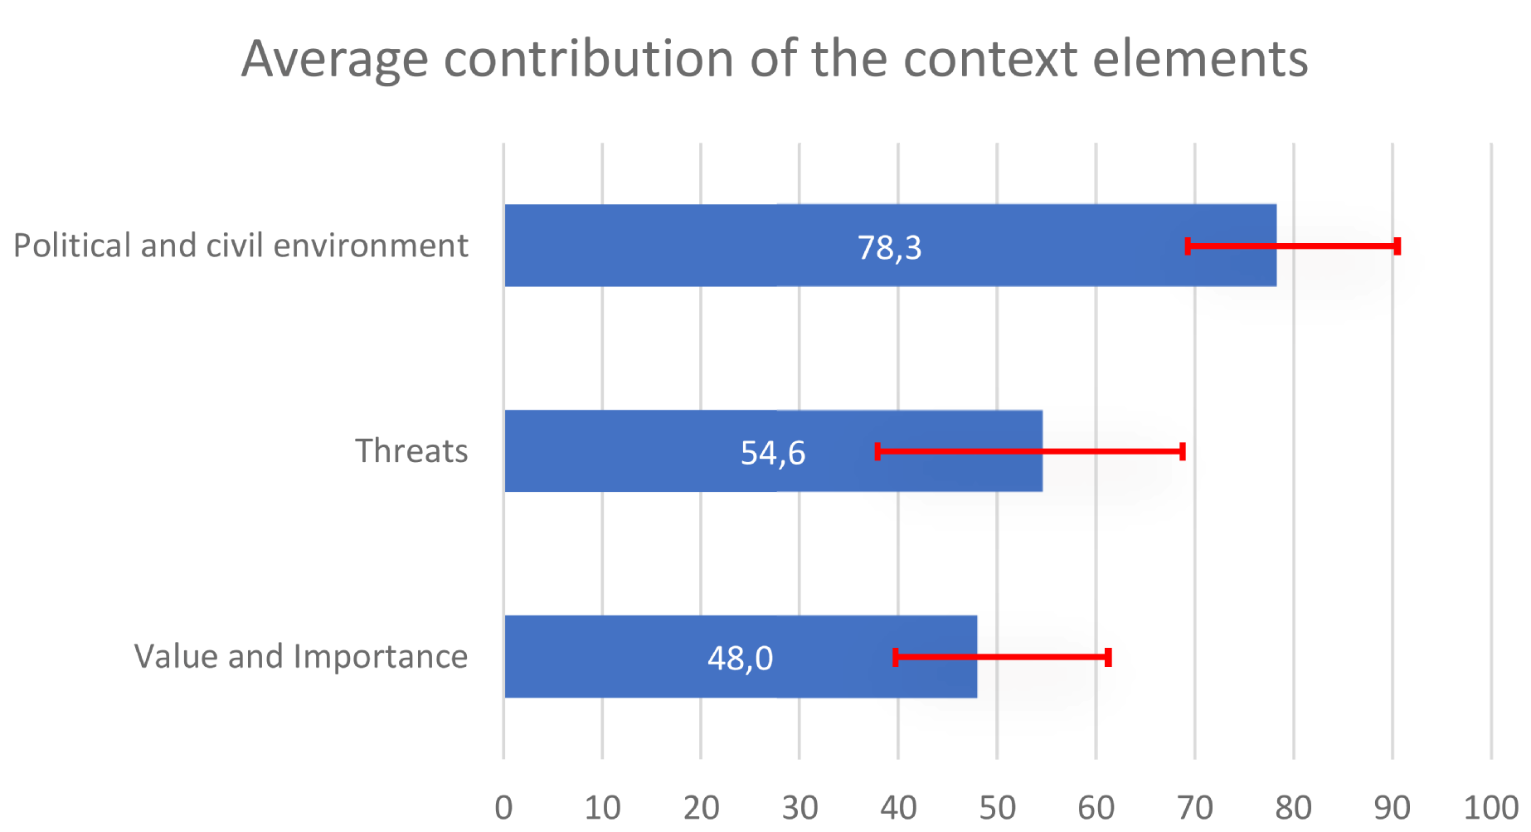

The average value for all the PAs is 56 points, within a rather positive benchmark of 50–60[5].

“Political and civil environment” shows an average level of 78.3 points, with certainly the highest contribution to the overall “Management context” in Burundi. Additionally, the differences within the scores of “Political and civil environment” are relatively low. However the analysis of the responses given in the assessment of this indicator requires more attention because the Burundi national parks are fundamentally suffering from threats due to high population density. It is worth noting that, especially in the Burundian context, the association of high political and civil context values, together with high values of threats seems inconsistent.

Much larger differences among PAs are observed with respect to “Threats”, scoring on average 54.6 points and thus having a lower contribution to the overall score of the context. Variability of threats is also much larger than for other components of the context. This could be due to the fact that each protected area is specific. Threats values are sometimes low for the protected areas of Group 4. This could be due to variety of reasons. In particular we could mention the fact that if a protected area is very poor in terms of biodiversity or ecosystem services, there are low threats.

The specific situation of protected areas such as Monge, Makamba and Chutes Karera must be assessed more deeply as there is a potential inconsistency with other indicators scoring high values such as the indicator of “Political and civil environment”, outlined above.

The lowest contribution to the overall context score is observed from the indicator “Value and importance”. On average, protected areas score merely 48.0 points, a relatively low score. In addition, such score is associated with rather low variability. Possible interpretations for this rather low contribution of the indicator “Value and Importance” were provided in the previous section.

**Conclusions and possible operational recommendations**

The analysis of the results of the indicator “Values and Importance” shows a:

* considerable convergence in values for the sub-indicators “Classification”, “Habitats” and “Key species” for all the PAs. This provides a significant contribution to the overall “Context” score; however this situation seems to be contradicted by the high levels of “Threats” and the relatively low levels of “Political and civil environment”;
* divergence in values for the sub-indicators “Climate Change” and “Ecosystem services” between Groups 1–2 and Groups 3–4;
* strong leading position of only one PA (Bururi), especially – in comparison with the other PAs - in the very high value for the sub-indicator Governance.

The “Political and civil environment” indicator is extremely high, which is in contrast with high “Threats”.

The PAs of Groups 1 and 2 are characterised by a more balanced “Context” than the PAs from Groups 3 and 4. PAs, which score high on “Key species”, “Habitats” and “Classification”, but really low on “Governance”, “Climate change” and “Ecosystem services” – probably because the PAs staff is not used to manage these elements in the management process of a protected area.

***Possible operational recommendations are:***

* ***to double check the reasons of the low scores on biodiversity (“Key species” and “Habitats”),***
* ***to support capacity building on the integration of “Climate change” effects and of “Ecosystem services” into the management process of the PAs,***
* ***to check with the support of the “Cross analysis” table (see annexe 3.2) the consistency between the scores observed for the indicators on “Political and Civil Environment” and on “Threats”,***
* ***to verify and ensure the overall consistency among the 3 indicators of the “Management Context”.***

### Planning

“Planning” constitutes the second dimension of the management effectiveness cycle. It consists of five indicators, which are “P1 - Adequacy of legal and regulatory provisions”, “P2 - Design and shape of the protected area”[6], “P3 - Demarcation of the protected area”, “P4 - Objectives of the protected area”, “P5 - Management plan” and “P6 - Work Plan”.

Figure 9: Ranking of protected areas in Burundi with respect to the score in the dimension of Planning

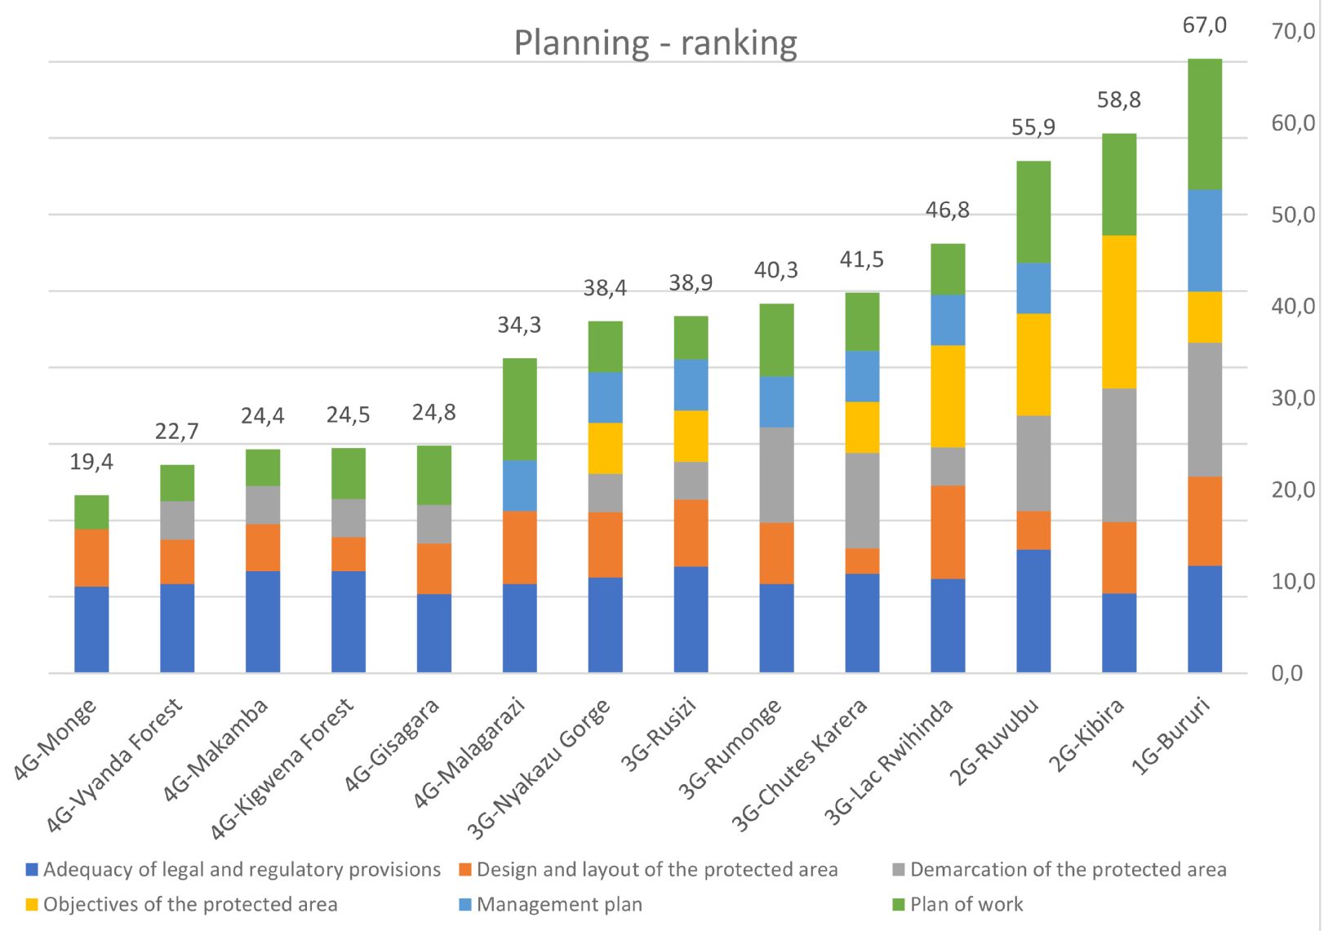

There are huge differences in the performance related to “Planning” in Burundi. The difference between the best scoring PA, Bururi, and the worst scoring PA, Monge is more than threefold.

Table 11: Scores of the indicators of Planning

|  |  |  |  |  |  |  |
| --- | --- | --- | --- | --- | --- | --- |
| **Protected areas** | **Adequacy of legal and regulatory provisions** | **Design and layout of the protected area** | **Demarcation of the protected area** | **Objectives of the protected area** | **Management plan** | **Work plan** |
| 1G-Bururi | 70,4 | 58,4 | 87,5 | 33,3 | 66,7 | 85,7 |
| 2G-Kibira | 52,2 | 46,7 | 87,5 | 100,0 | 0,0 | 66,7 |
| 2G-Ruvubu | 81,0 | 25,0 | 62,5 | 66,7 | 33,3 | 66,7 |
| 3G-Chutes Karera | 65,0 | 16,7 | 62,5 | 33,3 | 33,3 | 38,1 |
| 3G-Lac Rwihinda | 61,7 | 61,1 | 25,0 | 66,7 | 33,3 | 33,3 |
| 3G-Nyakazu Gorge | 62,5 | 42,9 | 25,0 | 33,3 | 33,3 | 33,3 |
| 3G-Rumonge | 58,4 | 40,0 | 62,5 | 0,0 | 33,3 | 47,6 |
| 3G-Rusizi | 69,7 | 43,8 | 25,0 | 33,3 | 33,3 | 28,6 |
| 4G-Gisagara | 51,7 | 33,4 | 25,0 | 0,0 | 0,0 | 38,9 |
| 4G-Kigwena Forest | 66,7 | 22,2 | 25,0 | 0,0 | 0,0 | 33,3 |
| 4G-Makamba | 66,7 | 31,0 | 25,0 | 0,0 | 0,0 | 23,8 |
| 4G-Malagarazi | 58,4 | 47,6 | 0,0 | 0,0 | 33,3 | 66,7 |
| 4G-Monge | 56,7 | 37,5 | 0,0 | 0,0 | 0,0 | 22,2 |
| 4G-Vyanda Forest | 58,4 | 29,2 | 25,0 | 0,0 | 0,0 | 23,8 |

|  |  |  |  |  |  |  |  |  |
| --- | --- | --- | --- | --- | --- | --- | --- | --- |
| Value visualisation for categories: | 0 |  | 1-32 |  | 33-50 |  | 51-100 |  |

The indicator ‘P1 - Adequacy of legal and regulatory provisions’ received high or very high scores for all the protected areas.

Table 12: Ranking Planning

|  |  |
| --- | --- |
| **Protected Areas** | **Synthesis of Planning** |
| 1G-Bururi | 67,0 |
| 2G-Kibira | 58,8 |
| 2G-Ruvubu | 55,9 |
| 3G-Lac Rwihinda | 46,8 |
| 3G-Chutes Karera | 41,5 |
| 3G-Rumonge | 40,3 |
| 3G-Rusizi | 38,9 |
| 3G-Nyakazu Gorge | 38,4 |
| 4G-Malagarazi | 34,3 |
| 4G-Gisagara | 24,8 |
| 4G-Kigwena Forest | 24,5 |
| 4G-Makamba | 24,4 |
| 4G-Vyanda Forest | 22,7 |
| 4G-Monge | 19,4 |

|  |  |  |  |  |
| --- | --- | --- | --- | --- |
| Value visualisation for categories: |  | 0 |  | 1-32 |
|  | 33-50 |  | 51-100 |

“P2 - Design and shape of the protected area’ shows medium or low values. Negative assessments of PA design and configuration are most likely driven by the threats to park biodiversity due to anthropogenic pressure from the country’s high population density. Differently, but with the exception of a few PAs (generally of Groups 1 and 2 and the Lac Rwihinda – Group 3), the analysis of the results of the IMET assessment shows critical levels for the remaining indicators of planning, P3, P4, P5 and P6.

A more detailed analysis of the results for the different “Planning indicators” of the 14 Burundi’s PAs is provided below.

**Adequacy of legal and regulatory provisions**

Table 13: Ranking Adequacy of legal and regulatory provisions

|  |  |
| --- | --- |
| **Protected Areas** | **Adequacy of legal and regulatory provisions** |
| 2G-Ruvubu | 81,0 |
| 1G-Bururi | 70,4 |
| 3G-Rusizi | 69,7 |
| 4G-Kigwena Forest | 66,7 |
| 4G-Makamba | 66,7 |
| 3G-Chutes Karera | 65,0 |
| 3G-Nyakazu Gorge | 62,5 |
| 3G-Lac Rwihinda | 61,7 |
| 3G-Rumonge | 58,4 |
| 4G-Malagarazi | 58,4 |
| 4G-Vyanda Forest | 58,4 |
| 4G-Monge | 56,7 |
| 2G-Kibira | 52,2 |
| 4G-Gisagara | 51,7 |

|  |  |  |  |  |
| --- | --- | --- | --- | --- |
| Value visualisation for categories: |  | 0 |  | 1-32 |
|  | 33-50 |  | 51-100 |

All protected areas valued positively the “P1 - Adequacy of Legal and Regulatory Provisions”. It is most likely because they are located in a relatively homogeneous system and the overall differences are not very important.

Ruvubu (Group 2) is leading the score in Burundi PAs system. On the other hand, it is worth noting that Kibira – a PA belonging to same Group 2 – lies just before the last position. Other PAs report lower scores. The differences exist because protected areas regulation can be either better or worse-suited to the objectives of specific PAs. The above mentioned relatively low score of Kibira (Group 2) seems to indicate that for the scope of protection required for this very PA, current regulations are far from being adequate and well-fitted.

**Design and shape of the protected area**

Table 14: Ranking Design and layout of the protected area

|  |  |
| --- | --- |
| **Protected Areas** | **Design and layout of the protected area** |
| 3G-Lac Rwihinda | 61,1 |
| 1G-Bururi | 58,4 |
| 4G-Malagarazi | 47,6 |
| 2G-Kibira | 46,7 |
| 3G-Rusizi | 43,8 |
| 3G-Nyakazu Gorge | 42,9 |
| 3G-Rumonge | 40,0 |
| 4G-Monge | 37,5 |
| 4G-Gisagara | 33,4 |
| 4G-Makamba | 31,0 |
| 4G-Vyanda Forest | 29,2 |
| 2G-Ruvubu | 25,0 |
| 4G-Kigwena Forest | 22,2 |
| 3G-Chutes Karera | 16,7 |

|  |  |  |  |  |
| --- | --- | --- | --- | --- |
| Value visualisation for categories: |  | 0 |  | 1-32 |
|  | 33-50 |  | 51-100 |

The majority of the PAs deliver low or medium scores in “P2 - Design and shape of the protected area”. Only Lac Rwihinda and Bururi seem to be convenient for conservation, being beyond the acceptable threshold of 50 points. Chutes de Karera and Kigwena Forest are the PAs struggling more. Also Ruvubu (Group 2) scores very low. Considering its position in the overall ranking (Group 2) a clear priority should be given in such PA to the minimisation of the negative effects due to the apparent bad design and shape of the PA.

**Demarcation of the protected area**

Table 15: Ranking Demarcation of the protected area

|  |  |
| --- | --- |
| **Protected Areas** | **Demarcation of the protected area** |
| 1G-Bururi | 87,5 |
| 2G-Kibira | 87,5 |
| 2G-Ruvubu | 62,5 |
| 3G-Chutes Karera | 62,5 |
| 3G-Rumonge | 62,5 |
| 3G-Lac Rwihinda | 25,0 |
| 3G-Nyakazu Gorge | 25,0 |
| 3G-Rusizi | 25,0 |
| 4G-Gisagara | 25,0 |
| 4G-Kigwena Forest | 25,0 |
| 4G-Makamba | 25,0 |
| 4G-Vyanda Forest | 25,0 |
| 4G-Malagarazi | 0,0 |
| 4G-Monge | 0,0 |

|  |  |  |  |  |
| --- | --- | --- | --- | --- |
| Value visualisation for categories: |  | 0 |  | 1-32 |
|  | 33-50 |  | 51-100 |

“P3 - Demarcation of the protected area” is crucial because it allows to clearly define rangers’ activities and to maintain not-conflictual relationships with neighbouring populations. The demarcation process seems to be best executed in Bururi and Kibira. On the contrary, there are PAs for which demarcation is inexistent (Monge and Malagarazi). Their representatives recorded a score of zero indicating almost inexistent demarcation for these PAs.

**Objectives of the protected area**

Table 16: Ranking Objectives of the protected area

|  |  |
| --- | --- |
| **Protected Areas** | **Objectives of the protected area** |
| 2G-Kibira | 100,0 |
| 2G-Ruvubu | 66,7 |
| 3G-Lac Rwihinda | 66,7 |
| 1G-Bururi | 33,3 |
| 3G-Chutes Karera | 33,3 |
| 3G-Rusizi | 33,3 |
| 3G-Nyakazu Gorge | 33,3 |
| 3G-Rumonge | 0,0 |
| 4G-Gisagara | 0,0 |
| 4G-Kigwena Forest | 0,0 |
| 4G-Makamba | 0,0 |
| 4G-Malagarazi | 0,0 |
| 4G-Monge | 0,0 |
| 4G-Vyanda Forest | 0,0 |

|  |  |  |  |  |
| --- | --- | --- | --- | --- |
| Value visualisation for categories: |  | 0 |  | 1-32 |
|  | 33-50 |  | 51-100 |

All protected areas have rather poor identification of “P4 – Objectives”. It applies also to the overall leader, Bururi (Group 1). Kibira (Group 2) is the only PA that clearly established its objectives. Relatively good definition of objectives is reported also for Lac Rwihinda and Ruvubu.

It is important that PAs acknowledge that this is a fundamental element, critical for any possibility of management improvement, which needs to be urgently addressed.

**Management plan and Work plan**

These two instruments of planning are closely interconnected and need to be analysed together. The scores of these two indicators are ranked, by Groups, in the table here bellow (table 17).

As for the long-term objectives of the PAs, the “P5 - Management plan” and the “P6 - Work plan” of the Burundi PAs seem to lack all necessary formalities to be clearly implemented or properly functioning. With respect to P5, it is essential to ensure that the management plan exists and that it is functional. None of the PAs scored all points in this regard, which shows that the management plans, even when they are operational, lack all necessary formalities to be clearly implemented. In Bururi the situation is the best, but in as many as six protected areas, there is no management plan at all. Including Kibira, assessed in Group 2. A slightly better situation on “Planning” is recorded for Ruvubu (Group 2) and for Malagarazi (Group 4): the management plan is poor but the work plan seems to be available and functional.

Table 17: Ranking Management plan and Work plan

|  |  |  |
| --- | --- | --- |
| **Protected Areas** | **Management plan** | **Work plan** |
| 1G-Bururi | 66,7 | 85,7 |
| 4G-Malagarazi | 33,3 | 66,7 |
| 3G-Nyakazu Gorge | 33,3 | 33,3 |
| 3G-Rusizi | 33,3 | 28,6 |
| 3G-Rumonge | 33,3 | 47,6 |
| 3G-Chutes Karera | 33,3 | 38,1 |
| 3G-Lac Rwihinda | 33,3 | 33,3 |
| 2G-Ruvubu | 33,3 | 66,7 |
| 4G-Monge | 0,0 | 22,2 |
| 4G-Vyanda Forest | 0,0 | 23,8 |
| 4G-Makamba | 0,0 | 23,8 |
| 4G-Kigwena Forest | 0,0 | 33,3 |
| 4G-Gisagara | 0,0 | 38,9 |
| 2G-Kibira | 0,0 | 66,7 |

|  |  |  |  |  |  |  |  |  |
| --- | --- | --- | --- | --- | --- | --- | --- | --- |
| Value visualisation for categories: | 0 |  | 1-32 |  | 33-50 |  | 51-100 |  |

In the dimension of Work plan, Bururi is clearly leading the classification with an edge over Kibira (Group 2 but without Management plan!), Ruvubu and Malagarazi. The worst performers on “P6 - Work plan” are Monge, Vyanda Forest and Makamba Forest, which ranks in the last position also with regards to “P5 - Management plan”.

**General analysis of the “Planning” element of the management cycle of a protected area**

Figure 10: The average contribution to planning of its dimensions for all of the protected areas

(Note: In order to present the relative importance for the Planning of (1) Adequacy of regulatory and legal provisions, (2) Design and layout of the protected area, these indicators were normalized from their original scale to the scale ranging from 0 (worst situation) to +100 (the best situation))

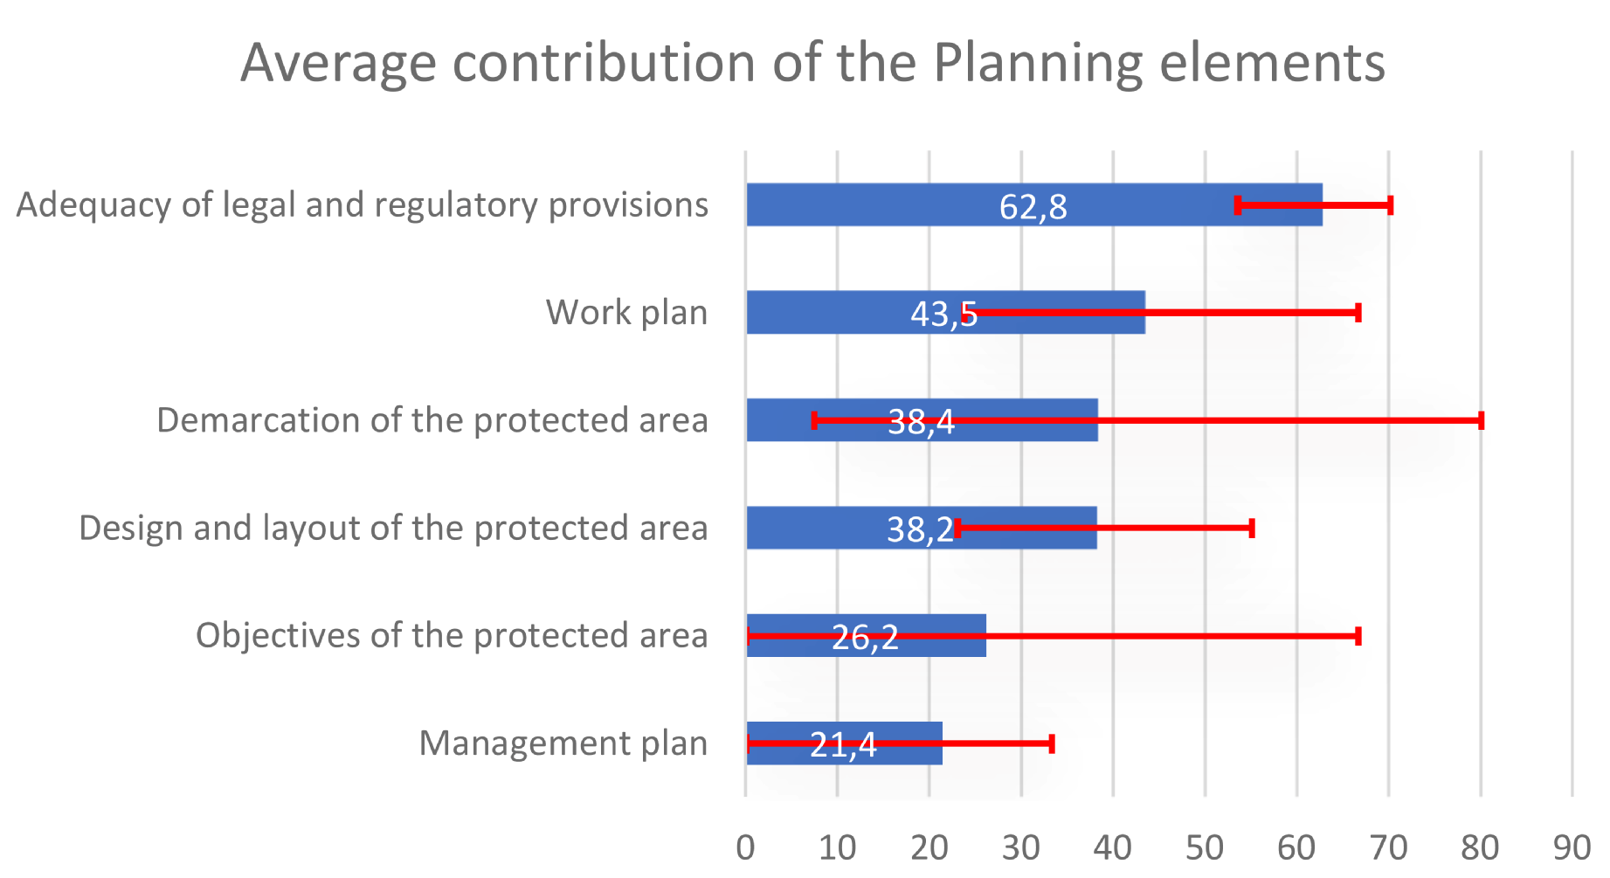

The most significant contribution is observed for “P1 - Adequacy of regulatory and legal provisions”. Relatively small differences between protected areas were observed, suggesting that the conditions are common in most of the protected areas of the system and influence them more or less to the same extent.

The second contributor (with relatively low values), to the overall score in the planning dimension is “P5 - Work plan”, with large discrepancy among PAs. The third place belongs to “P3 - Demarcation of the protected area”, where differences in reported scores are very important. The scores on “P2 - Design and layout of the protected area” are low but more homogeneous across the whole Burundi system.

It is worth highlighting that, in general terms, the elements most directly related to a planning process (“P5 - Management plan”, “P6 - Work plan” and “P4 – Objectives”) are low or very low, with large discrepancy among different PAs, especially for the indicator on “Objectives – P4”.

**Conclusions and operational recommendations**

The analysis indicates the presence of a positive “regulation and provision base” for conservation, which is however severely impaired by “Design and shape of the protected areas”. Low scores in PA “Design and shape” also result into threats to park biodiversity due to the increasing anthropogenic pressure from the country’s high population density. This element is certainly related to the low value of demarcation of the protected areas. Also, it is usually related to conflicts on natural resources use.

Limitation in the definition of long-term objectives, as well as in the availability of sound management plans and work plans are, indeed, significant obstacles to the development of PAs in Burundi. Low average score for the work plan - 43.5 -accompanied by very low scores in management plan and objectives are the consequence of a short-term vision/approach in planning and stem from the lack of long-term targets and goals. This conservation aptitude needs to be improved as a priority.

The next section, on “Inputs”, will show a generally bad situation in terms of inputs and current and future budgets. This can contribute to undermine staffs’ motivation and commitment and contributes to the overall poor situation in terms of “Planning”. However, it is worth highlighting that this situation should not, in any way, preclude focusing on the development of a proper long-term planning at the national and PA level.

***Possible operational recommendations include:***

* ***to follow the improvement suggested in the context, namely to establish priorities and opportunities (e.g. ecosystem service payment for hydroelectricity) for the management process of the key conservation elements,***
* ***to recognize that the use of low-level conservation targets (as exploiting only targets linked to work plan) reduces high-level conservation performance: it is better to define a long-term vison and to set clear and attainable objectives,***
* ***to link short-term targets, achievable even with limited resources, with the long-term goals, ,***
* ***to be transparent and to clearly communicate any improvement resulting from “results-oriented planning”, in view of attracting more funds thanks to improved planning and management processes.***

### Inputs

Inputs constitute the third dimension of the management effectiveness cycle. Its assessment is based on the following five indicators: “I1 (Availability of) basic information”, “I2 – Staffing”, “I3 - Current Budget”, “I4 - Securing the budget” and “I5 - Infrastructure, equipment and facilities”. The ranking of PAs in Burundi with respect to their Inputs is presented in Figure 11.

Figure 11: Ranking of protected areas in Burundi with respect to the score in the dimension of Inputs

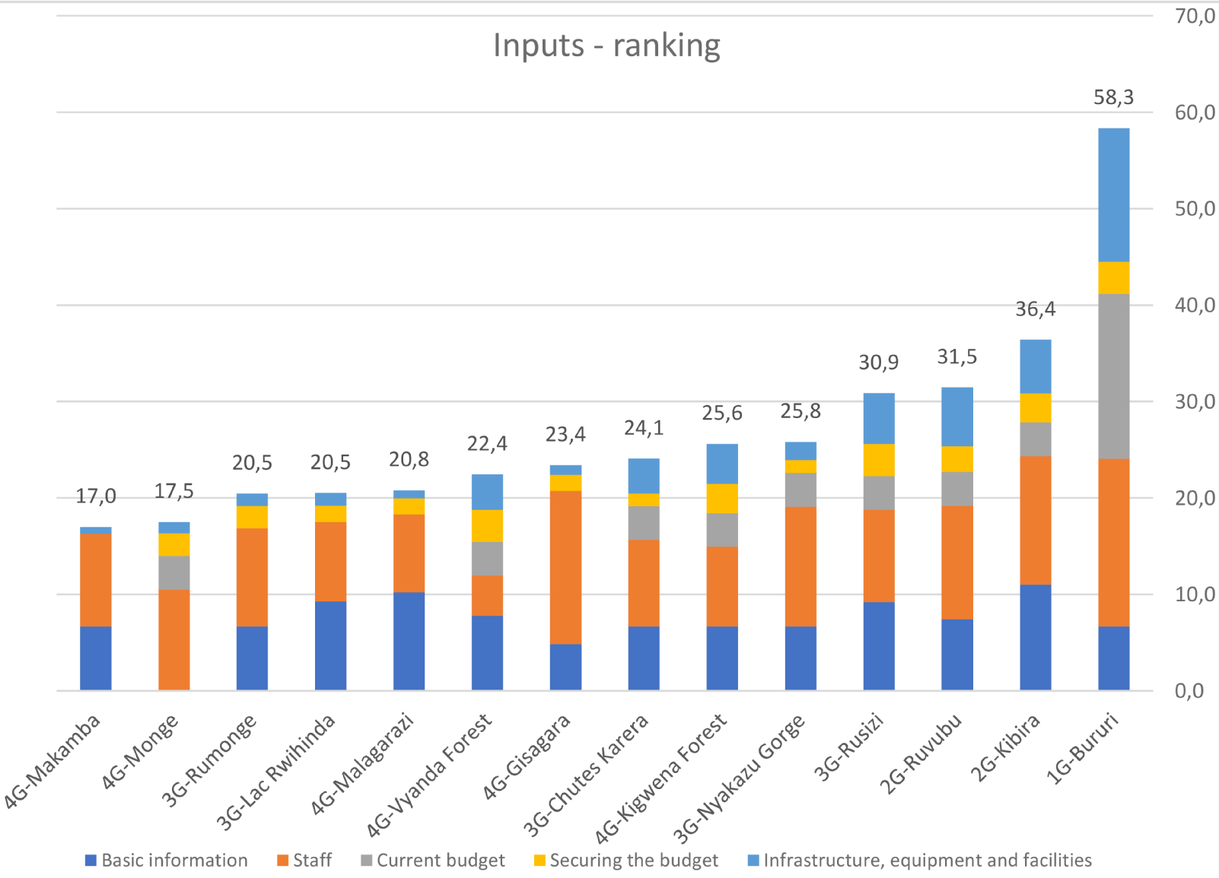

Table 18: Scores of the indicators of Inputs

|  |  |  |  |  |  |
| --- | --- | --- | --- | --- | --- |
| **Protected areas** | **Basic information** | **Staff** | **Current budget** | **Securing the budget** | **Infrastructure, equipment and facilities** |
| 1G-Bururi | 33,3 | 87,0 | 85,5 | 16,7 | 69,2 |
| 2G-Ruvubu | 37,0 | 58,9 | 17,5 | 13,4 | 30,5 |
| 2G-Kibira | 55,0 | 66,7 | 17,5 | 15,0 | 27,8 |
| 3G-Rumonge | 33,3 | 50,9 | 0,0 | 11,7 | 6,4 |
| 3G-Lac Rwihinda | 46,3 | 41,3 | 0,0 | 8,4 | 6,7 |
| 3G-Chutes Karera | 33,3 | 44,9 | 17,5 | 6,7 | 18,0 |
| 3G-Nyakazu Gorge | 33,3 | 62,1 | 17,5 | 6,7 | 9,5 |
| 3G-Rusizi | 45,9 | 47,9 | 17,5 | 16,7 | 26,3 |
| 4G-Makamba | 33,3 | 48,0 | 0,0 | 0,0 | 3,6 |
| 4G-Monge | 0,0 | 52,4 | 17,5 | 11,7 | 6,0 |
| 4G-Malagarazi | 51,1 | 40,3 | 0,0 | 8,4 | 4,2 |
| 4G-Vyanda Forest | 38,9 | 20,8 | 17,5 | 16,7 | 18,3 |
| 4G-Gisagara | 24,1 | 79,5 | 0,0 | 8,4 | 5,0 |
| 4G-Kigwena Forest | 33,3 | 41,4 | 17,5 | 15,0 | 20,8 |

|  |  |  |  |  |  |  |  |  |
| --- | --- | --- | --- | --- | --- | --- | --- | --- |
| Value visualisation for categories: | 0 |  | 1-32 |  | 33-50 |  | 51-100 |  |

Burundi’s PAs, as it is frequently the case for many protected areas in Central and West Africa, suffer from a lack of resources, with the exception of “I2 – Staffing”, that is the most important contributor to the overall Inputs score. “I3 - Current budget” and “I4 - Securing the budget” are the factors with highest limiting effect among the inputs, strongly impacting on the insufficiency of the performance of the system.

Table 19: Ranking Inputs

|  |  |
| --- | --- |
| **Protected Areas** | **Synthesis of Inputs** |
| 1G-Bururi | 58,3 |
| 2G-Kibira | 36,4 |
| 2G-Ruvubu | 31,5 |
| 3G-Rusizi | 30,9 |
| 3G-Nyakazu Gorge | 25,8 |
| 4G-Kigwena Forest | 25,6 |
| 3G-Chutes Karera | 24,1 |
| 4G-Gisagara | 23,4 |
| 4G-Vyanda Forest | 22,4 |
| 4G-Malagarazi | 20,8 |
| 3G-Rumonge | 20,5 |
| 3G-Lac Rwihinda | 20,5 |
| 4G-Monge | 17,5 |
| 4G-Makamba | 17,0 |

|  |  |  |  |  |
| --- | --- | --- | --- | --- |
| Value visualisation for categories: |  | 0 |  | 1-32 |
|  | 33-50 |  | 51-100 |

The analysis of the values of the ‘Inputs’ summary indicator does not show any particular anomaly with respect to the values collected. However, for the analysis, it is interesting to associate it with the comparison of PAs by categories, according to the groups evidenced by the statistical assessment.

The highest scoring protected area in Burundi, with respect to Inputs, is Bururi while the protected areas of Group 2, Kibira and Ruvubu, but also Rusizi of Group 3 show low score, just slightly over 30 points. The remaining 10 PAs have even lower scores, demonstrating a very difficult situation in the entire Burundi PAs network, with respect to the available Inputs.

**Basic information**

Table 20: Ranking Basic information

|  |  |
| --- | --- |
| **Protected Areas** | **Basic information** |
| 2G-Kibira | 55,0 |
| 4G-Malagarazi | 51,1 |
| 3G-Lac Rwihinda | 46,3 |
| 3G-Rusizi | 45,9 |
| 4G-Vyanda Forest | 38,9 |
| 2G-Ruvubu | 37,0 |
| 1G-Bururi | 33,3 |
| 3G-Chutes Karera | 33,3 |
| 3G-Nyakazu Gorge | 33,3 |
| 3G-Rumonge | 33,3 |
| 4G-Kigwena Forest | 33,3 |
| 4G-Makamba | 33,3 |
| 4G-Gisagara | 24,1 |
| 4G-Monge | 0,0 |

|  |  |  |  |  |
| --- | --- | --- | --- | --- |
| Value visualisation for categories: |  | 0 |  | 1-32 |
|  | 33-50 |  | 51-100 |

With respect to the quantity of basic information available for the functioning of the protected area, all the PAs report low values. The only exceptions are Kibira (Group 2) and Malagarazi (Group 4). However, for the latter, it is worth noting that this value shows a strong inconsistency with the zero reported value for the indicator on “Objective of Planning”.

A much more difficult situation, with respect to the availability of information, is observed in Monge, where, according to the PA staff, no information essential for the functioning of the protected area is available. Lack of information is a significant constraint because it limits management capacity and management actions. It precludes a proper selection of the management direction. Without basic information, the management process is blindfolded and unable to set goals for the protected area.

**Staff**

Table 21: Ranking I2: Staff

|  |  |
| --- | --- |
| **Protected Areas** | **Staff** |
| 1G-Bururi | 87,0 |
| 4G-Gisagara | 79,5 |
| 2G-Kibira | 66,7 |
| 3G-Nyakazu Gorge | 62,1 |
| 2G-Ruvubu | 58,9 |
| 4G-Monge | 52,4 |
| 3G-Rumonge | 50,9 |
| 4G-Makamba | 48,0 |
| 3G-Rusizi | 47,9 |
| 3G-Chutes Karera | 44,9 |
| 4G-Kigwena Forest | 41,4 |
| 3G-Lac Rwihinda | 41,3 |
| 4G-Malagarazi | 40,3 |
| 4G-Vyanda Forest | 20,8 |

|  |  |  |  |  |
| --- | --- | --- | --- | --- |
| Value visualisation for categories: |  | 0 |  | 1-32 |
|  | 33-50 |  | 51-100 |

The most adequate staffing is reported in Bururi. Nevertheless, Gisagara (Group 4) closely follows the performance of the leader. Relatively good levels of staffing are also observed in PAs of Group 2 but also for most PAs of Groups 3 and 4 (especially in Nyakazu Gorge and in Monge). The most difficult situation with respect to staffing is observed in Vyanda forest (Group 4).

The human resources indicator analysed in correlation with the indicator on the “Objectives to be achieved by the PAs”, shows that all PAs require capacity building actions. The necessity is higher in PAs with better values of management effectiveness, mostly because they are expanding and improving their management skills in various areas and hence they need to be supported. It is worth recalling that staffing adequacy is a strong element in the improvement of management strategies and of management implementation.

**Current Budget and Securing the budget**

An even worse situation is reported with respect to the budget: both the “I3 - Current budget” and for “I4 - Securing budget for future activities”.

Table 22: Ranking Current Budget and I4: Securing the budget

|  |  |  |
| --- | --- | --- |
| **Protected Areas** | **Current budget** | **Securing the budget** |
| 1G-Bururi | 85,5 | 16,7 |
| 2G-Ruvubu | 17,5 | 13,4 |
| 2G-Kibira | 17,5 | 15,0 |
| 3G-Rusizi | 17,5 | 16,7 |
| 3G-Rumonge | 0,0 | 11,7 |
| 3G-Nyakazu Gorge | 17,5 | 6,7 |
| 3G-Lac Rwihinda | 0,0 | 8,4 |
| 3G-Chutes Karera | 17,5 | 6,7 |
| 4G-Vyanda Forest | 17,5 | 16,7 |
| 4G-Monge | 17,5 | 11,7 |
| 4G-Malagarazi | 0,0 | 8,4 |
| 4G-Makamba | 0,0 | 0,0 |
| 4G-Kigwena Forest | 17,5 | 15,0 |
| 4G-Gisagara | 0,0 | 8,4 |

|  |  |  |  |  |
| --- | --- | --- | --- | --- |
| Value visualisation for categories: |  | 0 |  | 1-32 |
|  | 33-50 |  | 51-100 |

With respect to I3, almost all the PAs report extremely low scores. For five protected areas the budget meets 0% (all belonging to Groups 3 and 4). Scoring zero means that the PAs do not have any budget for functioning. Only the salaries and some basic expenditure are ensured.

With the exception of Bururi, in all the other protected areas of the Burundi national network the fulfilment of the budgetary requirements is extremely low. All the PAs of Groups 2, 3 and 4 cannot fulfil their requirements for the own basic functioning.

Most of the protected areas struggle with the current budget as it covers a part extremely small of their needs of protected areas. An even worse outlook for “I4 - Securing the budget for the following years” emerges. Financial resources of PAs are very random, controlled by the central services and without any security for the future. This is clearly a situation linked to the severe limitation of financial resources in the country. However, this has a considerable impact on the management. Even the Bururi NP suffers from a lack of security of the budget, despite achieving overall good results in the area of inputs. Very low scores on budgets are consequential to very low level of financing but might also be a consequence of the lack of sufficient efficiency in managing the available resources.

**Infrastructure, equipment and facilities**

Table 23: Ranking I5: Infrastructure, equipment and facilities

|  |  |
| --- | --- |
| **Protected Areas** | **Infrastructure, equipment and facilities** |
| 1G-Bururi | 69,2 |
| 2G-Ruvubu | 30,5 |
| 2G-Kibira | 27,8 |
| 3G-Rusizi | 26,3 |
| 4G-Kigwena Forest | 20,8 |
| 4G-Vyanda Forest | 18,3 |
| 3G-Chutes Karera | 18,0 |
| 3G-Nyakazu Gorge | 9,5 |
| 3G-Lac Rwihinda | 6,7 |
| 3G-Rumonge | 6,4 |
| 4G-Monge | 6,0 |
| 4G-Gisagara | 5,0 |
| 4G-Malagarazi | 4,2 |
| 4G-Makamba | 3,6 |

|  |  |  |  |  |
| --- | --- | --- | --- | --- |
| Value visualisation for categories: |  | 0 |  | 1-32 |
|  | 33-50 |  | 51-100 |

The last dimension of Inputs relates to “I5 - Infrastructure, equipment and facilities”. Low scores in this area indicate very poor conditions and lack of possibility in investing in the development of the protected areas. The best performer is again Bururi with almost 70 points. All the other protected areas score much lower. Half of the protected areas (Groups 3 and 4) do not manage to exceed the threshold of 10 points (out of 100), which is an extremely low score. This clearly indicates significant weaknesses for the staff in implementing. The fundamental principles of fundraising and of fund mobilization impose to ensure a close link between the investments in infrastructure and equipment and the conservation targets.

**General**

On average the most important contributor to the “Inputs’” score is staff. Despite difficulties and relatively low average (53 points out of 100) staff is the main source of “Inputs” for PAs in Burundi.

Figure 12: Average contribution of the sub-dimensions of Inputs to the total Inputs score

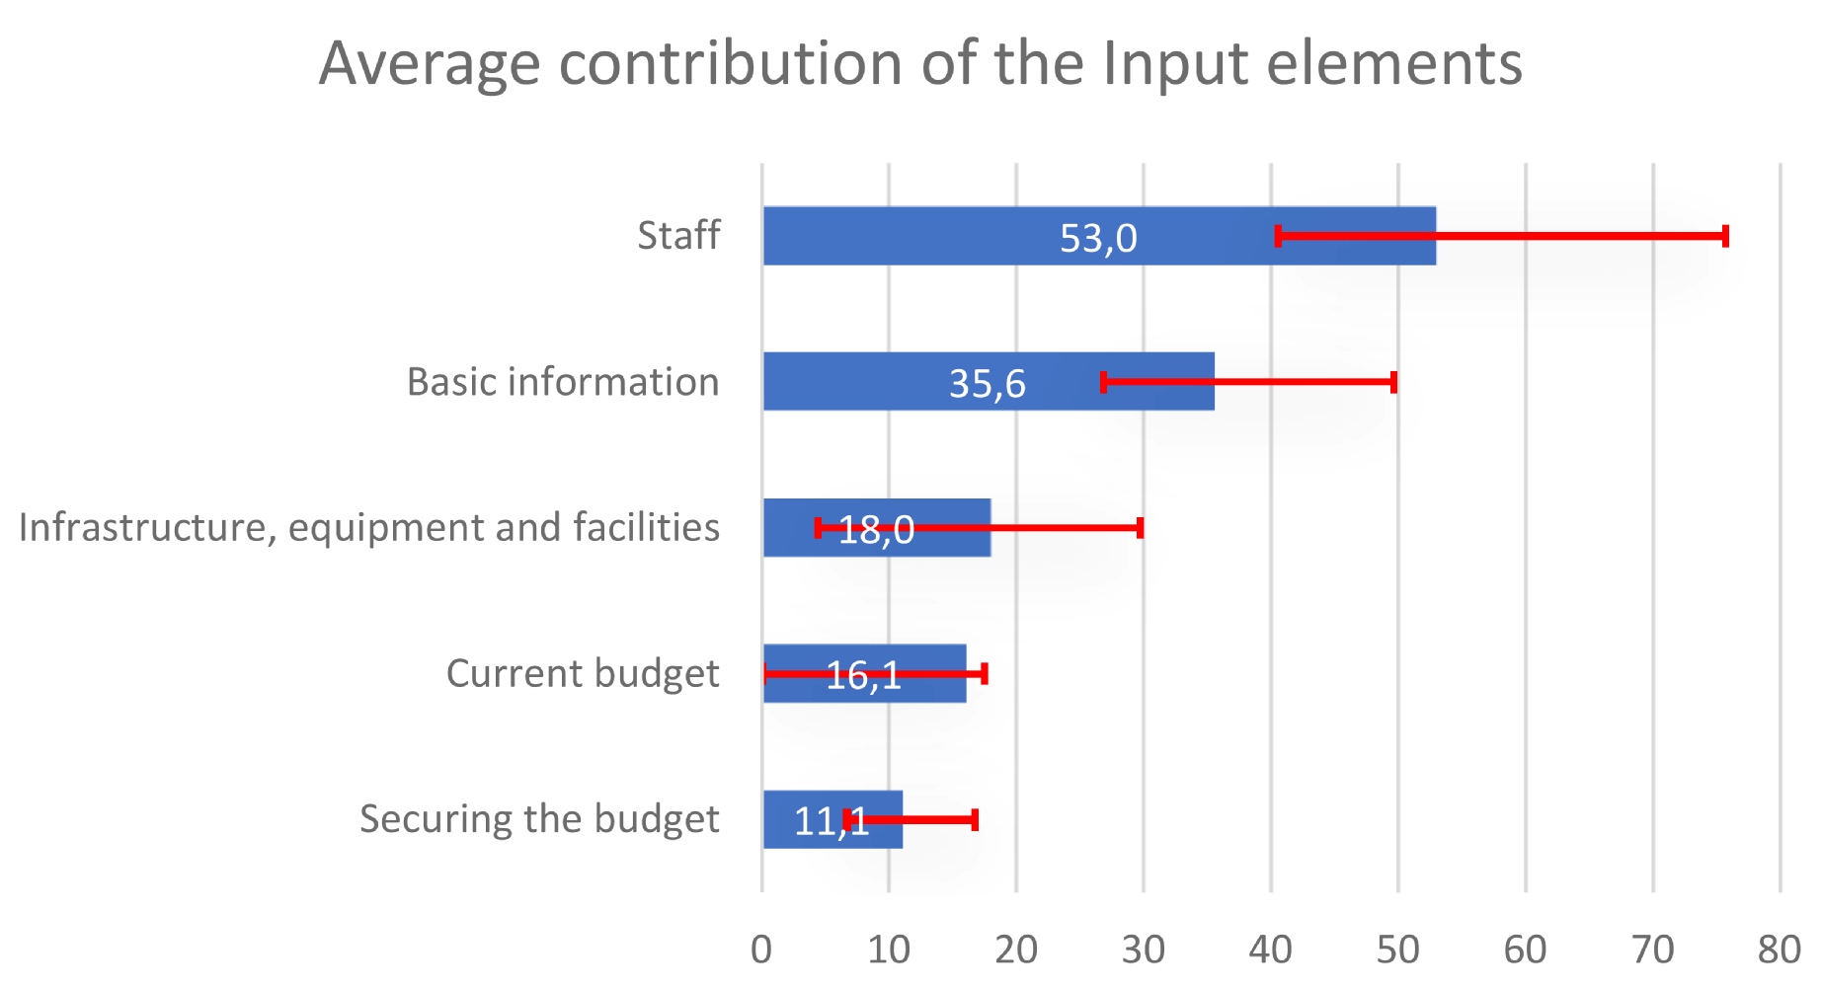

The average protected area in the national system reports the score of 35.6 points for the indicator on the “Availability of basic information”. The indicator on “Infrastructure, equipment and facilities” scores on average merely 18 points, e.g. approximately 1/5 of the maximum score, which indicates very poor conditions and absence of possibility to invest in the management and in the development of the national PAs.

An even worse situation is with respect to the available budget (“Current budget”), which scores merely 16.1 points. Most of the protected areas struggle with it as it covers only an extremely small part of the needs of the PAs. Even bleaker is the situation when it comes to the indicator on the budget available for the subsequent years (“Securing the budget”), where the average score is of 11.1 points out of 100.

**Conclusions and Suggestions**

The improvement of management effectiveness, and even the mere implementation of basic activities, requires inputs.

With the exception of “Staff”, the general limitation in the inputs undermines all the managing efforts to improve or maintain biodiversity conservation in Burundi. The reported values show serious deficits both in financial and in material resources.

With poor resources, but even more with lack of certainty with respect to funding for the subsequent years, protected areas have no chance to pursue any long-term goal. Even more important, this situation undermines the process of developing or updating management plans which might become obsolete in one year time, due to the lack of funding or due to insufficient funding.

The indicator on the “Availability of basic information” is not at the same level for all of the protected areas of the national system. It is worth noting that the small size of the country and the relative homogeneity of the protected area system in Burundi makes that the basic information available is more or less the same, and relatively limited extent for most of the different PAs within the system. The absence (or insufficiency) of information is also a problem to be pretty urgently addressed as it constrains management actions and precludes the identification/definition of a clear direction for management. Without basic information management is blindfolded and unable to set the goals for the protected area.

The sufficiently high score achieved in the area of human resources (in terms of staff availability) could be utilized by Burundi PAs to introduce capacity building programmes and actions oriented on achieving higher management effectiveness for all the PAs. Budget availability for immediate actions, as well as longer-term vision (and consequent fundraising or budget allocation) needs to be improved, in synergy with the necessary improvements in the previous 2 elements of the management cycle of a PA, “Context” and “Planning”. Thus, an important base to improve biodiversity conservation in Burundi would be established.

Fundamentally, the lack of security in inputs might be the most important element explaining the overall insufficient performance of the system.

***On the basis of the above observations, possible operational recommendations could be as follows:***

* ***to ensure constant flow of inputs (even if small) to enforce confidence in a proactive result-oriented approach,***
* ***to secure and stabilize at least a minimum acceptable level of Inputs in view of entrusting the belief in the long-term conservation targets,***
* ***to reinforce the capacity of identifying management priorities and of optimizing management approaches in accordance of the available inputs, even if limited,***
* ***to monitor the level and the flow of Inputs for the different PAs of the Burundi’s national system – even when limited – to improve planning and to better orient field interventions to enhance the results.***

### Process

“Process” represents the fourth key element in the management cycle of a protected area. Process addresses nineteen different indicators, which can be grouped into six basic sub-dimensions:

* **PR. A – Internal management**

|  |  |
| --- | --- |
| PR1: Capacities and Staff Training | PR2: Human Resource Management Policies and Procedures |
| PR3: HR Management Systems and Processes | PR 4: Management and Internal Leadership |
| PR 5: Accounting and Financial Management | PR 6: Maintenance of Infrastructure, Equipment and Facilities |

* **PR. B –  Protection Management**

|  |  |
| --- | --- |
| PR 7: Management of Values and Significance Aspects of the Protected Area | PR 8: Degree of Protection of the Values and Significance of the Protected Area |
| R 9: Control of Protected Area | PR 10: Law Enforcement |

* **PR. C – Relationships**

|  |  |
| --- | --- |
| PR 11: Involvement of communities, rights holders and stakeholders | PR 12: Appropriate benefits/assistance for communities |
| PR 13: Stakeholder Relations and Environmental Education | |

* **PR. D – Tourism**

|  |  |
| --- | --- |
| PR 14: Visitor Management | PR 15: Visitors and Impacts |

* **PR. E – Monitoring and Research**

|  |  |
| --- | --- |
| PR 16: Monitoring systems for protected area values and aspects of importance | PR 17: Research and biomonitoring |

* **PR. F – Climate change and Ecosystem Services.**

|  |  |
| --- | --- |
| PR 18: Managing the effects of climate change | PR19: Ecosystem services |

The values for the overall summary indicator for “Process”, as well as the values of the six sub-dimensions of the Process (described here above) are weak for all of the PAs of the national system, with the only exception of Bururi NP (once again). The ranking of the score of the different PAs is presented in Figure n. 13. The analysis shows that PAs’ staff, during the management process, pays particular attention to Pr-B, “Protection Management, and to Pr-A, “Internal Management”. All the other sub-elements of the “Process” receive relatively little attention and less management efforts. The values of the Pr-C indicator, on “Relationships” are very low. Given Burundi’s context of intervention, the values for “Tourism” (PR. D) and for “Monitoring and research” (PR. E) show the lowest levels among all management efforts.

Figure 13: The ranking of protected areas in Burundi with respect to the score in the dimensions of Processes

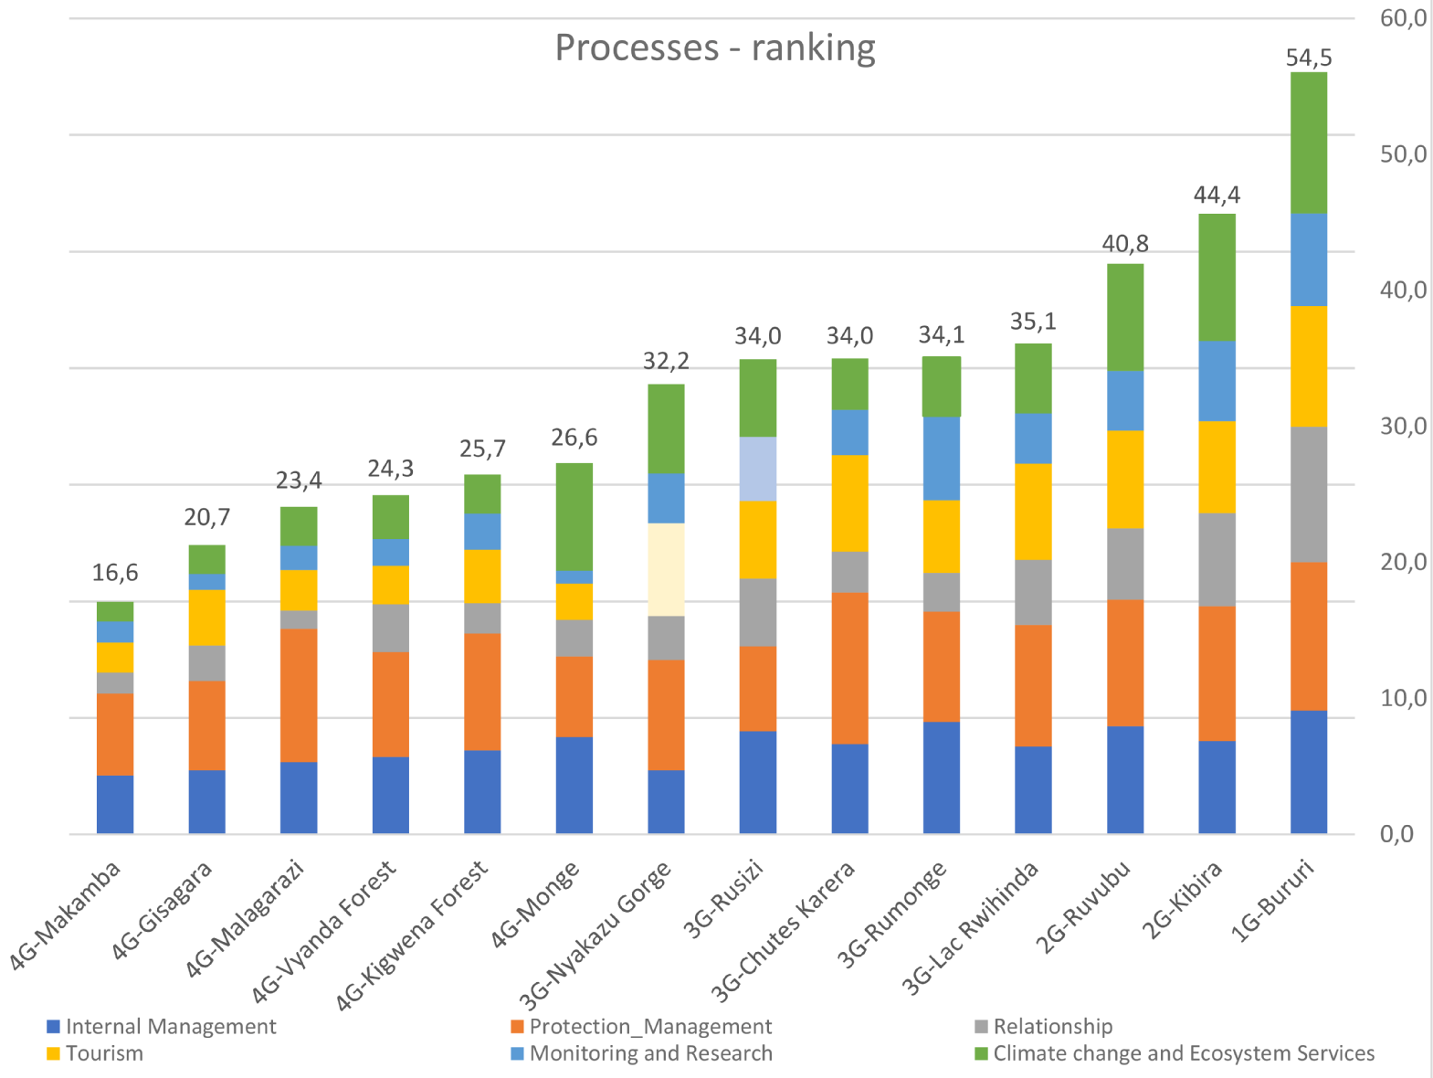

Such overall ranking of PAs based on the specific scores in the “Process” dimension of the PA’s management cycle corroborates the findings of the Grouping approach. The scores observed allow to easily and clearly identify the 4 different groups of protected areas in Burundi, as outlined in the previous sections. The Process ranking also follows the ranking in the groups’ overall analysis. The general low scores with regards to “Process” in the Burundi national system of PAs (see table 24) could be explained by the fact that the management process is particularly focused on day to day activities and on « Protection management ». All the other sub-dimensions of the “Process” score, in general terms, low.

Table 24: Ranking Process

|  |  |
| --- | --- |
| **Protected Areas** | **Synthesis of Processes** |
| 1G-Bururi | 54.5 |
| 2G-Kibira | 44.4 |
| 2G-Ruvubu | 40.8 |
| 3G-Lac Rwihinda | 35.1 |
| 3G-Rumonge | 34.1 |
| 3G-Rusizi | 34,0 |
| 3G-Chutes de Karera | 34,0 |
| 3G-Nyakazu Gorge | 32,2 |
| 4G-Monge | 26,6 |
| 4G-Kigwena Forest | 25,7 |
| 4G-Vyanda Forest | 24.3 |
| 4G-Malagarazi | 23.4 |
| 4G-Gisagara | 20.7 |
| 4G-Makamba | 16.6 |

|  |  |  |  |  |
| --- | --- | --- | --- | --- |
| Value visualisation for categories: |  | 0 |  | 1–32 |
|  | 33–50 |  | 51–100 |

Eventually, it is worth taking into consideration the fact that PA’s staff provides more readily responses directly linked to “Protection management” activities, as this is the area they are most used to work on. On the contrary, they are less comfortable in addressing other management issues, as they are less experienced (or less accustomed) in addressing other aspects of the management process. The other aspects of management process very often (and not only in Burundi), receive much less attention and focus.

With regards to the situation of specific PAs, the best score of Bururi PAs can be mostly attributed to very good performance in ”Protection management” but also to very good performance on “Climate change” and “Ecosystem services”. The same situation is observed in Kibira PA. Also the strengths of Ruvubu and Lac Rwihinda mainly lie in ”Protection management”, yet in the latter case, managing “Climate change” and “Ecosystem services” is much weaker than in the case of the leading PAs. The strengths of Rumonge lie in “Internal management”, while Chutes de Karera excels in “Protection management”. However both areas, significantly suffer from poor performance in managing their “Relationships” with the stakeholders. The focus of Rusizi should be to improve “Protection management”. Nyakazu Gorge, despite being behind Rusizi, outperforms it in “Protection management”. However, it is not able to show high performance in “Internal management”. The areas ranking lower show problems in many aspects of the “Process” dimension of the management cycle of PAs. Nevertheless, apparent weakness of the lowest scoring PAs relates to very weak performance in managing “Tourism”, “Monitoring and research” but also in “Managing the effects of climate change”

Table 25: Scores of all indicators of the Process

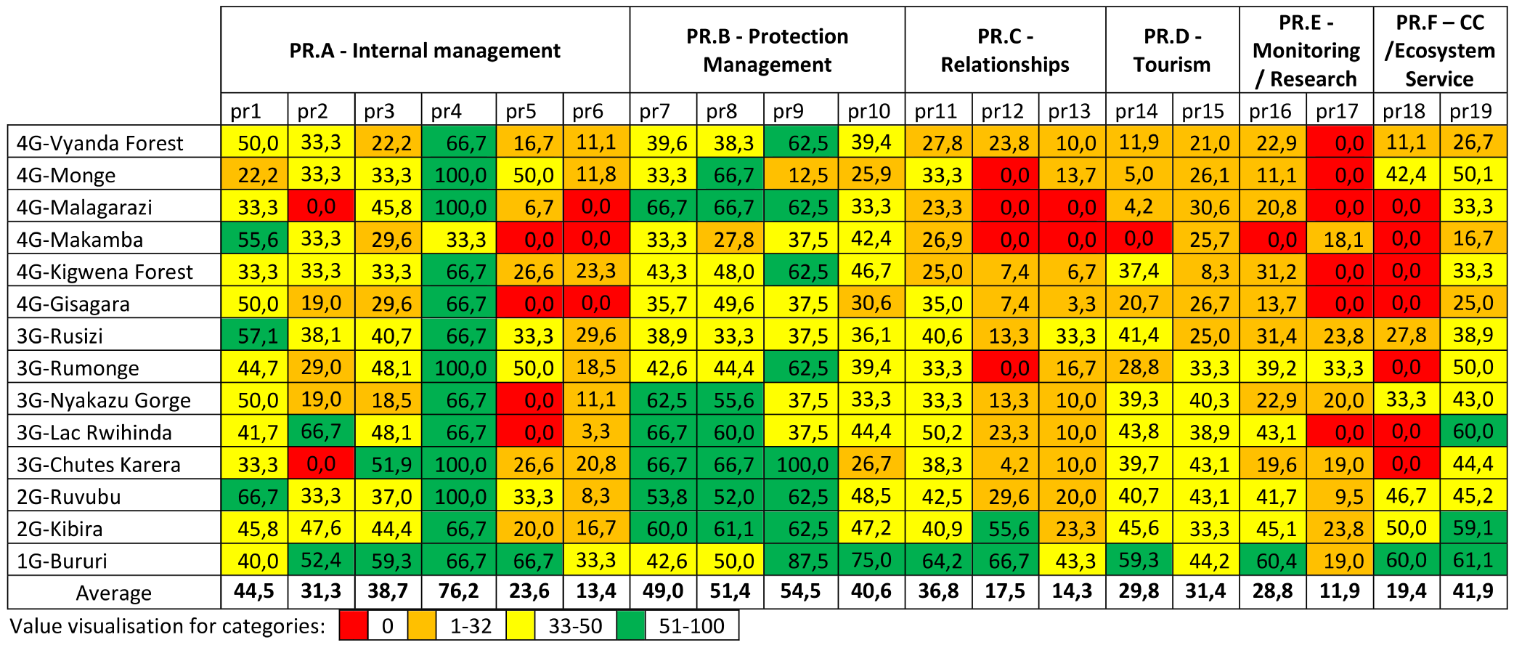

The analysis of the specific indicators of the 6 sub-dimensions of the “Process” element of the management cycle of PAs shows:

PR. A – Internal management

* A large gap between PR : “Management and Internal Leadership” and all the others indicators, in order PR1: “Capacities and Staff Training ; PR3: “HR Management Systems and Processes”; PR2: “Human Resource Management Policies and Procedures;” PR 5: “Accounting and Financial Management” and PR 6: “Maintenance of Infrastructure, Equipment and Facilities”

PR. B – Protection Management

* The large gap between PR 9: “Protected Area Control” and PR 10: “Law Enforcement,” PR 7: “Management of Values and Significance Aspects of the Protected Area,” and PR 8: “Degree of Protection of the Values and Significance of the Protected Area”;

PR. C – Relationships

* The large gap between PR 11: “Involvement of communities, rightholders and stakeholders” and PR 12: “Appropriate benefits/assistance for communities”, PR 13: “Stakeholder Relations and Environmental Education”;

PR. D – Tourism

* Low values for both PR 14: “Visitor Management” and PR 15: “Visitors and Impacts;”

PR. E – Monitoring and Research

* Considerable gap between PR 16: “Monitoring systems for protected area values and aspects of importance” and PR 17: “Research and biomonitoring”;

PR. F – Climate change and Ecosystem Services

* The large gap between PR 18: “Managing the effects of climate change” and PR19: “Ecosystem services”;

Below each sub-element of the Process is specifically analysed.

* **PR. A – Internal management**

|  |  |
| --- | --- |
| PR1: Capacities and Staff Training | PR2: Human Resource Management Policies and Procedures |
| PR3: HR Management Systems and Processes | PR 4: Management and Internal Leadership |
| PR 5: Accounting and Financial Management | PR 6: Maintenance of Infrastructure, Equipment and Facilities |

With reference to the indicators of the 1st sub-element of Process “Internal management”, Burundi’s PAs rank as shown in the table below. In general terms, the specific indicators of the sub-element rank as follows:

Table 26: Ranking Internal Management

|  |  |
| --- | --- |
| **Protected Areas** | ***Synthesis of Internal Management*** |
| 1G-Bururi | 53.1 |
| 3G-Rumonge | 48.4 |
| 2G-Ruvubu | 46.4 |
| 3G-Rusizi | 44.3 |
| 4G-Monge | 41.8 |
| 2G-Kibira | 40,2 |
| 3G-Chutes de Karera | 38,8 |
| 3G-Lac Rwihinda | 37,7 |
| 4G-Kigwena Forest | 36,1 |
| 4G-Vyanda Forest | 33,3 |
| 4G-RN Malagarazi | 31.0 |
| 3G-Nyakazu Gorge | 27.6 |
| 4G-Gisagara | 27.5 |
| 4G-Makamba | 25.3 |

|  |  |  |  |  |
| --- | --- | --- | --- | --- |
| Value visualisation for categories: |  | 0 |  | 1–32 |
|  | 33–50 |  | 51–100 |

* PR 4: Management and Internal Leadership
* PR1: Capacities and Staff Training
* PR3: HR Management Systems and Processes
* PR2: Human Resource Management Policies and Procedures
* PR 5: Accounting and Financial Management
* PR 6: Maintenance of Infrastructure, Equipment and Facilities

The scores of PR4 “Internal leadership” and PR1 “Capacities and staff training” push up the average value of the sub-dimension (sub-element) on “Internal management”. This suggests the existence – at least theoretically – of a potential management capacity which is not exploited because of poor policies and procedures and lack of inputs. This might be explained by the fact that PAs’ staff tend to have a positive perception of their own work, especially work when it comes to the assessment of standard (day to day) operations. High values of leadership and staff capacities should normally result in high values for the other sub-dimensions of the Process. However, as we can see, this is not the case for all the other sub-elements and indicators. These inconsistencies should be further assessed by external coaches in future management effectiveness assessments. Management improvement should thus be oriented on improved accounting and financial management as well as on the “Maintenance of infrastructures, equipment and facilities”, in order to strengthen processes, even in situations characterized by limited inputs.

**PR. B – Protection Management**

|  |  |
| --- | --- |
| PR 7: Management of Values and Significance Aspects of the Protected Area | PR 8: Degree of Protection of the Values and Significance of the Protected Area |
| R 9: Control of Protected Area | PR 10: Law Enforcement |

With reference to the indicators of the 2nd sub-element of Process”, “Protection management”, Burundi’s PAs rank as shown in the table below. In general terms, the specific indicators of the sub-element rank as follows:

* PR 9: Control of Protected Area

Table 27: Ranking Protection and Management

|  |  |
| --- | --- |
| **Protected Areas** | ***Synthesis of Protection & Management*** |
| 3G-Chutes the Karera | 65,0 |
| 1G-Bururi | 63,8 |
| 3G.Kibira | 57,7 |
| 1G.RN Malagarazi | 57,3 |
| 3G.Ruvubu | 54,2 |
| 3G-Lac Rwihinda | 52,2 |
| 1G.Kigwena Forest | 50,1 |
| 3G-Rumonge | 47,2 |
| 3G-Nyakazu Gorge | 47,2 |
| 1G.Vyanda Forest | 45,0 |
| 1G.Gisagara | 38,4 |
| 3G-Rusizi | 36,5 |
| 1G.Makamba | 35,3 |
| 1G.Monge | 34,6 |

|  |  |  |  |  |
| --- | --- | --- | --- | --- |
| Value visualisation for categories: |  | 0 |  | 1–32 |
|  | 33–50 |  | 51–100 |

* PR 8: Degree of Protection of the Values and Significance of the Protected Area
* PR 7: Management of Values and Significance Aspects of the Protected Area
* PR 10: Law Enforcement

“Control of protected Area” and “Degree of protection of the values and significance of the protected Area” are characterised by relatively high scores, while the control of area and protection of values results in average values. The score of Chutes de Karera (Group 3) is higher than this of all the other protected areas in the ranking. Lac Rwihinda and Malagarazi (PAs of Groups 3 and 4 respectively) also score over 50. The remaining PAs score also relatively well. Only four protected areas score less than 40 points. It is worth noting that Burundi’s PAs do not have sufficiently large extension (in terms of surface) to properly ensure their functioning. However, the staffs of the Burundi’s national PAs system are convinced of its ability to ensure protection and management of the values (with the exception of only four PAs which were already mentioned). These results combined with those on “Threats”, “Planning” and “Inputs” show that a substantial improvement in the definition of values followed by improved law enforcement, needs to be targeted.

**PR. C – Relationships**

|  |  |
| --- | --- |
| PR 11: Involvement of communities, rights holders and stakeholders | PR 12: Appropriate benefits/assistance for communities |
| PR 13: Stakeholder Relations and Environmental Education | |

With reference to the indicators of the 3rd sub-element of “Process”, “Relationships”, Burundi’s PAs rank as shown in the table below. In general terms, the specific indicators of the sub-element rank as follows:

Table 28: Ranking Relationship

|  |  |
| --- | --- |
| **Protected Areas** | ***Synthesis of Relationships*** |
| 1G-Bururi | 58,1 |
| 3G.Kibira | 39,9 |
| 3G.Ruvubu | 30,7 |
| 3G-Rusizi | 29,1 |
| 3G-Lac Rwihinda | 27,8 |
| 1G.Vyanda Forest | 20,5 |
| 3G-Nyakazu Gorge | 18,9 |
| 3G-Chutes de Karera | 17,5 |
| 1G.Monge | 16,7 |
| 3G-Rumonge | 16,7 |
| 1G.Gisagara | 15,2 |
| 1G.Kigwena Forest | 13,0 |
| 1G.Makamba | 9,0 |
| 1G.RN Malagarazi | 7,8 |

|  |  |  |  |  |
| --- | --- | --- | --- | --- |
| Value visualisation for categories: |  | 0 |  | 1–32 |
|  | 33–50 |  | 51–100 |

* PR 11: Involvement of communities, right holders and stakeholders
* PR 12: Appropriate benefits/assistance for communities
* PR 13: Stakeholder Relations and Environmental Education

The global value of Relationship is also low for the protected areas of Group 3. Bururi is, as usual, exception in the network of Burundi PAs.

The PAs are limiting their interaction to very low benefits/assistance for the population and even lower engagement in environmental education.

Considering the values of indicators related to “Appropriate benefits/assistance” and in “Environmental education”, considering the high level of threats and considering the inadequacy of funds available for supporting the population in the buffer areas, constant interaction between stakeholders located in the same territorial context is highly recommended. Also, an intensification of environmental education initiatives would be very beneficial to sustain and improve the relations between the protected areas and the surrounding populations, right holders and stakeholders.

**PR. D – Tourism**

|  |  |
| --- | --- |
| PR 14: Visitor Management | PR 15: Visitors and Impacts |

With reference to the indicators of the 4th sub-dimension of the “Process” element - “Tourism” - Burundi’s PAs rank as shown in the table below. In general terms, the specific indicators of the sub-element rank as follows:

Table 29: Ranking Tourism

|  |  |
| --- | --- |
| **Protected areas** | ***Synthesis of Tourism*** |
| 1G-Bururi | 51,8 |
| 3G.Ruvubu | 41,9 |
| 3G-Lac Rwihinda | 41,4 |
| 3G-Chutes de Karera | 41,4 |
| 3G-Nyakazu Gorge | 39,8 |
| 3G.Kibira | 39,4 |
| 3G-Rusizi | 33,2 |
| 3G-Rumonge | 31,1 |
| 4G-Gisagara | 23,7 |
| 4G-Kigwena Forest | 22,9 |
| 4G-RN Malagarazi | 17,4 |
| 4G-Vyanda Forest | 16,4 |
| 4G-Monge | 15,6 |
| 4G-Makamba | 12,8 |

|  |  |  |  |  |
| --- | --- | --- | --- | --- |
| Value visualisation for categories: |  | 0 |  | 1–32 |
|  | 33–50 |  | 51–100 |

* PR 15: Visitors and Impacts
* PR 14: Visitor Management

PAs from Group 4 are almost completely not concerned about the tourism. The PAs from Groups 2 and 3 also score relatively low. Only Bururi (Group 1) reached a sufficient score, just above 50 points over 100.

The analysis of the values of the indicator “Visitors and Impacts (generated by Tourism)” shows that this element is not a management priority for the protected areas of the Burundi PA system. This might be related to the fact that PAs of Burundi are poor on fauna, which is often the main driver of tourism. However, they are a testimonial of the ancient forest’s biodiversity. ***Burundi’s PAs could valuably support environmental education programmes. This would improve at the same time the presence of visitors and would also reinforce the conservation of the ecosystem services and of the historical and natural heritage.***

**PR.E - Monitoring and Research**

|  |  |
| --- | --- |
| PR 16: Monitoring systems for protected area values and aspects of importance | PR 17: Research and biomonitoring |

Table 30: Ranking Monitoring and research

|  |  |
| --- | --- |
| **Protected Areas** | ***Synthesis of Monitoring and Research*** |
| 1G-Bururi | 39,7 |
| 3G-Rumonge | 36,3 |
| 2G-Kibira | 34,5 |
| 3G-Rusizi | 27,6 |
| 2G-Ruvubu | 25,6 |
| 3G-Lac Rwihinda | 21,6 |
| 3G-Nyakazu Gorge | 21,5 |
| 3G-Chutes de Karera | 19,3 |
| 4G-Kigwena Forest | 15,6 |
| 4G-Vyanda Forest | 11,5 |
| 4G-RN Malagarazi | 10,4 |
| 4G-Makamba | 9,0 |
| 4G-Gisagara | 6,9 |
| 4G-Monge | 5,6 |

|  |  |  |  |  |
| --- | --- | --- | --- | --- |
| Value visualisation for categories: |  | 0 |  | 1–32 |
|  | 33–50 |  | 51–100 |

With reference to the indicators of the 5th sub-dimension of the “Process” element of the management cycle of PAs, “Monitoring and Research”, Burundi’s PAs rank as shown in the table below. In general terms, the specific indicators of the sub-element rank as follows:

* PR 16: Monitoring systems for protected area values and aspects of importance.
* PR 17: Research and biomonitoring,

“Monitoring” is the only management activity in Burundi PAs, even if with to a very limited extent, as shown consideration of the values, which are indeed low for practically all PAs. “Research and biomonitoring” is completely inexistent in many PAs and nearly inexistent in the others, even in those of Groups 1 and 2. ***Considering the low values of the indicator of the “Planning” dimension, on the “Objectives of the protected area (P4)”, this situation clearly confirms the fact that “Planning” in Burundi PAs is not based on a result-oriented approach. Monitoring levels should be substantially reinforced.***

**PR.F - Climate change and Ecosystem Services**

|  |  |
| --- | --- |
| PR 18: Managing the effects of climate change | PR19: Ecosystem services |

With reference to the indicators of the 6th and last sub-dimension of the “Process”, “Climate change and Ecosystem services”, Burundi’s PAs rank as showed in the table below. In general terms, the specific indicators of the sub-element rank as follows:

Table 31: Ranking Climate change and Ecosystem Services

|  |  |
| --- | --- |
| **Protected areas** | ***Synthesis of Climate change and Ecosystem Services*** |
| 1G-Bururi | 60,6 |
| 2G-Kibira | 54,5 |
| 4G-Monge | 46,2 |
| 2G-Ruvubu | 46,0 |
| 3G-Nyakazu Gorge | 38,2 |
| 3G-Rusizi | 33,4 |
| 3G-Lac Rwihinda | 30,0 |
| 3G-Rumonge | 25,0 |
| 3G-Chutes de Karera | 22,2 |
| 4G-Vyanda Forest | 18,9 |
| 4G-RN Malagarazi | 16,7 |
| 4G-Kigwena Forest | 16,7 |
| 4G-Gisagara | 12,5 |
| 4G-Makamba | 8,4 |

|  |  |  |  |  |
| --- | --- | --- | --- | --- |
| Value visualisation for categories: |  | 0 |  | 1–32 |
|  | 33–50 |  | 51–100 |

* PR19: Ecosystem services
* PR 18: Managing the effects of climate change

Monge (Group 4) scores high in spite of its low position in the overall ranking of the Burundi network. With the exception of Monge, and of Rusizi and Nyakazu Gorge (Group 3), all Burundi PAs show low scores on “Managing the effects of climate change” and on “Ecosystem services”. This situation is striking considering the importance that the PAs, should attribute to the provision of many different ecosystem services, especially in the Burundi context of high human population density. This situation reflects insufficient attention for - or knowledge of - the PAs functions. We must also notice that only the PAs with higher awareness on Ecosystem services seem to be attentive to Climate change effects.

With regards to the situation of specific PAs, the best score of Bururi PA can be mostly attributed to very good performance in “Protection management” but also to a very good processing response to “Climate change” and “Ecosystem services”. The same situation is observed in Kibira PA. The main strength of Ruvubu and Lac Rwihinda also lies in “Protection management”, yet in the latter case managing “Climate change” and “Ecosystem services” is weaker than the leading PAs. The strength of Rumonge lies in “Internal management”, while Chutes de Karera excels in “Protection management”. However both areas, significantly suffer from poor performance in managing their “Relationships with the stakeholders”. The focus of Rusizi should be to improve “Protection management”. Nyakazu Gorge, despite being behind Rusizi outperforms it in “Protection management”. Yet it is not able to deliver high performance in “Internal management”. The protected areas, which are ranked even lower, naturally experience problems in many dimensions related to “Process”. Nevertheless, the apparent weakness of these sites relates to very weak performance in managing “Tourism”, but also in “Monitoring and Research”.

**General**

On average, the most positive element in the “Process” dimension of the management cycle of a PA relates to “Protection and management of the values of the protected areas”, with an average score of 48.9 points. Despite being the best, this score should not be considered high. The two indicators with the largest positive contribution to “Protection and Management” are “PR9 – Control of the protected area” and “PR8 – Degree of protection of the values and significance of the protected area”. However it is worth nothing that even for the top scoring elements the scores on average are below 50.

Figure 14: Average performance in the sub-dimensions of Processes in Burundi

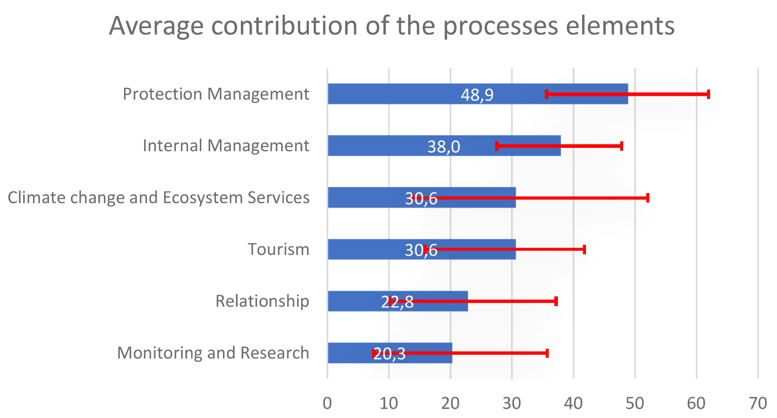

“Internal management” is even weaker with an average score of 38 points. This limited performance is driven by low score of “PR6 – Maintenance” and very low score of “PR5 - Accounting and financial management”. We should note that “PR4 - Management and internal leadership” scores the highest (76.2 to 100) among all the indicators of the “Process” dimension.

PAs in Burundi score low on “Climate change and Ecosystem services” with average reaching only 30.6 points. More importantly, there are significant differences between protected areas in Burundi in handling processes related to climate change and ecosystem services. “Tourism” management’s score is identical to the value of the sub-element “Climate change and Ecosystem services” (30.6 points). Also in this dimension the observed differences in scores for tourism are relatively large between PAs.

The weakest two sub-dimensions of “Process” are “Relationships” and “Monitoring and Research”. The former, on average, scores 22.8 points while the latter scores 20.3 points. As for “Tourism”, the internal differences in scores within the PAs are relatively important in both cases.

Eventually, it is worth highlighting that the response rate provided on the elements of the “Process” is only 77%. It is possible that PAs experienced difficulties in providing responses to some elements related to the Process due to limited knowledge and limited experience in dealing with the considered dimension. This might have been particularly apparent when responding on issues related to national policies and/or to specific legal provisions in force, for instance on aspects such as ”Relationships”, “Tourism”, “Research”, “Climate change”, “Ecosystem services” .

**Conclusions and Suggestions**

The average of the values of the indicators for the 14 PAs on “Process” is 31.9 points out of 100. The highest values are “Control of the protected area”, “Degree of Protection” and “Management of the key elements of biodiversity and importance of the protected areas” and the “Internal leadership”. Technically, these indicators address two fundamental aspects of the protected areas: (i) conservation of the values and importance, (ii) management capacities. However unfortunately, these relatively good values are not supported by other analysis that could confirm and ensure the proper evolution of conservation in the framework of protected areas. Generally, the values of the Process indicators should contribute more to the performance of a protected area (at least 50 points out of 100), that is not the case for the Burundi’s PAs network. Additionally, Burundi PAs show insufficient values on general lack of information, financial and equipment inputs, management plans, long-term objectives, monitoring and research activities and have poorly implemented their work plans There are therefore missing elements of “Process” (e.g. “Relationships” and “Monitoring and Research”) supposed to work together with “Context”, “Planning” and “Inputs” that should ensure sound management. Although we trust responses provided by the PAs’ staff, it is worth mentioning that it is extremely hard for them to justify with evidence their belief that biodiversity conservation is not worsening, as apparently confirmed by the very low values scores on the indicators about “Available information”, “Planning”, “Monitoring and Research”.

As the IMET analysis shows, “Climate change” is a complex topic and it is still not sufficiently incorporated into the management process of the protected areas in Africa in general and in Burundi in particular. However, PAs that adopt strategies for handling “Ecosystem services” seem to benefit from it and explicitly integrate the management of “Climate change effects”. This seems to be directly correlated with a wider management approach not only focus on key conservation species as for Burundi’s PAs.

Benefits from “Tourism” could be much higher and the protected areas could also benefit from the adoption of specific strategies for tourism based on environmental education, as well as on management of the ecosystem services delivered and stressing their importance.

“Monitoring and Research” activities are positioned extremely low. This constitutes a huge issue, causing difficulties in management. Although it will be really difficult to promote advanced important research programmes, especially in the Burundi situation of very low inputs, monitoring and research should be improved to contribute to a better understanding of the environment and therefore to improved planning.

It is important to highlight that the overall weak performance in the “Relationships” element should also be a matter of concern. The more in-depth analysis of the values of indicators shows low involvement of stakeholders in natural resources management.

***Based on the above considerations, possible operational recommendations are as follows:***

* ***to further assess, again in consistency, the scores assigned to the indicators “Control of the protected area”, “Degree of Protection” and “Management of the key elements of biodiversity and importance of the protected areas” ;***
* ***to work on internal consistency among the different “Process” indicators to optimize management effectiveness;***
* ***to select specific priorities and emblematic elements of biodiversity or of ecosystem services delivered by the protected area, as key elements of the protected area management;***
* ***to reinforce management activities on ecosystem services conservation;***
* ***to develop a synergy between ecosystem services management, environmental education and tourism, in order to communicate the importance and the role of the protected areas in delivering services to the population;***
* ***not to underestimate the effects of climate change in a country with high population density and small protected areas;***
* ***to reinforce the use of monitoring for planning and action.***
* ***to avoid confusion between “to maintain good relationship with the neighbouring populations in the objective of minimising threats” and “to establish functional and structural relationships with the stakeholders”, with the joint obligation to ensure and maintain the delivery of services for the human well-being.***

### Outputs

***Analysis***

“Outputs” are the fifth element of the Management cycle of a protected area. All of the previous elements of the management cycle were focusing on how the area is being managed, without any specific consideration on the efficiency. The inclusion of the analysis of the “Outputs” in the overall assessment brings into the debate also the results of the management process and of the specific actions implemented.

Figure 15: Ranking Outputs

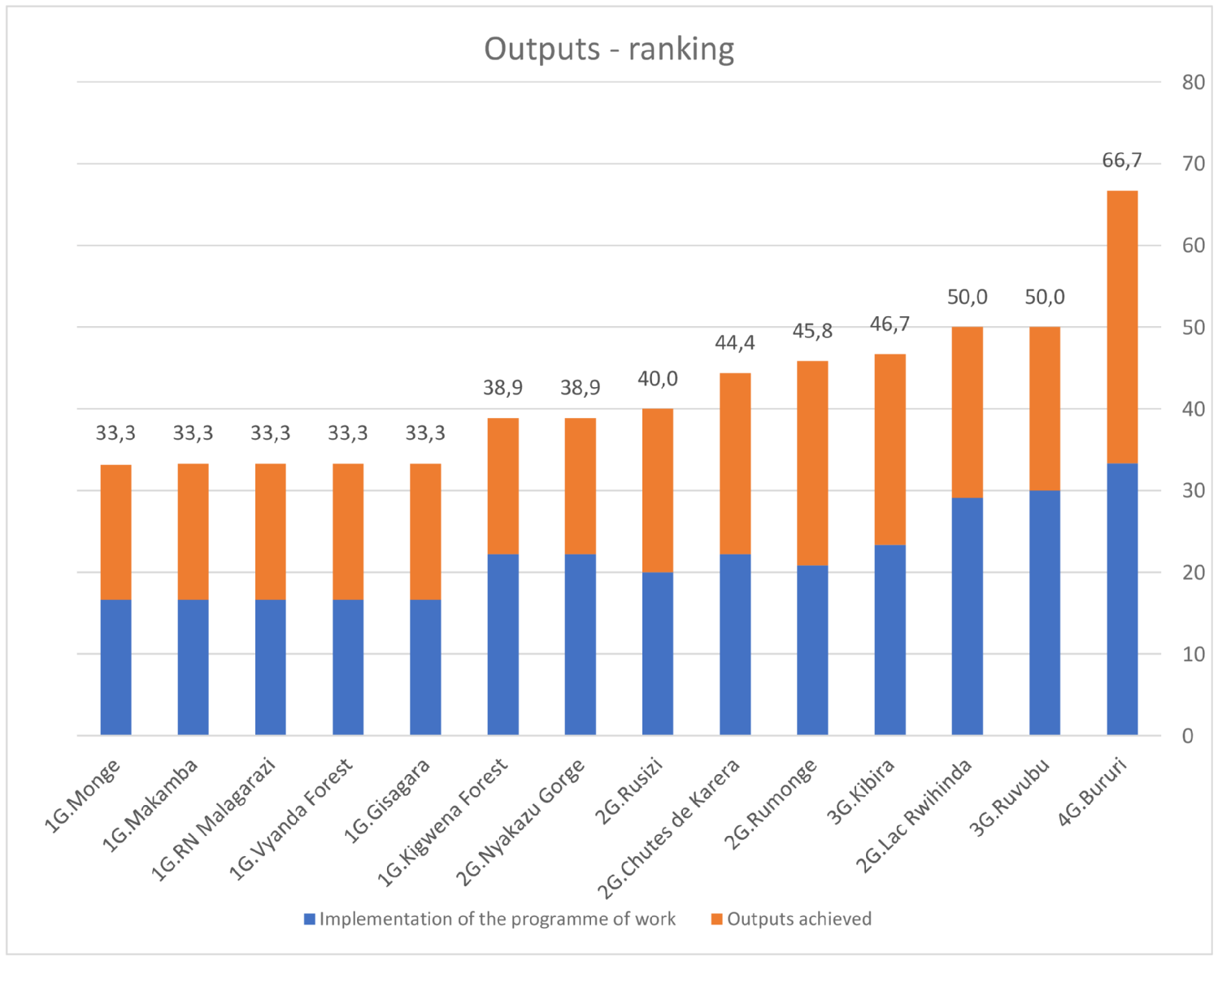

The ranking of the performance of the Burundi protected areas in the achievement of “Outputs”, as well as the relative contribution of the 2 indicators which are considered in IMET for the assessment of the “Outputs” dimension are presented in Figure 15, together with the total score achieved.

Table 32: Scores of the indicators of the Outputs

|  |  |  |
| --- | --- | --- |
| **Protected areas** | **Implementation of the programme of work** | **Outputs achieved** |
| 1G-Bururi | 66,7 | 66,7 |
| 2G-Kibira | 46,7 | 46,7 |
| 2G-Ruvubu | 60,0 | 40,0 |
| 3G-Nyakazu Gorge | 44,4 | 33,3 |
| 3G-Rusizi | 40,0 | 40,0 |
| 3G-Chutes Karera | 44,4 | 44,4 |
| 3G-Rumonge | 41,7 | 50,0 |
| 3G-Lac Rwihinda | 58,3 | 41,7 |
| 4G-Monge | 33,3 | 33,0 |
| 4G-Makamba | 33,3 | 33,3 |
| 4G-Malagarazi | 33,3 | 33,3 |
| 4G-Vyanda Forest | 33,3 | 33,3 |
| 4G-Gisagara | 33,3 | 33,3 |
| 4G-Kigwena Forest | 44,4 | 33,3 |

|  |  |  |  |  |
| --- | --- | --- | --- | --- |
| Value visualisation for categories: |  | 0 |  | 1-32 |
|  | 33-50 |  | 51-100 |

Unsurprisingly, the top performing protected area in terms of outputs is Bururi. The protected areas of Groups 2 and 3 lag with much lower scores - the final values ranging between 40 and 50 points. The scores of other PAs, especially those of Group 4 are even lower – close to merely 33.3 points.

Table 33: Ranking Outputs

|  |  |
| --- | --- |
| **Protected Areas** | **Synthesis of Outputs** |
| 1G.Bururi | 66,7 |
| 3G-Lac Rwihinda | 50,0 |
| 2G-Ruvubu | 50,0 |
| 2G-Kibira | 46,7 |
| 3G-Rumonge | 45,8 |
| 3G-Chutes de Karera | 44,4 |
| 3G-Rusizi | 40,0 |
| 4G-Kigwena Forest | 38,9 |
| 3G-Nyakazu Gorge | 38,9 |
| 4G-Monge | 33,3 |
| 4G-Makamba | 33,3 |
| 4G-RN Malagarazi | 33,3 |
| 4G-Vyanda Forest | 33,3 |
| 4G-Gisagara | 33,3 |

|  |  |  |  |  |
| --- | --- | --- | --- | --- |
| Value visualisation for categories: |  | 0 |  | 1–32 |
|  | 33–50 |  | 51–100 |

The small difference between the values of the indicators: “R1: Implementation of the work program” and “R2: Results achieved” by all the APs could mean an almost perfect evolution in the management efforts. On the other hand, this can mean that the parks’ staffs confuse the implementation of the annual plan with the results to be achieved. In any case the scores of the Outputs indicators are inconsistent with the scores of other indicators, i.e., “Objectives of the protected area” (average of 26.2 points over 100), “Management plan” (average of 21.4 points over 100), as well as with the very low value of “Monitoring” (average of 22.3 points over 100). This analysis also suggests that the staffs are very often used to manage the PAs following an operating approach rather than in a results-oriented approach.

**Implementation of the programme of work and Outputs achieved**

Table 34: Ranking Implementation of the programme of work and outputs achieved

|  |  |  |  |  |
| --- | --- | --- | --- | --- |
| **Protected Areas** | **Implementation of the programme of work** |  | **Protected Areas** | **Outputs achieved** |
| 1G-Bururi | 66,7 |  | 1G-Bururi | 66,7 |
| 2G-Ruvubu | 60,0 |  | 3G-Rumonge | 50,0 |
| 3G-Lac Rwihinda | 58,3 |  | 2G-Kibira | 46,7 |
| 2G-Kibira | 46,7 |  | 3G-Chutes de Karera | 44,4 |
| 3G-Nyakazu Gorge | 44,4 |  | 3G-Nyakazu Gorge | 33,3 |
| 4G-Kigwena Forest | 44,4 |  | 3G-Rusizi | 40,0 |
| 3G-Chutes de Karera | 44,4 |  | 2G-Ruvubu | 40,0 |
| 3G-Rumonge | 41,7 |  | 3G-Lac Rwihinda | 41,7 |
| 3G-Rusizi | 40,0 |  | 4G-Kigwena Forest | 33,3 |
| 4G-Monge | 33,3 |  | 4G-Monge | 33,0 |
| 4G-Makamba | 33,3 |  | 4G-Makamba | 33,3 |
| 4G-RN Malagarazi | 33,3 |  | 4G-RN Malagarazi | 33,3 |
| 4G-Vyanda Forest | 33,3 |  | 4G-Vyanda Forest | 33,3 |
| 4G-Gisagara | 33,3 |  | 4G-Gisagara | 33,3 |

|  |  |  |  |  |  |  |  |  |
| --- | --- | --- | --- | --- | --- | --- | --- | --- |
| Value visualisation for categories: | 0 |  | 1-32 |  | 33-50 |  | 51-100 |  |

Considering strong alignment of the scores of Implementation and Achievement (respectively 43.8 and 40.2 points), a single analysis was carried out for the two indicators.

The two series of scores show that the protected areas are scoring very similar values for both indicators. The data suggests that the Burundi protected areas (5 out of 14 PAs have exactly the same score for the two indicators) have low management organisation and lack objectives, planning, inputs, monitoring, which limits their performance to merely “minimum efficiency”.

**General**

The similarity in the implementation of the programme of work over the Outputs achieved is confirmed by the averages calculated for all of the protected areas in Burundi – see Figure 16.

Figure 16: Average contribution of the Outputs elements

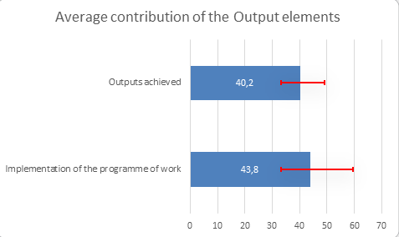

The score in “Outputs achieved” is 40.2 points on average, while the score for the “Implementation of the programme of work” is on average slightly higher and equal to 43.8 points. This very little difference among the 2 sub-elements does not provide additional added value for the analysis. The larger variability within different PAs in the “Implementation of the programme of work” indicates that probably for this indicator faster improvements can be achieved. The scores of the “Outputs achieved” are relatively similar, showing a similar situation on this indicator for all the PAs across the country. This relative homogeneity in the score can be explained by a mix of lack of long-term goals linked to an approach to management driven by operations rather than by a result-oriented approach.

Generally, there could be confusion between “Outputs” and “Outcomes” when planning and monitoring are low. This seems to be the case of Burundi, considering the inconsistency among the relatively high scores in the indicator of “Work plan” (P5) and the low values for the indicators “Long-term objectives” (P6) and “Management plan” (P4).

**Conclusions and suggestions**

The analysis of the “Outputs” highlights the following aspects:

* a misidentification of the indicators of Output, which yearns for more capacity building in management of protected areas and analysis of management effectiveness,
* a misunderstanding of the connection between the elements and sub-elements of the management cycle,
* a management without a clear direction.

All these elements could be an effect of lack of a results-oriented approach and of interventions not supported by an integrated system of planning-monitoring-evaluation.

The different elements of management seem to be addressed in a non-connected way, not aligned with specific objectives or results to be achieved instead of ensuring a logical link to achieve targets and long-term objectives. There is also an unclear understanding of the potential and the role that PAs could play at the country level.

**The possible operational recommendations based on the above considerations are as follows:**

* **to adopt a very basic and simple approach oriented on results and focusing on priorities,**
* **to improve the link between different management elements in order to improve both quality and focus of the interventions.**

### Outcomes

***Analysis***

Figure 17: The ranking of protected areas in Burundi with respect to the score in the dimensions of Outcomes

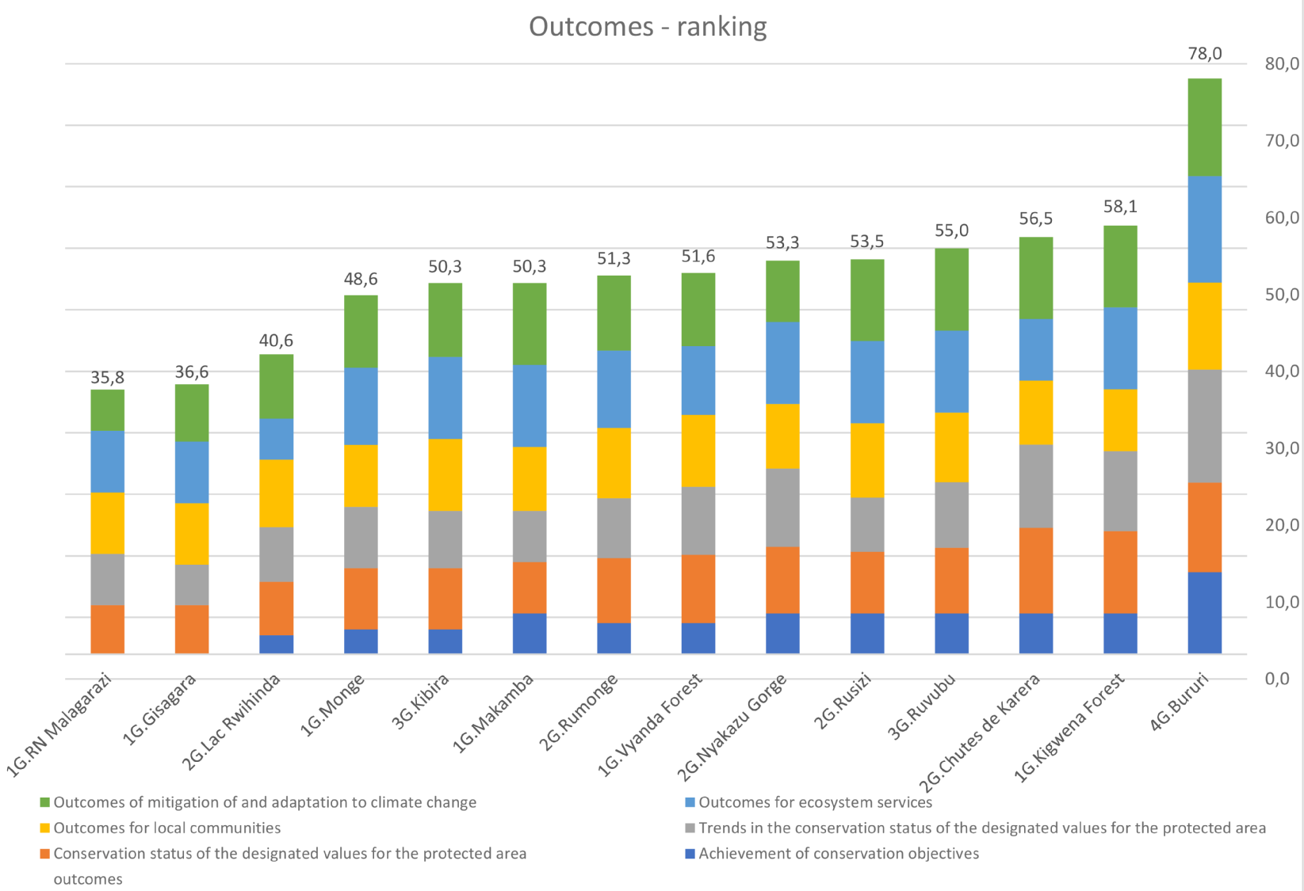

Table 35: Scores of the indicators of the Outcomes

|  |  |  |  |  |  |  |
| --- | --- | --- | --- | --- | --- | --- |
| **Protected areas** | **Achievement of conservation objectives** | **Conservation status of the designated values for the protected area** | **Trends in the conservation status of the designated values for the protected area** | **Outcomes for local communities** | **Outcomes for ecosystem services** | **Outcomes of mitigation of and adaptation to climate change** |
| 1G-Bururi | 66,7 | 72,9 | 91,7 | 70,9 | 86,7 | 79,2 |
| 2G-Kibira | 20,0 | 50,0 | 46,7 | 58,4 | 66,7 | 60,0 |
| 2G-Ruvubu | 33,3 | 53,2 | 53,4 | 56,7 | 66,7 | 66,7 |
| 3G-Lac Rwihinda | 15,4 | 43,4 | 44,5 | 55,0 | 33,4 | 52,1 |
| 3G-Rumonge | 25,2 | 52,8 | 49,0 | 57,2 | 62,8 | 61,1 |
| 3G-Nyakazu Gorge | 33,3 | 54,2 | 63,6 | 52,4 | 66,7 | 50,0 |
| 3G-Rusizi | 33,3 | 50,0 | 44,2 | 60,4 | 66,7 | 66,7 |
| 3G-Chutes Karera | 33,3 | 69,6 | 67,5 | 52,1 | 50,0 | 66,7 |
| 4G-Malagarazi | 0,0 | 40,0 | 41,7 | 50,0 | 50,0 | 33,4 |
| 4G-Gisagara | 0,0 | 40,0 | 32,8 | 50,0 | 50,0 | 46,7 |
| 4G-Monge | 20,0 | 50,0 | 50,0 | 50,0 | 63,0 | 58,8 |
| 4G-Makamba | 33,3 | 41,7 | 41,7 | 51,9 | 66,7 | 66,7 |
| 4G-Vyanda Forest | 25,2 | 55,6 | 55,6 | 58,3 | 55,8 | 59,5 |
| 4G-Kigwena Forest | 33,3 | 66,7 | 65,3 | 50,0 | 66,7 | 66,7 |

|  |  |  |  |  |  |  |  |  |
| --- | --- | --- | --- | --- | --- | --- | --- | --- |
| Value visualisation for categories: | 0 |  | 1-32 |  | 33-50 |  | 51-100 |  |

The final element of the management cycle relates to the assessment of the “Outcomes” generated for different categories of beneficiaries, near or far from the protected area. It is worth recalling here that PAs are not conceived as self-serving entities. They should provide services for the largest possible number of stakeholders. The measurement of management effectiveness with the IMET tool, in terms of “Outcomes” makes use of six different indicators in which protected areas are expected to deliver specific outcomes. Such indicators are: “Achievement of conservation objectives”, “Conservation status of the designated values for the protected area”, “Trends in the conservation status of the designated values for the protected area”, “Outcomes for local communities”, “Outcomes for ecosystem services”, “Outcomes of mitigation and adaptation to climate change”. The ranking of protected areas, based on the overall score achieved with respect to the “Outcomes” is presented in Figure 17.

Table 36: Ranking OUTCOMES

|  |  |
| --- | --- |
| **Protected areas** | **Synthesis of Outcomes** |
| 1G-Bururi | 78,0 |
| 4G-Kigwena Forest | 58,1 |
| 3G-Chutes de Karera | 56,5 |
| 2G-Ruvubu | 55,0 |
| 3G-Rusizi | 53,5 |
| 3G-Nyakazu Gorge | 53,3 |
| 4G-Vyanda Forest | 51,6 |
| 3G-Rumonge | 51,3 |
| 2G-Kibira | 50,3 |
| 4G-Makamba | 50,3 |
| 4G-Monge | 48,6 |
| 3G-Lac Rwihinda | 40,6 |
| 4G-Gisagara | 36,6 |
| 4G-RN Malagarazi | 35,8 |

|  |  |  |  |  |
| --- | --- | --- | --- | --- |
| Value visualisation for categories: |  | 0 |  | 1–32 |
|  | 33–50 |  | 51–100 |

The overall scores in this dimension are surprisingly high in relation to the general scores of the other elements of management effectiveness, nearly for all the protected areas. Scores higher than 51 points are reached by 10 of the 14 PAs. We can note that there is a significant gap between the score of Bururi (78 points) and the score of the other protected areas. The best score of Bururi could be justified as the result of a very good performance in every element of the management. Also, we can observe that other protected areas [of Groups 4 (Kigwena Forest and Vyanda Forest) and 3 (Chutes de Karera, Rusizi, Nyakazu Gorge)] score almost double in the dimension of “Outcomes” in comparison to the other elements of the management cycle. Four protected areas show scores with more equilibrated values for the different elements of management, while they show among the lowest scores in terms of “Outcomes”, i.e.: Malagarazi and Gisagara (Group 4), Lac Rwihinda (Group 3) and Kibira (Group 2). This situation seems to reflect the objectivity of the analysis. This offers the ground for a management effectiveness potential improvement.

**Achievement of conservation objectives**

Only Bururi reported a positive score with respect to the “Achievement of conservation objectives”. All remaining protected areas report low or null values. The zero score for Gisagara and Malagarazi could be the result of the lack of planning, but Kigwena Forest, Kibira and Vyanda Forest are in the high global ranking of “Outcomes” without having a “Management plan” (P4 indicator). On the other hand, the protected areas with null (Monge and Makamba) or low score on Management plan (Nyakazu Gorge, Chutes de Karera, Rusizi, Lac Rwihinda, Rumonge and Ruvubu) score low. Finally, the analysis seems to suggest that the “Achievement of objectives” is not related to planning. This situation highlights general inconsistencies in the situation assessment of management effectiveness of the PAs in Burundi.

Table 37: Achievement of conservation objective

|  |  |
| --- | --- |
| **Protected Areas** | **Achievement of conservation objectives** |
| 1G-Bururi | 66,7 |
| 4G-Kigwena Forest | 33,3 |
| 4G-Makamba | 33,3 |
| 3G-Chutes de Karera | 33,3 |
| 3G-Nyakazu Gorge | 33,3 |
| 3G-Rusizi | 33,3 |
| 2G-Ruvubu | 33,3 |
| 4G-Vyanda Forest | 25,2 |
| 3G-Rumonge | 25,2 |
| 4G-Monge | 20 |
| 2G-Kibira | 20 |
| 3G-Lac Rwihinda | 15,4 |
| 4G-Gisagara | 0 |
| 4G-RN Malagarazi | 0 |

|  |  |  |  |  |
| --- | --- | --- | --- | --- |
| Value visualisation for categories: |  | 0 |  | 1–32 |
|  | 33–50 |  | 51–100 |

**Conservation status and Trend of the designated values for the protected areas**

The “Conservation status” and the “Trend of the key values of the protected areas” are analysed together because they assess the same elements, even if adopting a different perspective (status and trend). The protected areas score similar results for both indicators.

Table 38: Ranking Implementation of the programme of work and outputs achieved

|  |  |  |  |  |
| --- | --- | --- | --- | --- |
| **Protected Areas** | **Conservation status of the designated values for the protected area** |  | **Protected Areas** | **Trends in the conservation status of the designated values for the protected area** |
| 1G-Bururi | 72,9 |  | 1G-Bururi | 91,7 |
| 3G-Chutes de Karera | 69,6 |  | 3G-Chutes de Karera | 67,5 |
| 4G-Kigwena Forest | 66,7 |  | 4G-Kigwena Forest | 65,3 |
| 4G-Vyanda Forest | 55,6 |  | 3G-Nyakazu Gorge | 63,6 |
| 3G-Nyakazu Gorge | 54,2 |  | 4G-Vyanda Forest | 55,6 |
| 2G-Ruvubu | 53,2 |  | 2G-Ruvubu | 53,4 |
| 3G-Rumonge | 52,8 |  | 4G-Monge | 50 |
| 4G-Monge | 50 |  | 3G-Lac Rwihinda | 44,5 |
| 3G-Rusizi | 50 |  | 2G-Kibira | 46,7 |
| 2G-Kibira | 50 |  | 3G-Rumonge | 49 |
| 3G-Lac Rwihinda | 43,4 |  | 3G-Rusizi | 44,2 |
| 4G-Makamba | 41,7 |  | 4G-RN Malagarazi | 41,7 |
| 4G-Gisagara | 40 |  | 4G-Gisagara | 32,8 |
| 4G-RN Malagarazi | 40 |  | 4G-Makamba | 41,7 |

|  |  |  |  |  |  |  |  |  |
| --- | --- | --- | --- | --- | --- | --- | --- | --- |
| Value visualisation for categories: | 0 |  | 1-32 |  | 33-50 |  | 51-100 |  |

The indicators show relatively good values, ranging from 40 points to more than 90 (Bururi – Trend). Many protected areas show very similar score for both indicators; 8 out of 14 PAs show less than 2 points of difference between the two indicators (see the PAs identified by the grey colour in the table). Probably protected areas’ staffs are convinced that their key values are globally in good or stable conservation condition and stable or positive trend. However, they cannot confirm this with the data because high scores in both status and trends are also observed among the same protected areas that previously scored low or very low values on “Monitoring and Research” (also Bururi scored a mere 19 points for the indicators “Biomonitoring and Research”). This is a clear overestimation considering the scoring of the other elements of the management cycle. Many protected areas of Groups 3 and 4 are in high position in the ranking of “Outcomes”, which indicates that performance in these two indicators is not consistent

**Outcomes for local communities**

All the protected areas score high on “Outcomes for local communities”. The minimum value registered is 50 points. As for other Outcome indicators, the evaluation seems to be excessive when compared with low and very low scores of all the protected areas (with the exception of Kibira and Bururi) for the indicator of “Process” concerning the “Management of appropriate benefits/assistance for local communities” (PR12). This might suggest a misidentification between economic benefits for local communities (i.e.: income, employment, payment for environmental services, etc.) and the ecosystem services delivered by the PAs to local stakeholders (see next indicator).

Table 39: Outcomes for local communities

|  |  |
| --- | --- |
| **Protected Areas** | **Outcomes for local communities** |
| 1G.Bururi | 70,9 |
| 3G-Rusizi | 60,4 |
| 2G-Kibira | 58,4 |
| 4G-Vyanda Forest | 58,3 |
| 3G-Rumonge | 57,2 |
| 2G-Ruvubu | 56,7 |
| 3G-Lac Rwihinda | 55 |
| 3G-Nyakazu Gorge | 52,4 |
| 3G-Chutes de Karera | 52,1 |
| 4G-Makamba | 51,9 |
| 4G-Gisagara | 50 |
| 4G-Kigwena Forest | 50 |
| 4G-Monge | 50 |
| 4G-RN Malagarazi | 50 |

|  |  |  |  |  |
| --- | --- | --- | --- | --- |
| Value visualisation for categories: |  | 0 |  | 1–32 |
|  | 33–50 |  | 51–100 |

**Outcomes for ecosystem services**

Table 40: Outcomes for ecosystem services

|  |  |
| --- | --- |
| **Protected Areas** | **Outcomes for ecosystem services** |
| 1G-Bururi | 86,7 |
| 4G-Kigwena Forest | 66,7 |
| 4G-Makamba | 66,7 |
| 3G-Nyakazu Gorge | 66,7 |
| 3G-Rusizi | 66,7 |
| 2G-Kibira | 66,7 |
| 2G-Ruvubu | 66,7 |
| 4G-Monge | 63 |
| 3G-Rumonge | 62,8 |
| 4G-Vyanda Forest | 55,8 |
| 4G-Gisagara | 50 |
| 4G-RN Malagarazi | 50 |
| 3G-Chutes de Karera | 50 |
| 3G-Lac Rwihinda | 33,4 |

|  |  |  |  |  |
| --- | --- | --- | --- | --- |
| Value visualisation for categories: |  | 0 |  | 1–32 |
|  | 33–50 |  | 51–100 |

The protected areas in Burundi score very high (with the exception of Lac Rwihinda) on “Outcomes related to ecosystem services”. This means that globally the trend of the ecosystem services provided by the protected areas has improved. The strong level of threats (indicator “Threats – C3”) could suggest that it is quite difficult to preserve or improve the ecosystem services. On the other hand, if ecosystem services are of particular importance from the perspective of stakeholders, the protected area staff could improve management efforts on these aspects. This situation, according to the scores of the indicator “Ecosystem services – PR19), is currently not occurring.

**Outcomes of mitigation and adaptation to climate change.**

Table 41: Outcomes of mitigation and adaptation to climate change

|  |  |
| --- | --- |
| **Protected Areas** | **Outcomes of mitigation and adaptation to climate change** |
| 1G-Bururi | 79,2 |
| 4G-Kigwena Forest | 66,7 |
| 4G-Makamba | 66,7 |
| 3G-Chutes de Karera | 66,7 |
| 3G-Rusizi | 66,7 |
| 2G-Ruvubu | 66,7 |
| 3G-Rumonge | 61,1 |
| 2G-Kibira | 60 |
| 4G-Vyanda Forest | 59,5 |
| 4G-Monge | 58,8 |
| 3G-Lac Rwihinda | 52,1 |
| 3G-Nyakazu Gorge | 50 |
| 4G-Gisagara | 46,7 |
| 4G-RN Malagarazi | 33,4 |

|  |  |  |  |  |
| --- | --- | --- | --- | --- |
| Value visualisation for categories: |  | 0 |  | 1–32 |
|  | 33–50 |  | 51–100 |

As for the previous indicator, the high value of the “Outcome of mitigation and adaptation to climate change” does not match with the analysis of the indicators on management activities of the Process (PR18). The indicator of the interventions focused on “Mitigation and adaptation to climate change to conserve biological diversity and to ensure a sustainable management of natural resources” suggests low performance for all of the PAs. It is very hard to obtain effects and impact with little or no activities oriented towards these aspects. This is only possible when the outcomes emerge in any case, even in the absence of intervention (e.g. forests in equatorial regions, or when the required outcomes are set at an extremely low level). Most probably the PAs evaluated the “Regulating” ecosystem services provided by the protected area and not the impact of management to minimise the effects of climate change on the values of the protected area.

**General**

The largest contribution to the “Outcomes” achieved by PAs in Burundi is observed from the “Outcomes for Ecosystem Services”. The average score in this domain was at the level of 60.8 points (out of 100). There is also relatively little variation between the worst and the best performing protected area. Almost the same level of average contribution was noted for “Outcomes of mitigation and adaptation to climate change”. The average score for this indicator is 59.6 points. However in this respect a slightly larger dispersion of scores was noted. As the effects of climate change are relatively new, protected areas differ more on this either because they become leaders in this respect or because they make confusion between the concept of “Regulating” ecosystem services and the effect on climate change. Average performance of the indicators “Conservation status of the designated values for the protected area”, “Trends in the conservation status of the designated values for the protected area”, “Outcomes for local communities”is also relatively good among investigated Protected Areas in Burundi. The average score in all those indicators is above 50 points. Very little differences in the score between the best and worst performing PAs were observed in “Outcomes for local communities”.These more or less similar scores show that no specific management activities are undertaken to bring or to generate benefits to the local communities. Much larger differences are observed in the outcomes indicators related to conservation. Both for status and trends, the differences between good performing and underperforming PAs are substantial. The lowest score in “Outcomes” is observed for “Achievement of Conservation Objectives”, the average national score being merely 26.6 points. Outcomes in this domain are particularly poor fundamentally because the protected areas lack of management plan (P4).

Figure 18: Average contribution of the Outcome elements

Note: In order to present the relative importance for the Outcomes of (1) Conservation status of the designated values for the protected area, (2) Trends in the conservation status of the designated values for the protected area, (3) Outcomes for local communities, (4) Outcomes for ecosystem services, (5) Outcomes of mitigation and adaptation to climate change, these indicators were normalized from their original scale to the scale ranging from 0 (worst situation) to +100 (the best situation)

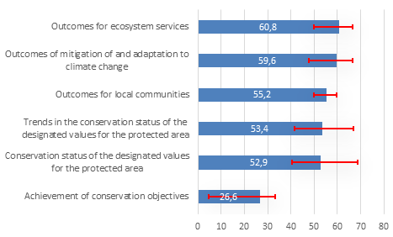

**Conclusions and suggestions**

The analysis outlines a situation that is very difficult to explain. Despite very low level of achievement of the long-term objectives (average 26.6 points), achievement of effects and impact of all the other indicators of the Outcomes is relatively high (between 52.9 and 60.8 points).

The management approach is clearly oriented on interventions carried out within the PAs borders, as the main activities undertaken address the preservation of biodiversity and ecosystem services. This situation is the result of a lack of planning, of monitoring and of evaluation (or self-evaluation) in management (see indicators P4 and PR16).

Conservation of biodiversity, of ecosystem services and of cultural values require ‘management guided by long-term objectives’. This means that one must adopt a proactive approach, i.e., designed to achieve specific targets and sets of results, rather than reactive, or simply responding to issues arising. It is important to highlight here that the use of low-level conservation targets reduces high-level conservation performance.

***Based on the above considerations, possible operational recommendations are as follows:***

* ***to establish a vision as well as long-term objectives in order to ensure high-level conservation performance,***
* ***to clearly identify the ”mission” for each protected areas, based on their specific context (e.g.: key biodiversity elements, ecosystem services, environmental education, cultural value, etc.), and to orient the management process accordingly,***
* ***to have a better knowledge and understanding of threats and opportunities to improve the services provided by the protected areas (e.g. ecosystem services).***

**Reliability of results**

Protected areas provided responses in most of the domains assessed. However, depending on the information actually available or the scope of activities performed, the staff of a protected area had the opportunity not to answer specific questions. Despite the fact that lack of responding can be a legitimate action, it decreases reliability of the results and needs to be reported. We decided to provide a measure of non-response by checking the number of domains to which responses were not provided by protected areas’ representatives in Burundi.

Figure 19: Number of IMET indicators (out of 41) with missing responses

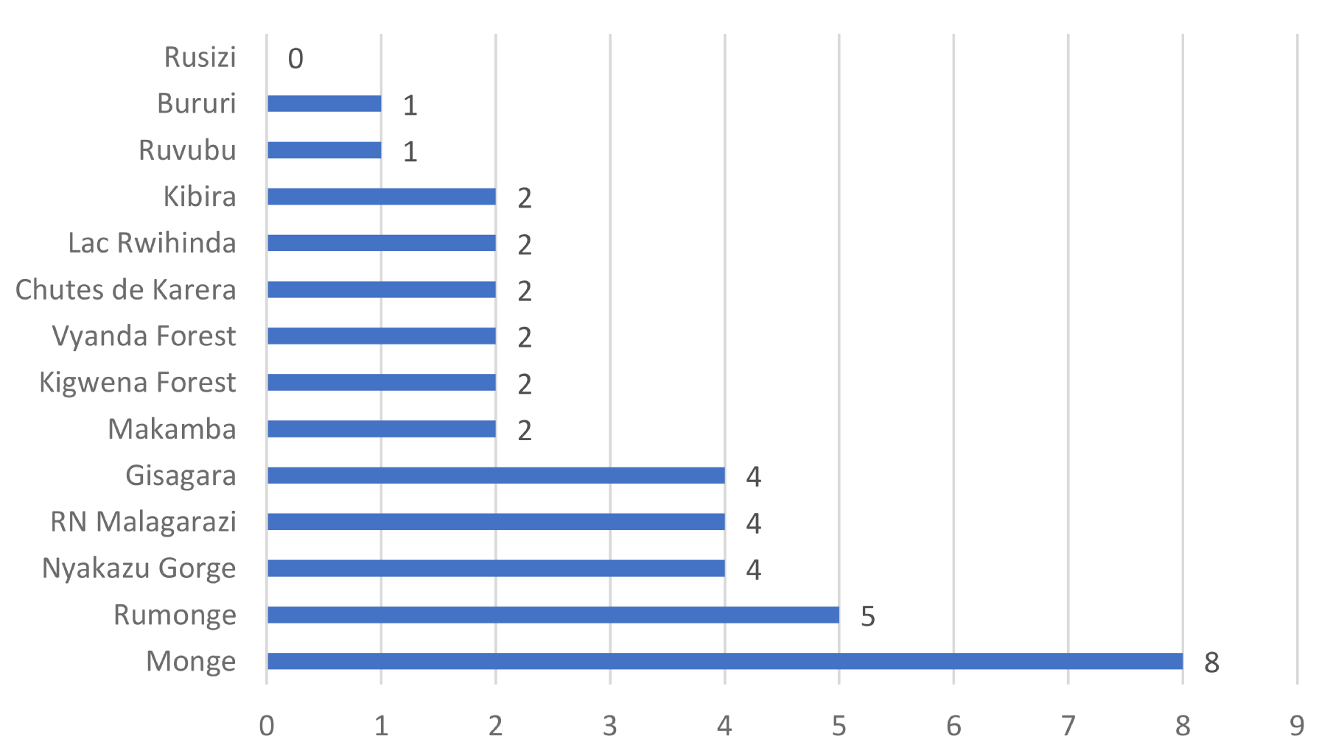

Figure 20: Discrepancy between the IMET score obtained with the use of raw data and imputed data

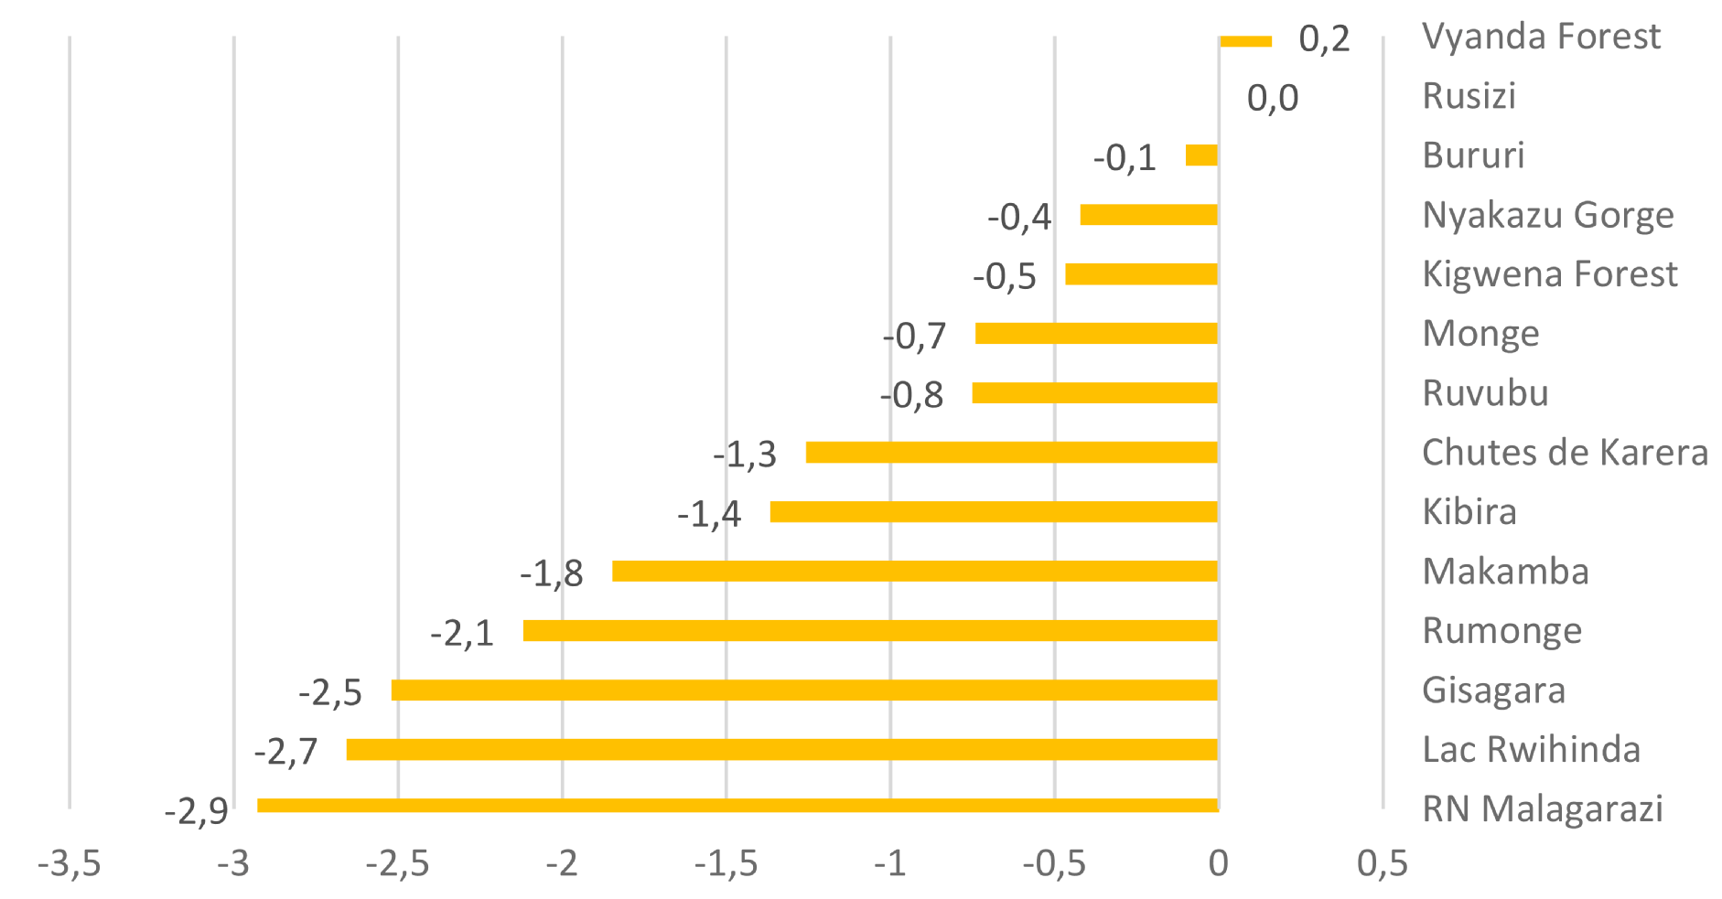

In addition to the non-response, we hypothesize that protected areas might be reluctant to provide information regarding the domains where they observe a difficult situation. This does not heed to be related to cheating. Such misreporting can be driven by convenience. However for a sound assessment, it is necessary to take also this aspect into consideration. In this objective, we identified the areas (questions) where the PAs did not provide a response and we introduced imputed values, as average value of the scores of the other PAs on that very question, to simulate the presence of a score for that question), despite lack of reporting. Subsequently, we calculated the overall score for the 2 different situations: 1) with multiple imputations included and 2) without multiple imputations included (raw). This approach helps to understand whether misreporting occurred in areas where substantial problem are present. Figure 19 indicates the number of domains reporting an absence of response from the protected area. Figure 20 provides information about the discrepancy between the score with multiple imputations and score without it (raw).

The largest number of non-response in the IMET indicators was noted in Monge. Out of 47 domains in which the no-response was measured as many as eight indicators were left without a proper response. A significant number of non-responses – 5 – was also noted in Rumonge. Three protected areas did not manage to describe their situation in as many as four areas: Gisagara, RN Malagarazi and Nyakazu Gorge. Two areas did not respond in only one indicator, while only one protected area – Rusizi – completed responses in all of the specified IMET indicators.

On average, we can observe that protected areas avoided responding on difficult dimensions. The scores calculated with multiple imputations (i.e. taking into account in which indicators missing responses were present), show that in average protected areas score worse if we take into account the missing patterns. This implies that the most difficult indicators were likely to be avoided by our respondents. Following the imputation, twelve out of fourteen protected areas ended up with a score that was lower than the initial one. Four protected areas had their score corrected by more than 2 points because of their overoptimistic pattern of responding. Vyanda Forest is the only area with a score higher (+ 0.2 points) than before the imputation. Rusizi keeps exactly the same IMET score before and after performing the imputations due to lack of missing responses.

These scores can be used to calculate the score of average bias. The score is designed to range between 0 and 100, where the 0 value represents no bias in responding, while 100 represents complete bias. For the Burundi system this score is 4.5, which can be associated with around 4.5% of expected bias/not-responding in the Burundi system. This score will become informative when compared to equivalent scores calculated for other systems. However as Burundi is the first country analysed at the network level there is no possible comparison yet.

# Overall Conclusion and Suggestions

The overall analysis for all PAs shows values for “Inputs” and “Process” always lower than other elements of PA management. The best values are awarded to “Outputs” and “Outcomes”.

Burundi’s conservation system seems to show good management results in spite of low values in “Planning”, “Inputs” and “Process”. This inconsistency does not find a technical justification and reveals a need for a thorough review of the PA network management system from an “operations-oriented” approach to a “results-oriented” management.

Table 42: Ranking of the six elements of the management cycle for all Burundi’ protected areas

|  |  |  |  |  |  |  |  |  |
| --- | --- | --- | --- | --- | --- | --- | --- | --- |
| **Protected areas** | **Context** | **Planning** | **Inputs** | **Processes** | **Outputs** | **Outcomes** | **IMET scores** | **Groups average** |
| 1G-Bururi | 74,2 | 67,0 | 58,3 | 55,4 | 66,7 | 78,0 | 66,6 | 66,6 |
| 2G-Kibira | 61,0 | 58,8 | 36,4 | 44,7 | 46,7 | 50,3 | 49,6 | 49,7 |
| 2G-Ruvubu | 63,7 | 55,9 | 31,5 | 42,9 | 50,0 | 55,0 | 49,8 |
| 3G-Nyakazu Gorge | 63,6 | 38,4 | 25,8 | 32,1 | 38,9 | 53,3 | 42,0 | 42,4 |
| 3G-Rumonge | 57,0 | 40,3 | 20,5 | 37,6 | 45,8 | 51,3 | 42,1 |
| 3G-Rusizi | 53,0 | 38,9 | 30,9 | 36,2 | 40,0 | 53,5 | 42,1 |
| 3G-Chutes Karera | 52,0 | 41,5 | 24,1 | 37,4 | 44,4 | 56,5 | 42,6 |
| 3G-Lac Rwihinda | 64,2 | 46,8 | 20,5 | 37,1 | 50,0 | 40,6 | 43,2 |
| 4G-Makamba | 51,1 | 24,4 | 17,0 | 20,0 | 33,3 | 50,3 | 32,7 | 35,5 |
| 4G-Gisagara | 60,4 | 24,8 | 23,4 | 23,7 | 33,3 | 36,6 | 33,7 |
| 4G-Monge | 56,4 | 19,4 | 17,5 | 30,0 | 33,3 | 48,6 | 34,2 |
| 4G-Vyanda Forest | 57,5 | 22,7 | 22,4 | 28,2 | 33,3 | 51,6 | 36,0 |
| 4G-Malagarazi | 65,2 | 34,3 | 20,8 | 27,7 | 33,3 | 35,8 | 36,2 |
| 4G-Kigwena Forest | 65,2 | 24,5 | 25,6 | 29,8 | 38,9 | 58,1 | 40,4 |

|  |  |  |  |  |  |  |  |  |
| --- | --- | --- | --- | --- | --- | --- | --- | --- |
| Value visualisation for categories: | 0 |  | 1–32 |  | 33–50 |  | 51–100 |  |

A set of the main characteristic elements of the Burundi PAs network is presented below, in the form of a SWOT analysis:

Table 43: Characteristic elements of the Burundi PAS network in the form of a SWOT exercise

|  |  |
| --- | --- |
| ***Strengths***   * Number of PAs * Number of people in PA staff * High potential for ecosystem services and environmental sensitisation and education | ***Weaknesses***   * Not clear identification of key management elements * Low inputs * Poor awareness of own situation * No vision and goals * Low capacity for self-analysis on PA management * No forms of governance with other stakeholders * Insufficient research and biomonitoring |
| ***Opportunities***   * High demand and expectation for all kinds of ecosystem services (especially for provisioning) * Proximity to roads and towns (proximity opportunity for environmental sensitisation and education) | ***Threats***   * High population density * Exotic invasive species |

Burundi’s conservation network is characterised by a limited set of protected areas showing positive or near positive management effectiveness values. PAs in Groups 1 and 2 (3 out of 14, 1 PA in Group 1 and 2 PAs in Group show an average on IMET of 66.6 and of 49.7 points (out of 100), respectively. The protected area of Group 1, Bururi NP, is the only PA showing – according to the assessment - a very positive situation in terms of management effectiveness.

Group 3 is characterised by low management values. It consists of 5 PAs for which the average IMET score is 42.4 points (out of 100). Within this set of weakly managed PAs, some of them are characterised by a sound consistency in the self-assessments. Group 4 delivers very inefficient management values. It consists of 6 PAS and shows an average IMET score of 35.5 points (out of 100). Within this set, based on the self-assessments, the PAs show quite high inconsistencies between the way management is implemented and the “Outcomes”.

**Based on the above considerations and for operational purposes, it is suggested to arrange Burundi’s PAs in 3 categories each of which would require different actions approach for management improvement:**

* a first set (Groups 1 and 2, Kibira, Ruvubu, Bururi) on which it is suggested to invest in management improvement to easily achieve well-defined conservation objectives;
* a second set of PAs (the Group 3 in order of priority: Rwihinda Lake, Nyakazu Gorge, Rumonge, Karera Falls, Rusizi) where it is recommended to invest in “Inputs” and in specific and targeted capacity-building initiatives, as they have the potential to demonstrate a rapid improvement in management;
* a final set of PASs (Group 4) that require a substantial effort in terms of capacity building, investment and time to move towards more suitable forms of management.

Suggestions for interventions need to focus both on establishing priorities to be addressed in the short term and on developing fundamentals of construction or reconstruction of the management system to be effective in the longer term.

The fundamentals for a long-term intervention concern: capacity building, essentially through action training, development of a national strategy with the definition of well-defined targets and fundraising approach to enhance the ecosystem services conservation management for human well-being.

Priorities for short-term actions include: analyses to draft, improve or adapt better management and work plans: (i) to develop ecosystem services management, (ii) to expand governance to other stakeholders, and (iii) to improve management capacities based on limited available resources. The table below provides a schematic visual approach to the key recommended actions for each group.

Table 44: Possible improvement in protected areas management in Burundi

| **Possible improvement in protected areas management in Burundi** | **Groups 1 and 2** | **Group 3** | **Group 4** |
| --- | --- | --- | --- |
| Refine analysis to better address the potential of the PA and on this basis to define simple and realistic elements of vision and objectives on which management and work plans can be built. | **P1** | **P2** | **P2** |
| Strengthen management skills essentially for training aimed at:   1. identification of manageable actions, 2. development of a proactive approach oriented on results 3. internalisation of management tools such as:    1. planning – monitoring – evaluation    2. problem solving, decision-making    3. prioritisation and management with limited resources | **FT** | **P1** | **P1** |
| Develop an approach to management of ecosystem services (knowledge, conservation and enhancement) in order to promote:   1. provision of sustainable ecosystem services for the populations 2. PAs’ growth through the development of environmental and environmental education 3. tourism based on ecosystem services associated with biodiversity | **FT** | **P3** | **P3** |
| Promote the governance of PAs to:   1. strengthen the management of ecosystem services 2. reduce the threats 3. preserve the cultural values of the minority and disadvantaged autochthonous populations [see pygmies] | **FT** | **FT** | **FT** |

Legend:

**P_Number** (1–2–3 in order of decreasing priority) = Priority

**FT** = Future targets (not priority at present)

# Annexes

## Annexe: Can the Key Landscapes of Conservation (KLC) criteria be used for grouping PAs? Can the PAs grouped in Key Landscapes of Conservation (KLC) be analysed with management effectiveness criteria?

For the purpose of statistical analysis, it was asked to Burundi authorities to propose a possible classification of the protected areas into plausible categories of Key Landscapes of Conservation (KLC). This classification was then assessed against the “Grouping” approach adopted in this report and based on management effectiveness criteria.

Beyond a general consideration on the fact that such a classification is very tentative, we want here to highlight the possible limitations of this statistical analysis.

Burundi authorities proposed 6 possible KLCs, based on territorial, biodiversity, and ecoregion criteria:

1. Parc national de la Kibira + Réserve naturelle de Bururi + Réserve naturelle de Monge
2. Réserve naturelle de Rumonge + Réserve naturelle de Kigwena + Réserve naturelle de Vyanda + paysages protégés de Makamba.
3. Paysages aquatiques protégés du nord : Lac Rwihinda
4. Parc national de la Ruvubu + Paysages protégés de Gisagara
5. Parc national de la Rusizi
6. Monuments de l’Est: failles de Nyakazu + Chutes de Karera + Réserve naturelle de la Malagarazi.

We present below, in Figure 21, the average level of performance for each of the six elements of management effectiveness reported for the 6 different KLCs (categories) proposed.

Figure 21: Performance in the six elements of the management cycle in the groups proposed as Burundi’s KLC. Source Own calculations

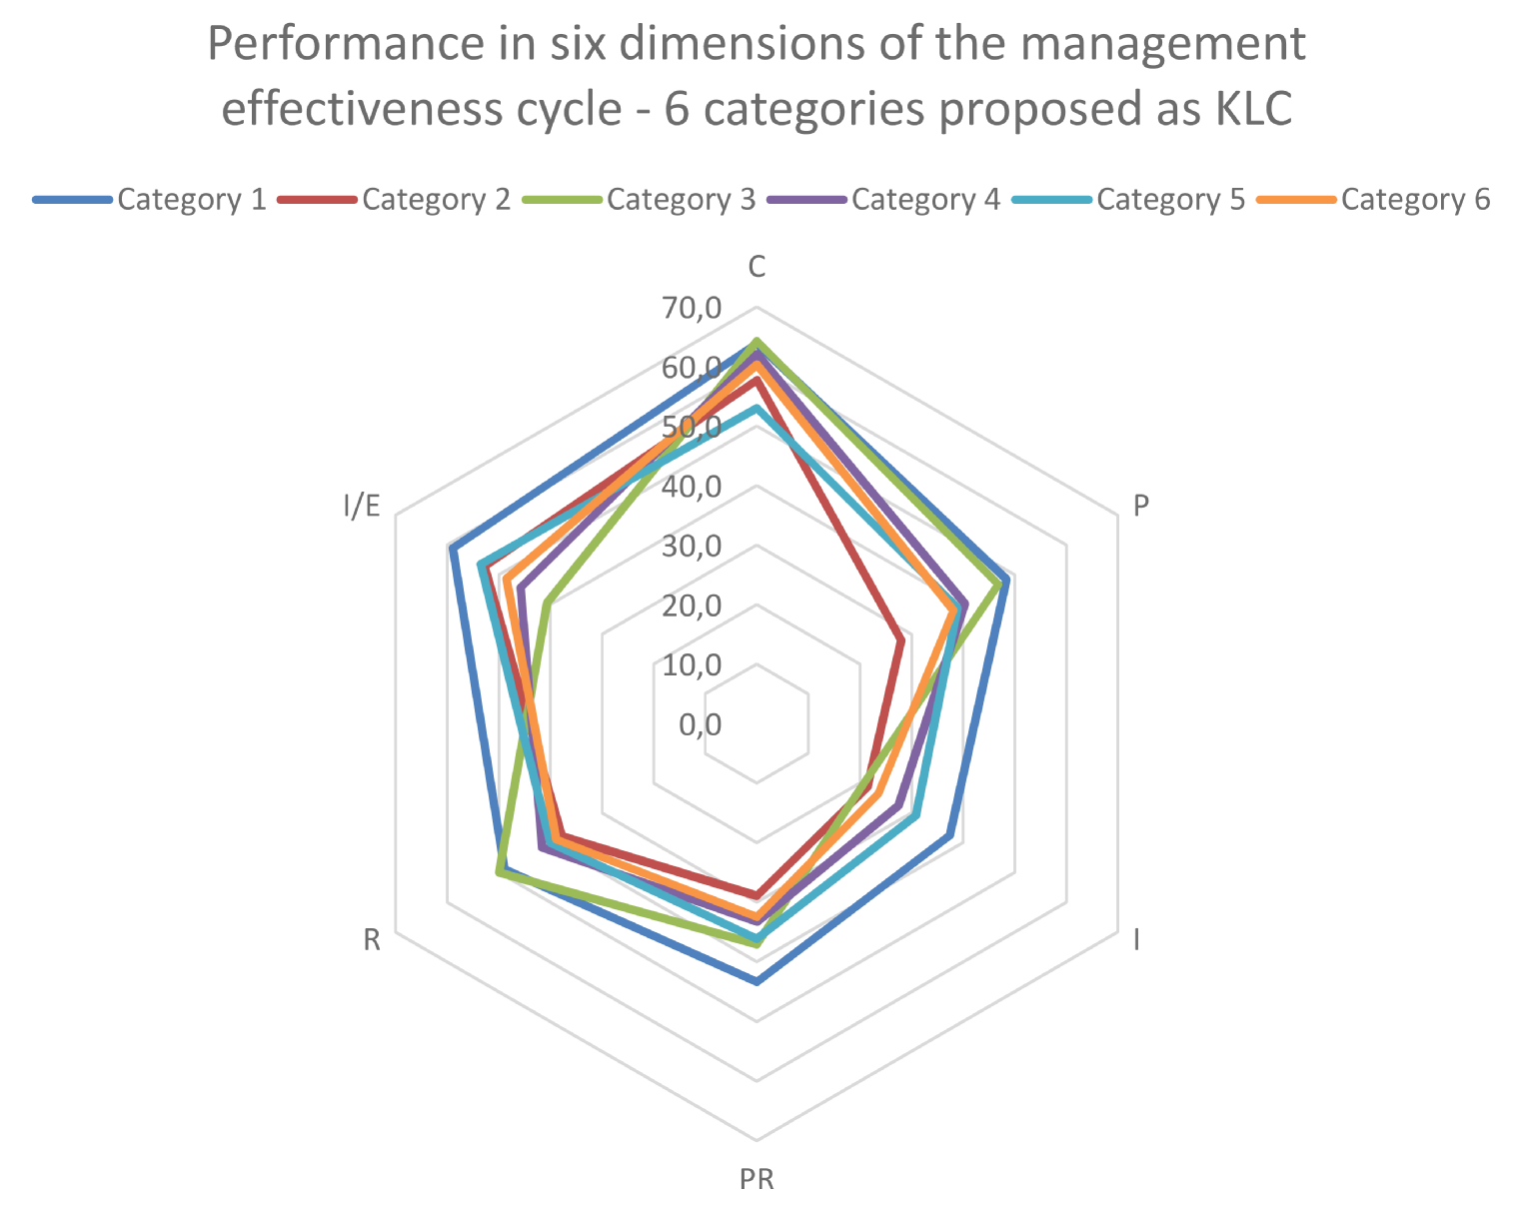

The group of PAs of the proposed KLCs are clearly less structured than the PAs associated using the “Grouping” approach based on management effectiveness homogeneity, adopted in the present report (previous pages).

It is very hard to outline a clear characterization of the different categories, based on their specificities, at least in terms of management effectiveness criteria. For example, protected areas in KLC Category 3 are the best in “Outputs” but the worst in “Outcomes”. Protected areas of KLC Category 1 score rather high but this is mostly due to the substantial contribution of the performance reported by one of the protected areas included in this KLC Category (Bururi) and not due to the overall good performance of all the PAs of this KLC Category.

It seems that the analysis of the protected areas based on the KLC criteria highlights a problem of significant lack of homogeneity among PAs of the same KLC Category, in terms of homogeneity of the values of the different elements of the management cycle of a PA. The following graph indicates differences between KLC Categories of protected areas in Burundi. The KLC Categories with only one protected area are excluded from the analysis and, therefore, are not included in the graph. The graph also provides comparison on average discrepancies between protected areas belonging to the groups identified with the statistical analysis and protected areas belonging to the categories identified with the KLCs criteria.

Figure 22: Performance in the six elements of the management cycle in the groups identified as Burundi’s KLC in the grouping performed in this study. Source Own calculations

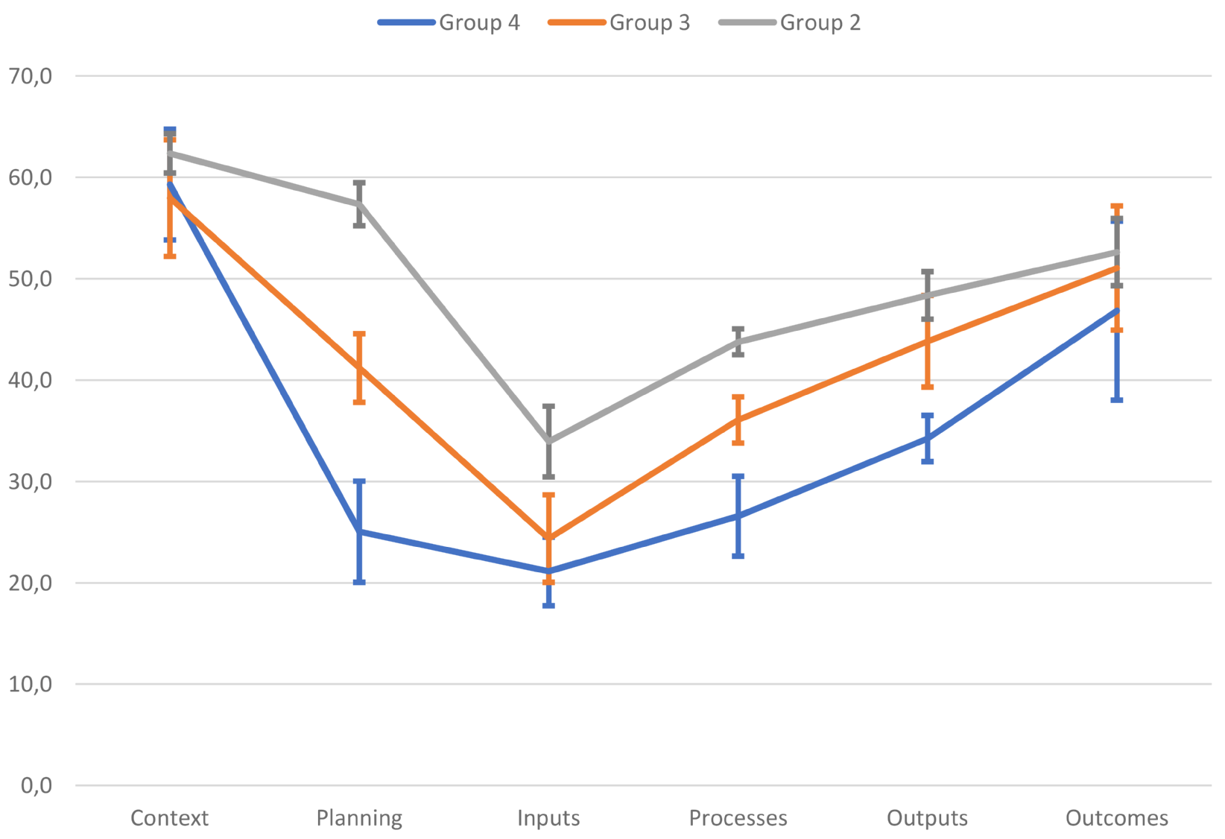

Average score and standard deviation of the score for PAs generated automatically (Group 1 not presented in the Graph (Figure 22) due to the fact that the Group includes only 1 PA). The standard deviation is represented by the height of the vertical segments (whiskers). Higher segments correspond to higher standard deviations.

Figure 23: Performance in the six elements of the management cycle in the groups proposed as Burundi’s KLC. Source Own calculations

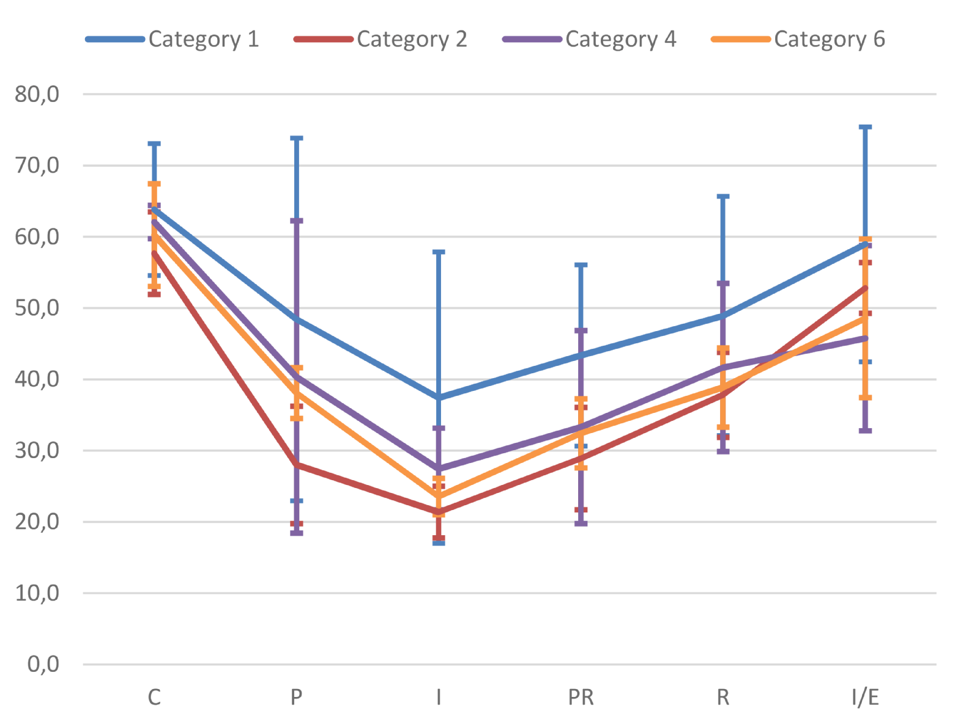

Average score and standard deviation of the score for PAs classified in KLCs (Category 3 and Category 5 not presented because of a single PA in the group)

One can observe that whiskers, representing standard deviation of score in particular dimensions of management effectiveness are significantly smaller in the case of automatic, predefined classification (Figure 22) than it is the case in classifications based on external assessment (KLC) (Figure 23). In the latter, differences are large because protected areas contributing to a particular dimension are much more diverse in terms of elements of the management effectiveness cycle. If we observe in a KLC a wider range of values of management effectiveness indicators, it means that we must adopt many different interventions in favour of the management enhancement. This would be a very difficult task with various obstacles to overcome.

Although an analysis of a consolidated KLC in other countries of Central Africa could give different results, the present work suggests that a global analysis of the KLCs’ PAs based only on management effectiveness criteria seems to be inappropriate. The PAs of the KLCs should preferably be analysed using criteria as:

* specific key conservation elements,
* specific key ecosystem services,
* key elements linked to specific values or targets.

## Annexe: Cross analysis (work in progress)

The cross analysis exploited in the report is used to easily identify the supposed inconsistency between the scores of groups of indicators which are usually “functionally linked” among them. Cross-analysis is the analysis among specific indicators of management effectiveness comparing the differences on values. The table 45 below displays the visualisation of the comparison between indicators of management effectiveness. For example, it can be possible to check the consistency of the indicator “P4 – Objectives of the protected area” with regards to other indicators usually functionally linked. The blue line identifies the functionally linked indicators with the indicator “P4 – Objectives of the protected area”. The statistical analysis could compare the value of the usually functionally linked indicators and emphasise the inconsistency as strong difference between values. The aim of the cross-analysis, as for the averaging, is to go deeper into the analysis, to identify possible recovery approaches.

Table 45: Table of visualisation of the cross analysis for the management effectiveness indicators

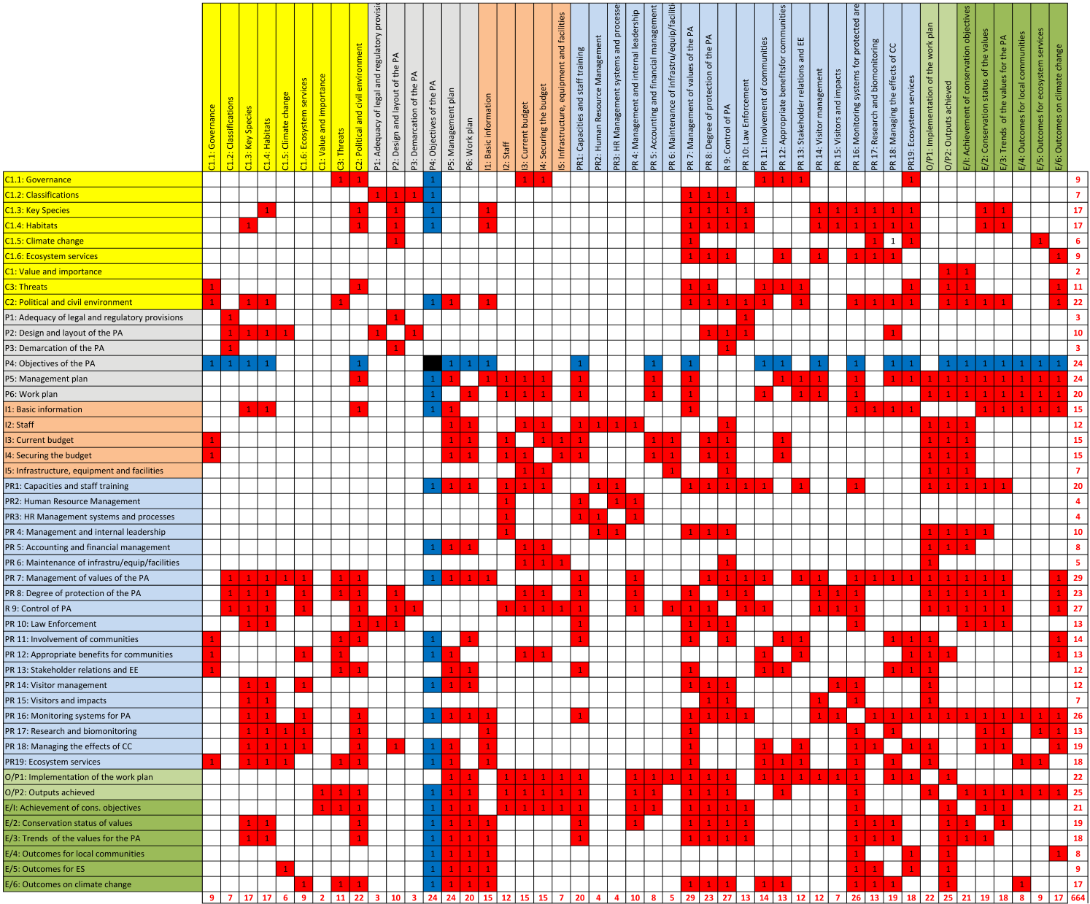

1. k-means clustering is a common method for cluster analysis in data mining. K-means clustering aims the partition of a number of observations into k clusters in which each observation belongs to the cluster with the nearest mean. The analysis of Burundi use the large used k-means Calinski-Harabasz Index.
2. Each point represents a PA (figure 2) or a Group of PAs (figure 3). The point represents the associated values of basic elements (management context, planning and inputs) in abscissae and process in principal tidy line (on the left). The values of outputs and outcomes are represented by a line in the second tidy line (on the right)
3. Cronbach’s Alpha coefficient measures reliability of a scale, i.e., whether the set of indicators is sufficiently coherent to be defined as unidimensional. Normally it is assumed that the values of 0.7 or higher of the Cronbach’s alpha coefficient indicate sufficient reliability of a scale.
4. Whiskers identify the variability
5. N.B.: The scores of “Values and importance” are always positive. The scores of “Political and civil environment” are either positive or negative depending on their positive or negative effect on the management of the PA. The scores of “Threats” are always negative. For the sake of assessment and visualisation, and to enable sound comparison of these three indicators, the above scores were statistically normalised in a scale 0 – 100.
6. Design issues include considerations on size and shape.